**FLUID MOTION**

**Exercises**

**Section 15.1 Density and Pressure**

**15. Interpret** This problem requires us to calculate the total mass of a substance given its density and volume.

**Develop** The density *ρ* is defined as the mass per unit volume, or *ρ* = *m*/*V*. Given the volume and the density, the mass can be calculated by solving this equation for *m*: *m* = *ρV*. Because we are given the mass in units of kg/m3 and the volume in terms of L, we will convert L to m3 using the conversion factor

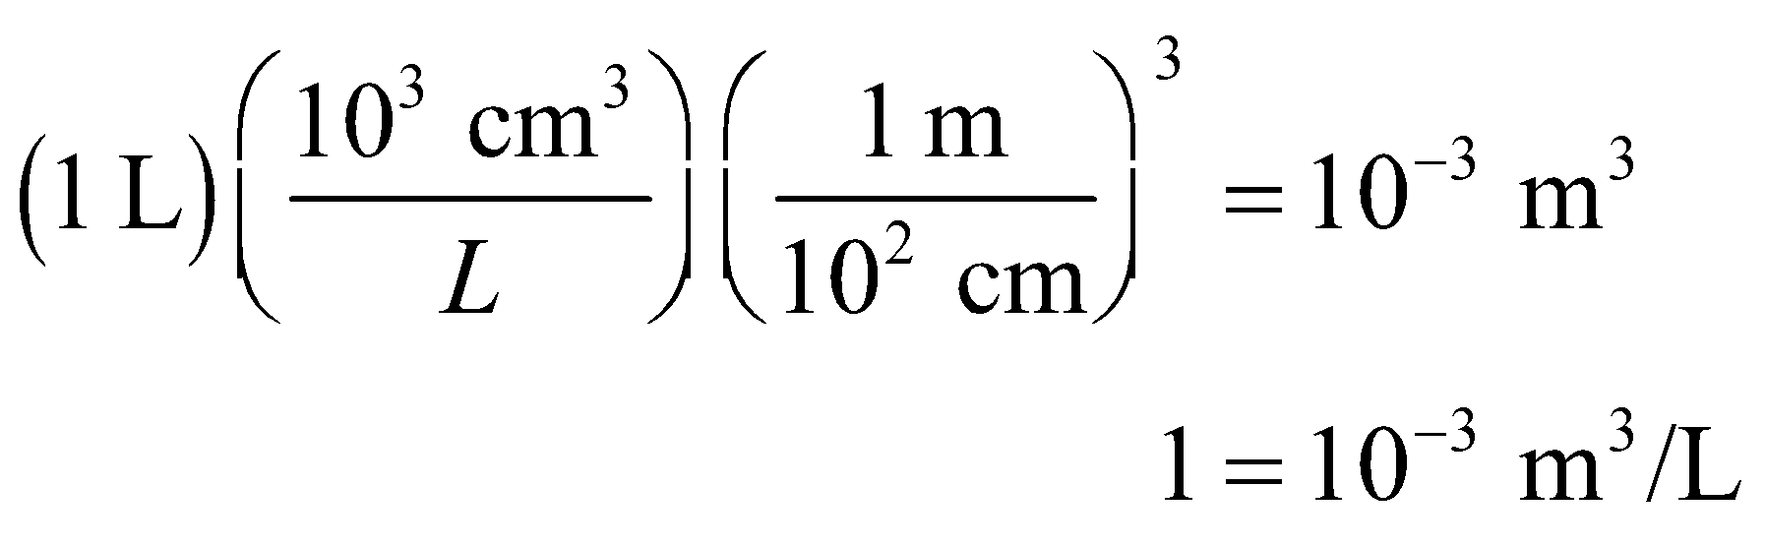

**Evaluate** Inserting the given quantities *ρ* = 1600 kg/m3 and *V* = (0.75 L)(10−3 m3/L) =0.75 × 10−3 m3, we find



**Assess** The mass is linearly proportional to the volume and to the density.

**16. Interpret** This problem is about the volume fraction of water that consists of atomic nuclei, which for this problem are considered to be solid. Given the density of water and atomic nuclei, we are to find the fraction of space (i.e. volume) in water that is *not* empty space (i.e., the fraction of the volume occupied by the nuclei).

**Develop** The volume occupied by the nuclei is *V*n = *m*n/*ρ*n, and the volume occupied by water is *V*w = *m*w/*ρ*w ≈ *m*n/*ρ*w if we ignore the mass of the electrons (which is much, much less than the mass of the nuclei so *m*w = *m*n + *m*e ≈ *m*n). The fraction of the water volume occupied by the nuclei is *V*w/*V*n.

**Evaluate** The fraction of volume occupied by nuclei in water is

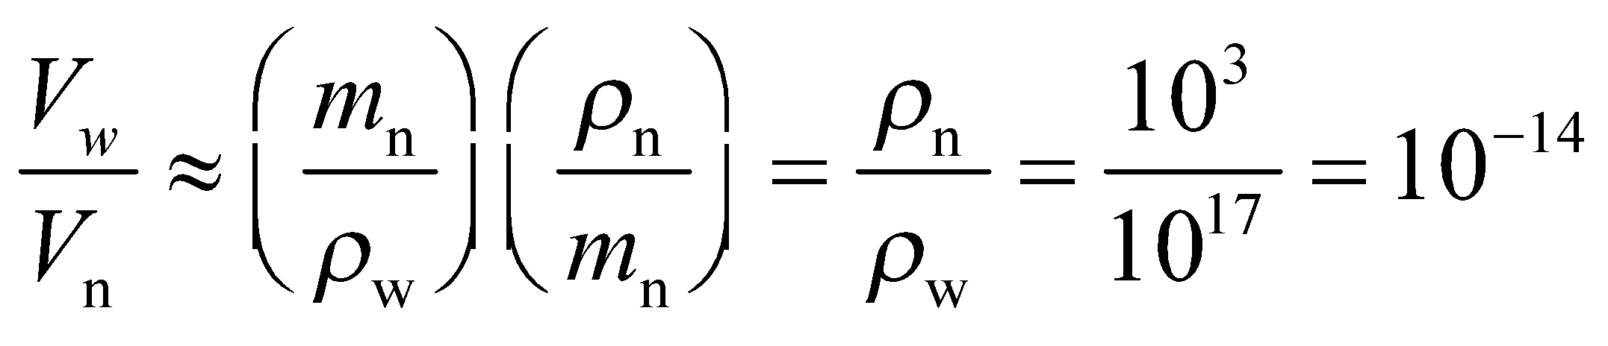

**Assess** The result agrees with the fact that almost the entire mass of an atom is concentrated in its nucleus, which is made up of protons and neutrons that are much more massive than the electrons.

**17. Interpret** This problem involves calculating the density given the mass and the volume of a substance, and calculating the volume were this same mass to have a different density.

**Develop** Use the definition of density *ρ* = *m*/*V* to find the density of the air in the cylinder, which we will call *ρ*1. For part (b), let *ρ*1 go to *ρ*2 = 1.2 kg/m3 and keep the mass the same (*m* = 8.8 kg) to calculate the new volume *V*2 occupied by the air.

**Evaluate** (a) The density of the air in the cylinder is

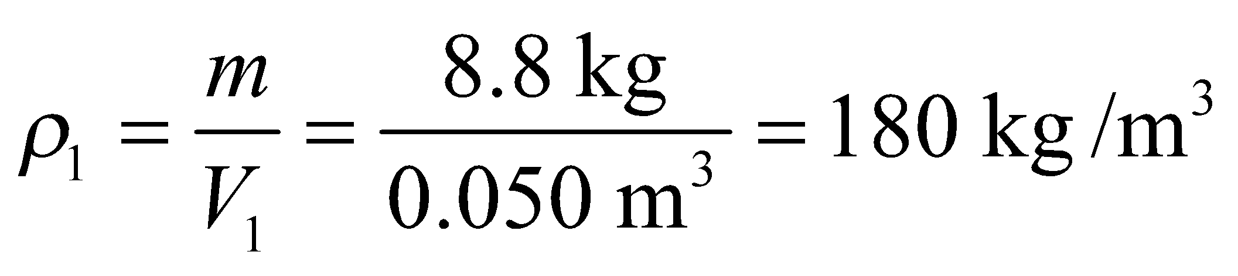

(b) The volume occupied by this mass of air at atmospheric density is

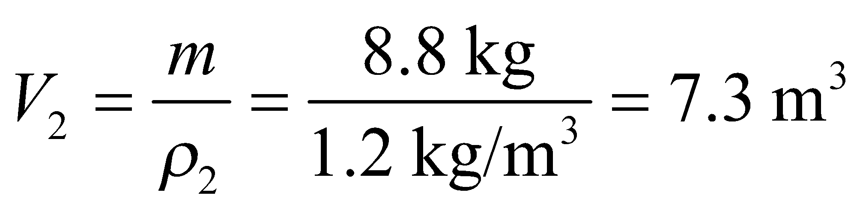

**Assess** These volumes are small enough that any variation in the density of the air due to gravity may be ignored.

**18. Interpret** This problem involves expressing pressure in SI units, using suitable conversion factors.

**Develop** The pressure at a depth *h* in an incompressible fluid of uniform density *ρ* is given by Equation 15.3:

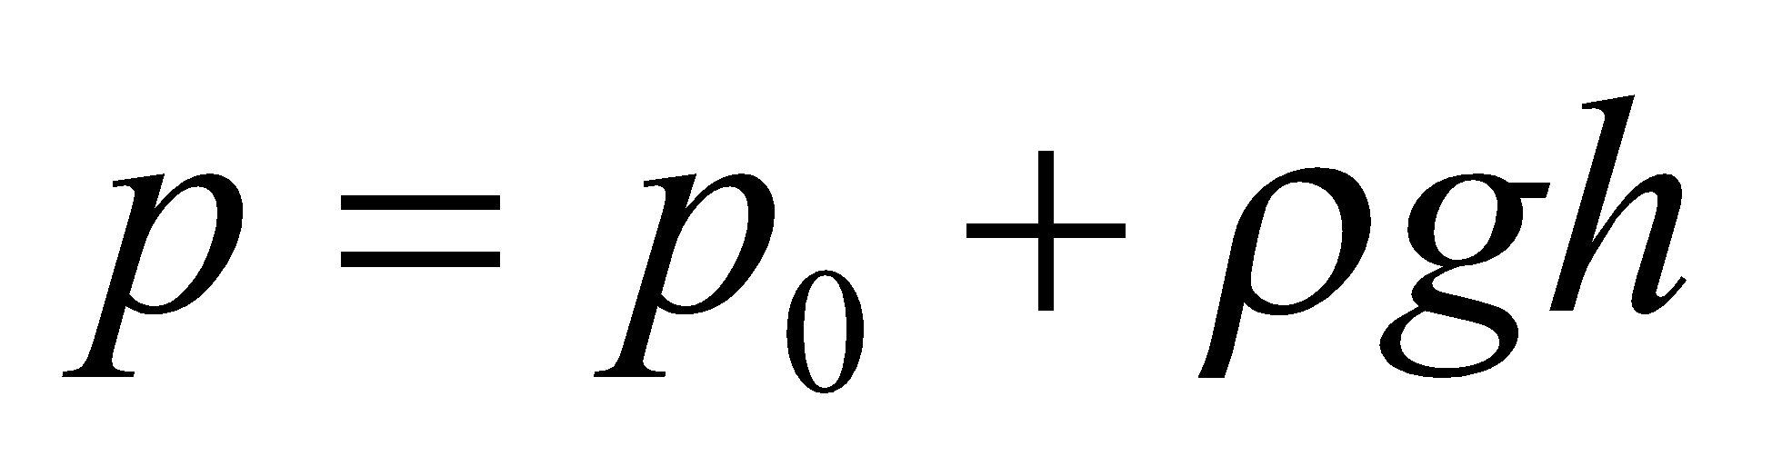

where *p*0 is the pressure at the surface of the liquid. By definition, one torr is the pressure that will support a column of mercury 1-mm high: 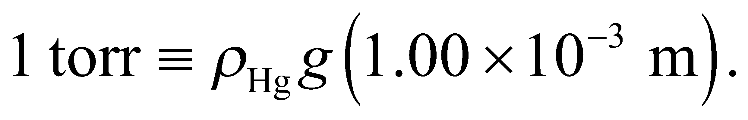

**Evaluate** From the definition above, we obtain



Similarly, 1 in (or 25.4 mm) of Hg is



**Assess** One atmosphere of pressure (1 atm) is 101.3 kPa and supports a column of Hg 760-mm (or 29.92 in) high. So 1 torr is 1/760 of 1 atm.

**19. Interpret** This problem is similar to the preceding one, except that we are to convert the pressure needed to support inches of water (instead of inches of Hg) to SI units.

**Develop** The density of water (by definition) is

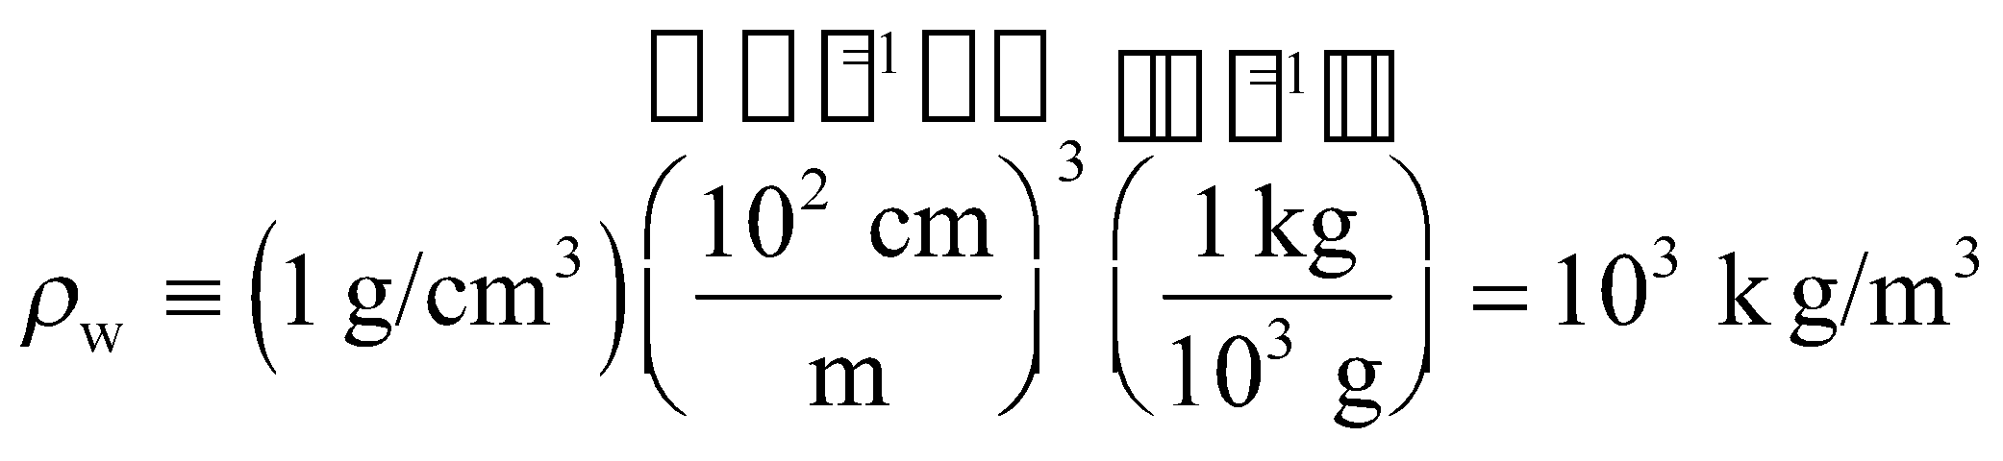

Because the pressure *p*0 = 0 at the upper surface of the water (see Figure 15.4), the hydrostatic pressure given by Equation 15.3 reduces to *p* = *ρgh*. For this problem, *ρ* = *ρ*w and *h* = 1 in = 25.4 × 10−3 m.

**Evaluate** Inserting the given quantities into the expression for pressure gives



**Assess** The pressure needed to support 25.4 mm (= 1 in) of water is about twice that needed to support 1 mm of Hg, which is expected because Hg is more dense than water.

**20. Interpret** This problem is about computing the weight of a column of air that extends from the Earth’s surface to the top of the atmosphere.

**Develop**  As shown in Equation 15.1, pressure measures the normal force per unit area exerted by a fluid, or *p* = *F*/*A*. Thus, knowing the pressure and the area, the force is given by their product. At the surface of the Earth, the atmospheric pressure is *p*atm = 101.3 kPa, so we can find the force exerted by this pressure using *F* = *p*atm*A*.

**Evaluate** The weight of a 1-m2 column of air is

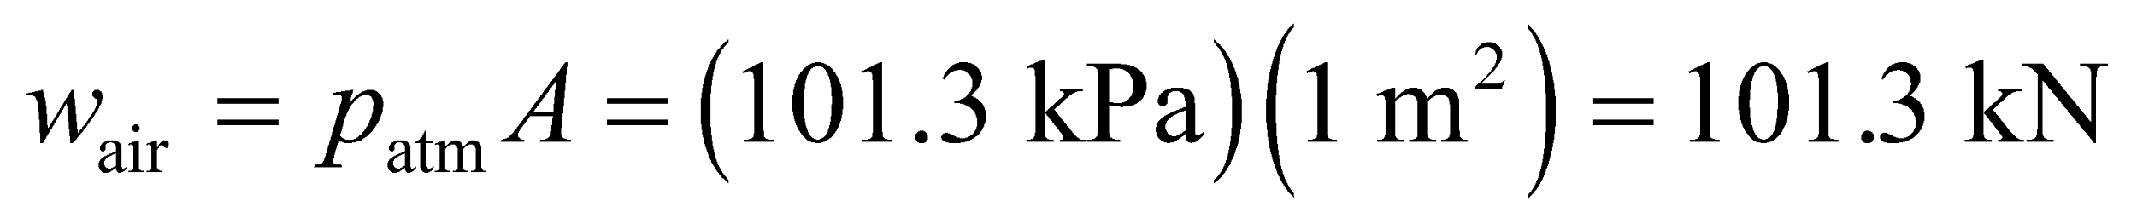

**Assess** This is the force that’s pushing down on the 1-m2 cross-sectional area. It is enormous! For this problem, you may be tempted to use Equation 15.2, because you consider (rightly) that the pressure changes as a function of height in the atmosphere. However, because air is compressible, its density also changes as a function of height, as does the force due to gravity. Thus, Equation 15.2 would give

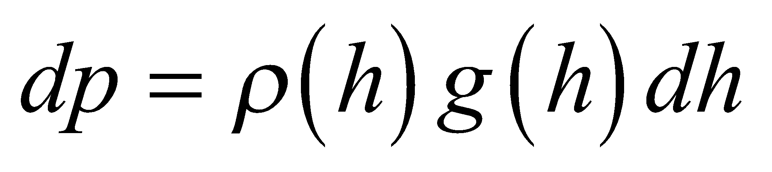

Given *ρ*(*h*) and *g*(*h*), we could integrate this expression, but it is much simpler to use the fact that the atmospheric pressure at the surface of the Earth is 101.3 kPa.

**21. Interpret** This problem involves calculating the pressure given the force and the area over which the force is applied.

**Develop** The force exerted on the ground is the elephant’s weight *Fg* = *mg*, which we can insert into Equation 15.1 to find the pressure.

**Evaluate** The pressure exerted by the elephant’s foot is

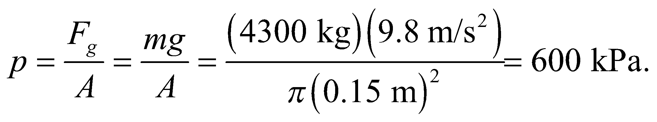

**Assess** Note that this is the average pressure. An elephant’s foot is undoubtedly nonuniform, so the pressure may be greater than this in some areas and less than this in other areas. Note also that this pressure is some 6 times the pressure due to the atmosphere, which seems reasonable.

**22. Interpret** This problem is about finding the force that must be exerted over a given area to result in a pressure of 120 atm.

**Develop** As shown in Equation 15.1, pressure measures the normal force per unit area exerted by a fluid, *p* = *F*/*A*. The cross-sectional area of the paper clip is 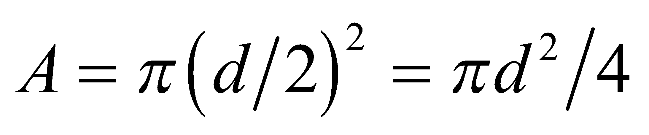, where *d* is the diameter. Assuming the force is applied normal to the paper-clip cross section, the requisite force is given by *F* = *pA*.

**Evaluate** An average pressure of 120 atm over the area results in a force of

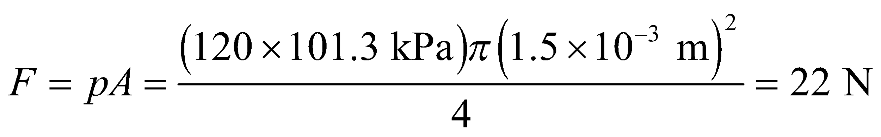

**Assess** Pressure is inversely proportional to the area the force is exerted. The smallness of the cross section of the paper clip is what makes the pressure so large.

**Section 15.2 Hydrostatic Equilibrium**

**23. Interpret** This problem involves calculating the density of an incompressible fluid, given the pressure increase as a function of depth.

**Develop**  For an incompressible fluid, the increase in pressure with depth is given by Equation 15.3, *p* = *p*0 + *ρgh*. Applying this equation to two depths *h*1 and *h*2, we can write

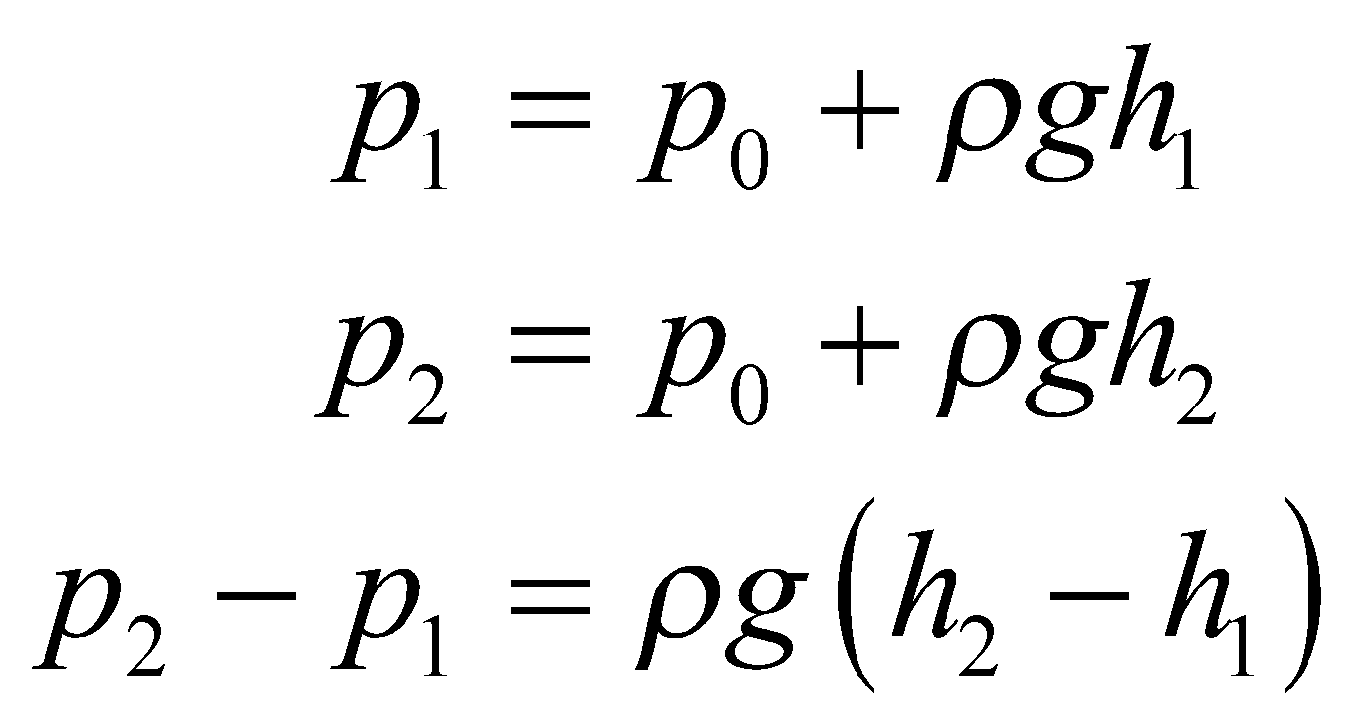

Given that *p*2 − *p*1 = 100 kPa for *h*2 − *h*1 = 6m, we can calculate the density *ρ*.

**Evaluate** Solving for the density, we find

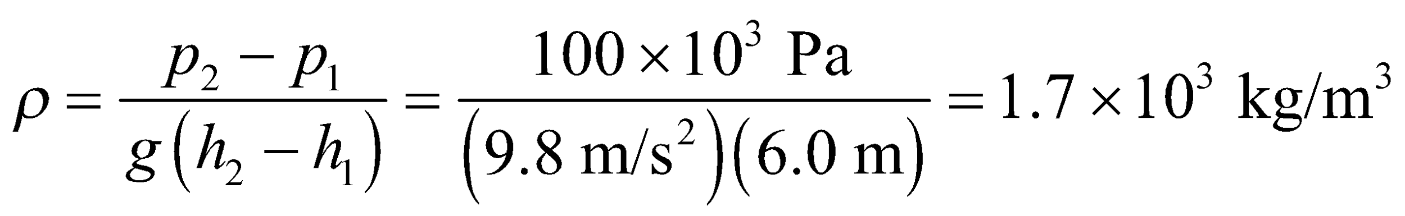

**Assess** Checking the units of this expression, we find

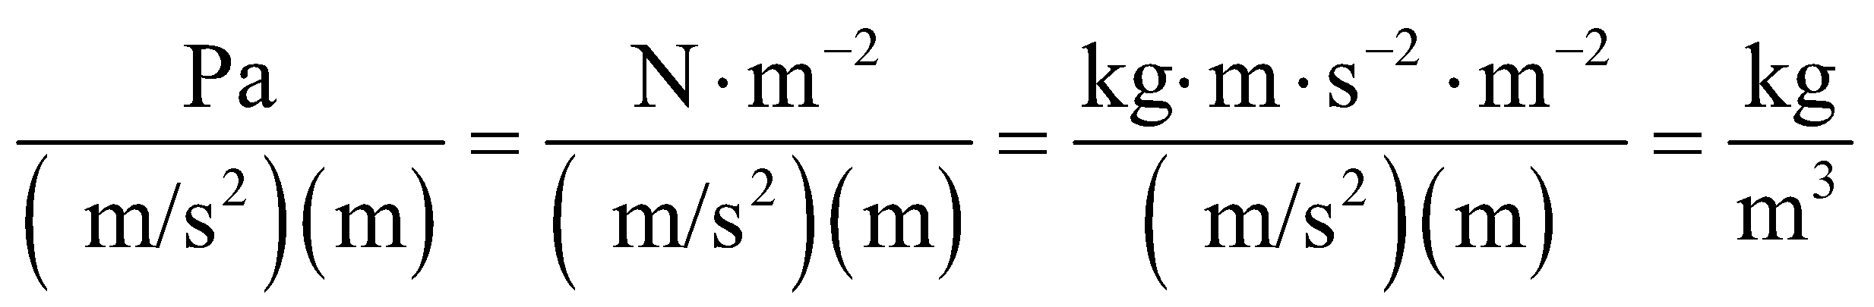

as expected for a density.

**24. Interpret** This problem is about hydrostatic equilibrium. Given the maximum pressure the submarine can withstand, we want to find its maximum-allowable depth below water.

**Develop** The external pressure *p* at a depth *h* below the surface of water () is given by Equation 15.1:



where the pressure *p*0 = 101.3 kPa is atmospheric pressure pushing down on the surface of the water. A typical density for open ocean seawater (which varies with salinity) is 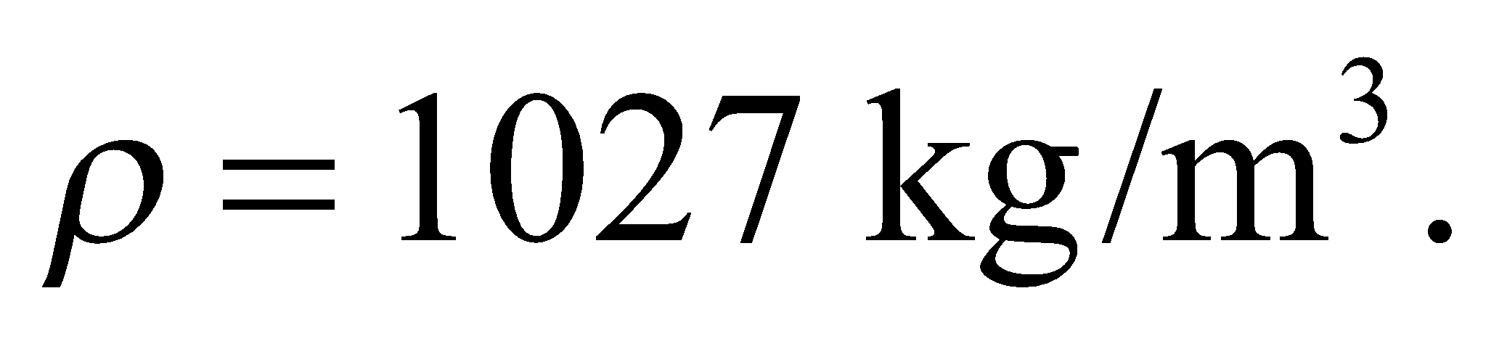

**Evaluate** The depth corresponding to *p* = 50 MPa is

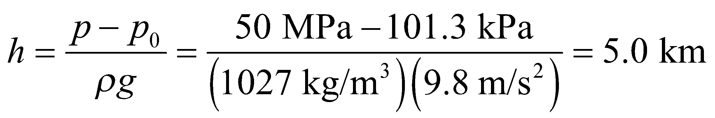

**Assess** The pressure the submarine can withstand is quite high (more than 490 × *p*atm). Note that our result is not exact because water at this depth is slightly compressible.

**25. Interpret** This problem involves calculating the depth at which water pressure is 1 MPa.

**Develop** Equation 15.3 *p* = *p*0 +*ρgh* gives the pressure as a function of depth. For this problem, we can assume that *p*0 = 1 atm = 101.3 kPa and that we are dealing with fresh water with a density of *ρ* = 103 kg/m3. Thus, we can solve for the depth *h* at which the pressure *p* = 1 × 106 Pa.

**Evaluate** Solving for the depth h, we find

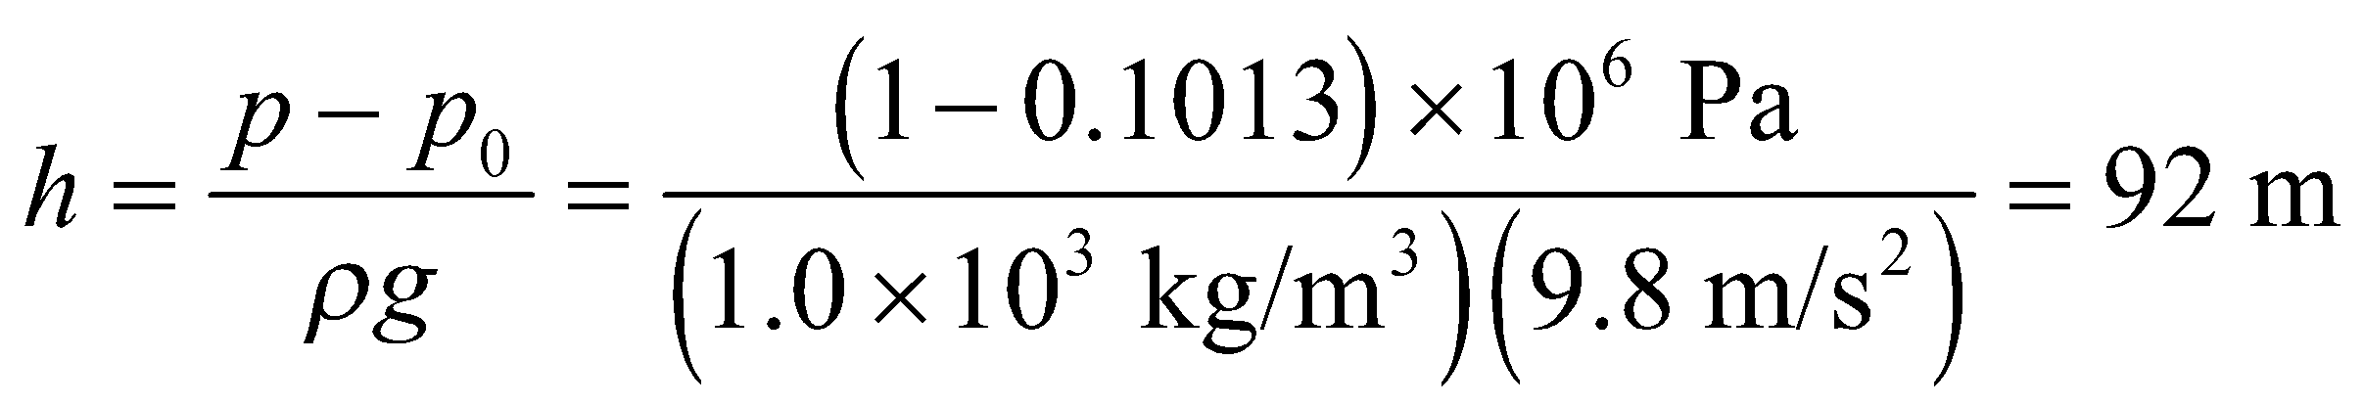

**Assess** The depth is a little less in salt water because its density is slightly greater.

**26. Interpret** We have an open tube filled with water on the bottom and oil on the top of water. The two fluids do not mix. We want to find the gauge pressure at the bottom of the tube.

**Develop** The pressure pushing down on the oil at the top of the tube is the atmospheric pressure, *p*atm (see figure below). Using Equation 15.3, the absolute pressure at the oil-water interface is 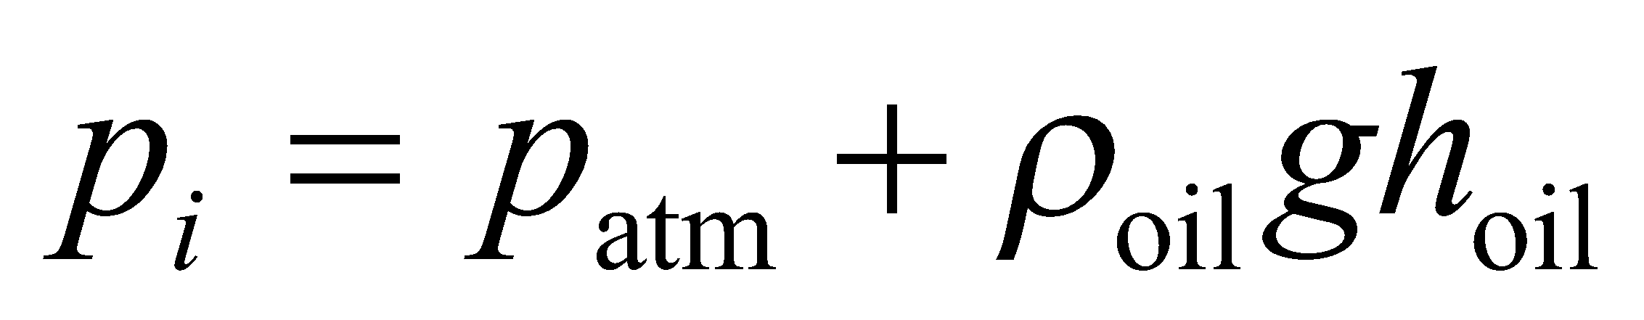 and the pressure at the bottom of the water is,





**Evaluate** Therefore, the gauge pressure at the bottom is

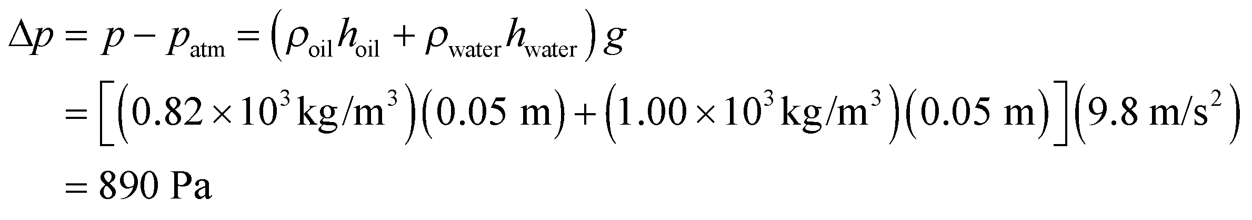

**Assess** Oil is less dense than water. Therefore it flows on top of the water. The gauge pressure at the bottom of the tube is due to the weight of both the oil and the water.

**27. Interpret** This problem involves calculating the pressure difference needed between that pushing down on the water in the cup and that pushing down on the water in the straw to generate the force needed to lift the water up the given amount.

**Develop** Make a sketch of the situation (see figure below) and apply Equation 15.3, which for this situation takes the form

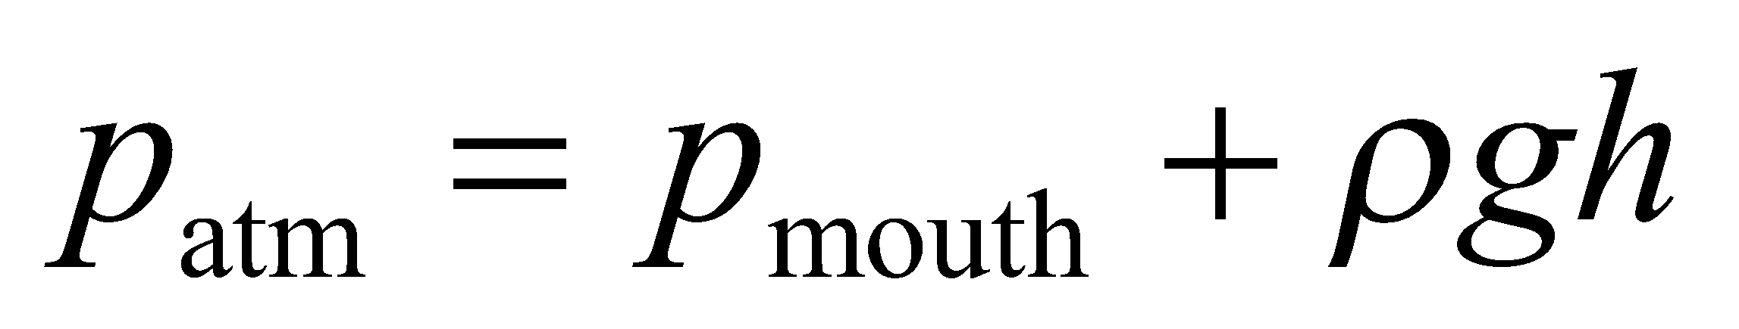

where *h* = 0.75 m and *p*atm = 101.3 kPa.



**Evaluate** Solving the expression above for *p*atm − *p*mouth gives



**Assess** This corresponds to a reduction of

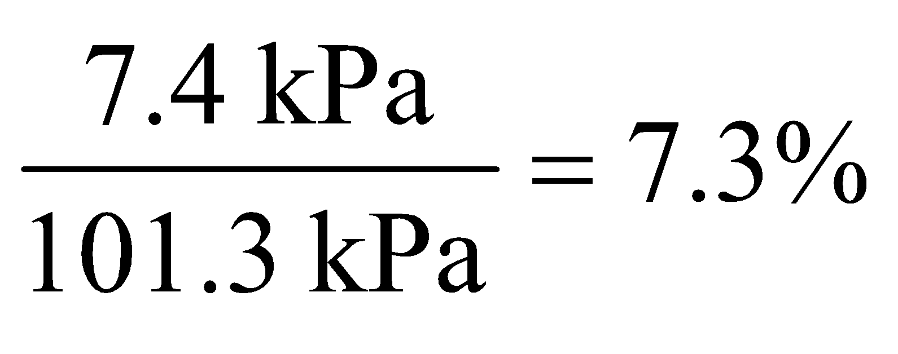

**28. Interpret** In this problem we are given two barometric pressures, one for the eye of a hurricane, another for a fair-weather region. We want to compare the level of the ocean surface between these two regions.

**Develop** The pressure difference between two points leads to a difference h in sea level given by Equation 15.3: *p* − *p*0 = *ρgh*.

**Evaluate** With *p* = 1.0 atm and *p*0 = 0.91 atm, we obtain

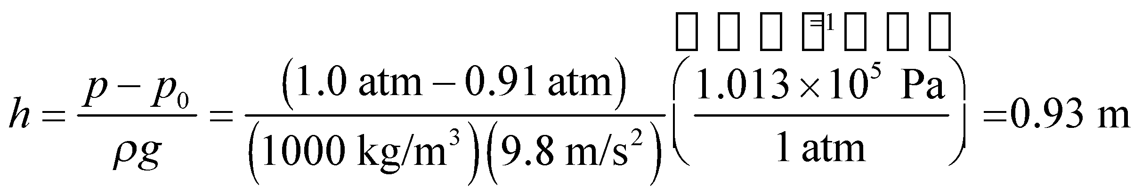

**Assess** The fair weather region is 0.93 m *below* the sea level at the eye of the hurricane.

**Section 15.3 Archimedes’ Principle and Buoyancy**

**29. Interpret** This problem involves the buoyancy force, which will help us to carry a concrete block if it is submerged in water. We can use Archimedes’s principal and Newton’s second law to calculate the most massive concrete block we could lift underwater. We are given the mass of the largest block we can carry on land and the density of the concrete.

**Develop** Make a free-body diagram of the situation (see Figure 15.8). Applying Newton’s second law to the concrete block gives

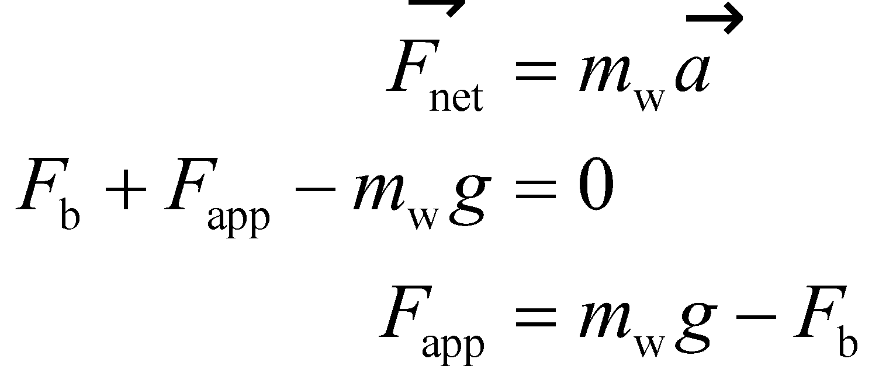

where the subscript w indicates the mass we can carry under water. The maximum force we can apply is *F*app = *m*L*g*, where *m*L = 25 kg is the maximum mass we can carry on land. The buoyancy force on a block is *F*b = *ρ*w*gV*c, where *ρ*w = 1.0 × 103 kg/m3 is the density of water and *V*c is the volume of the concrete block, which is given by *V*c = *m*w/*ρ*c where *ρ*c = 2200 kg/m3 is the density of the concrete. We can solve this expression for the maximum mass *m*w that we can carry in water.

**Evaluate** Inserting the given quantities in the expression for *F*app and solving for *m*w gives

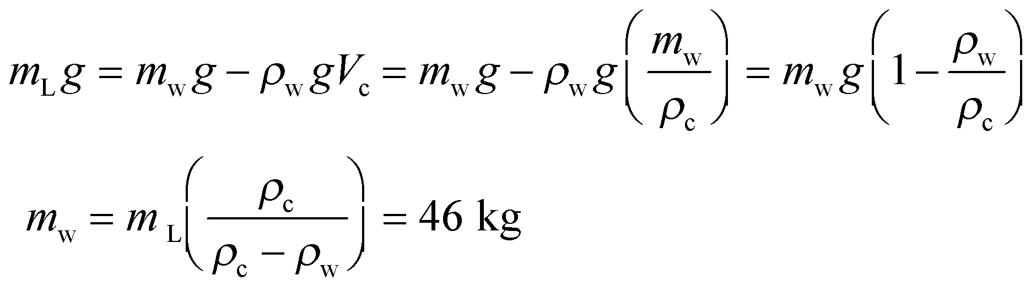

**Assess**We can check this solution by looking at what happens if *ρ*c = *ρ*w. In this case, the “block” would have neutral buoyancy and we would be able to lift any size.

**30. Interpret** Given the apparent weight of a jewel when submerged in water, we want to know whether the jewel is diamond or not. To answer this question, we need to calculate the density of the jewel using Archimedes’s principal.

**Develop** According to Archimedes’ principle, the buoyancy force on an object is equal to the weight of the fluid displaced by the object. Mathematically, this is expressed as

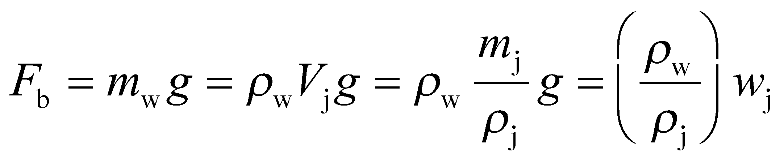

where *w*j = *m*j*g* is the true weight of the jewel. The apparent weight 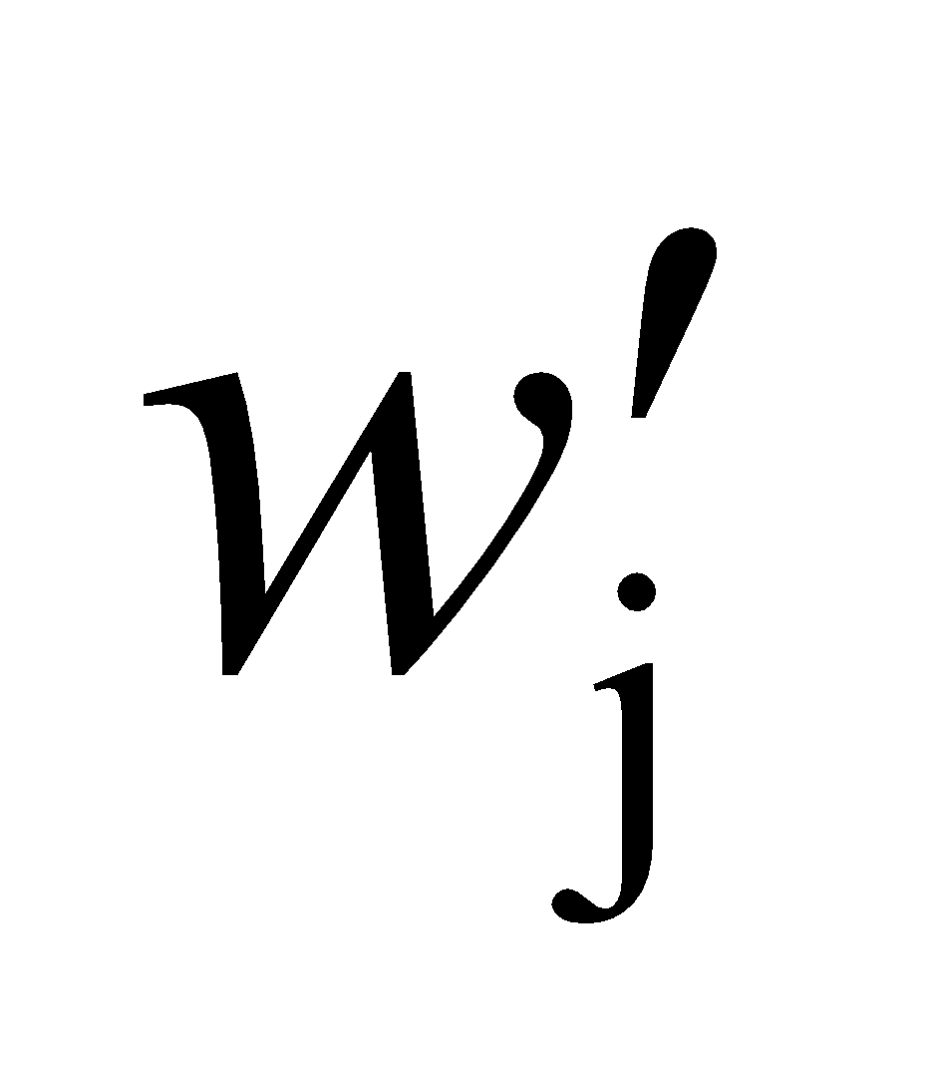 of the jewel is

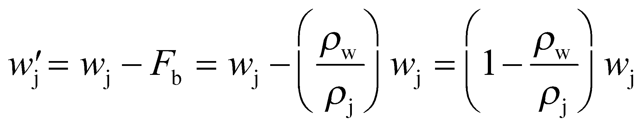

**Evaluate** Solving the expression above for the density of the jewel gives

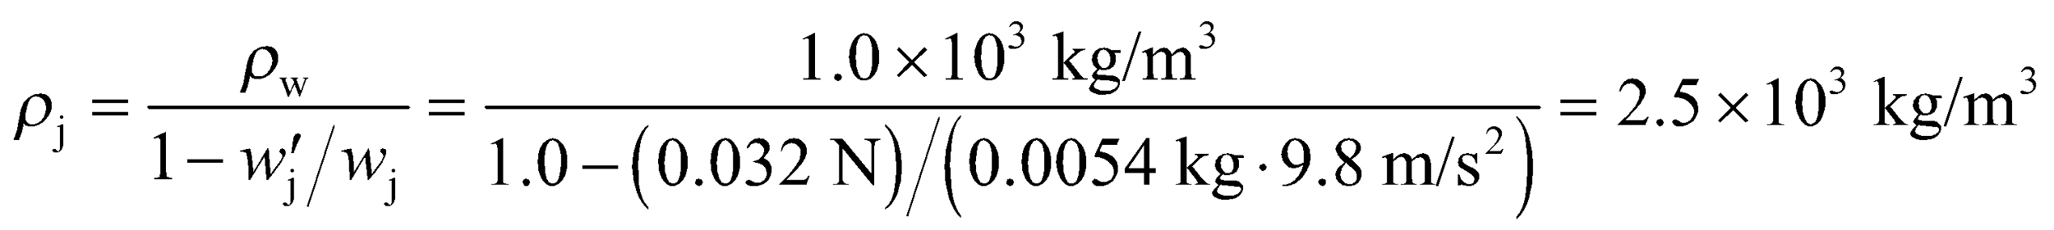

The value is too small for the density of diamond 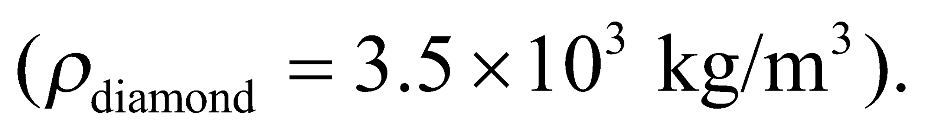

**Assess**Knowing the apparent weight of a submerged object allows us to determine the density of the object.

**31. Interpret** This problem involves the buoyancy force (Archimedes’s principal), which applies to objects in air just as it does to objects in water. We can use this to find the fractional error that occurs when weighing Styrofoam in air as opposed to in a vacuum.

**Develop** In a vacuum, the weight of a given volume *V* of Styrofoam is

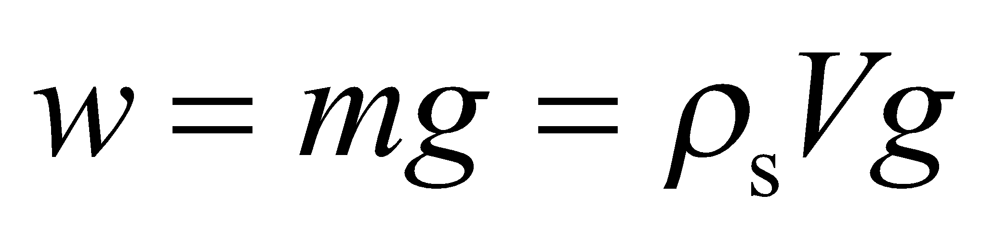

In air, the buoyancy force *F*b acts against gravity, so that the apparent weight *w*′ of the same volume of Styrofoam is

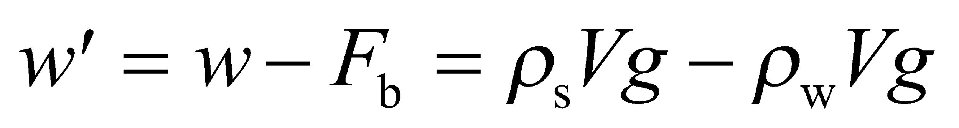

The fractional error *Δ* is

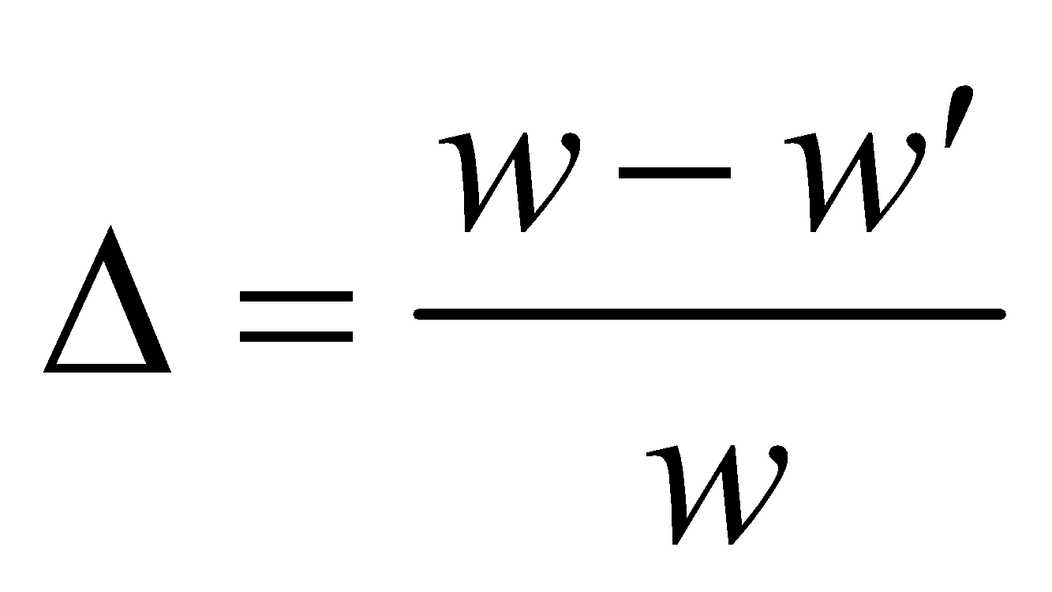

**Evaluate** Inserting the expression for the weights gives

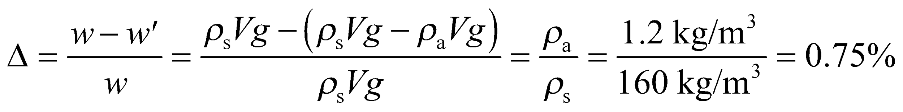

**Assess** This error of almost 1% may not be negligible in all situations

**32. Interpret** In this problem we are given the volume and mass of a steel drum and asked to determine whether or not it will float in water when filled with water or with gasoline.

**Develop** An object will float in water if its average density is less than the density of water. This follows from Archimedes’ principle, since the volume of water displaced by an object floating on the surface is less than its total volume, i.e.,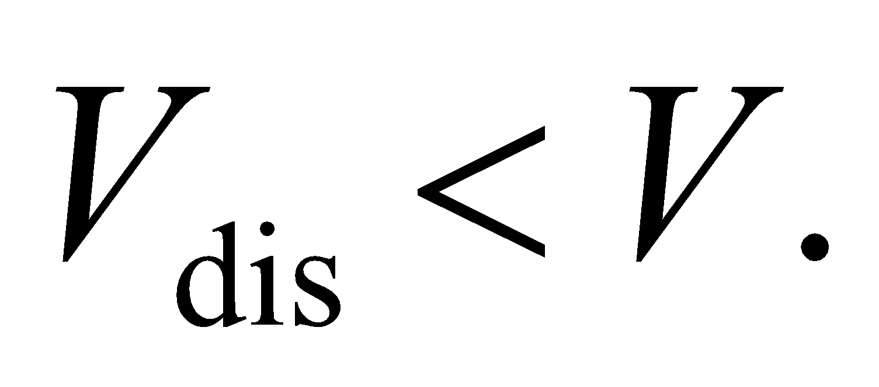 Since the buoyant force equals the weight of a floating object,

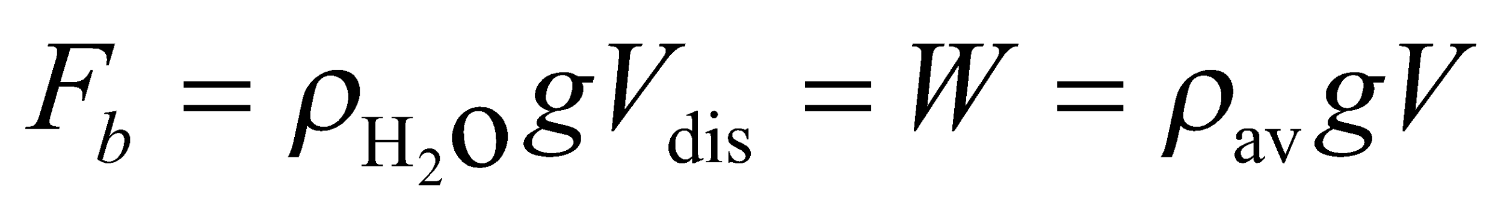

and this implies 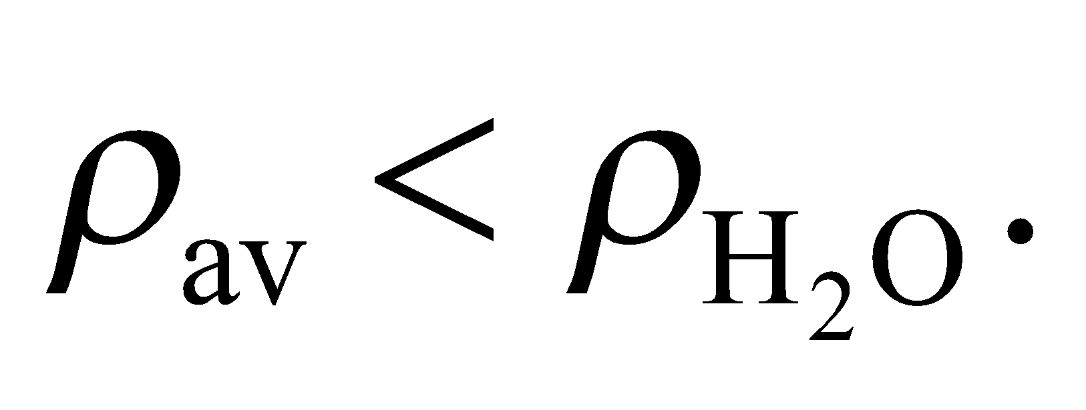

**Evaluate** (a) When the drum is filled with water, the combination of steel 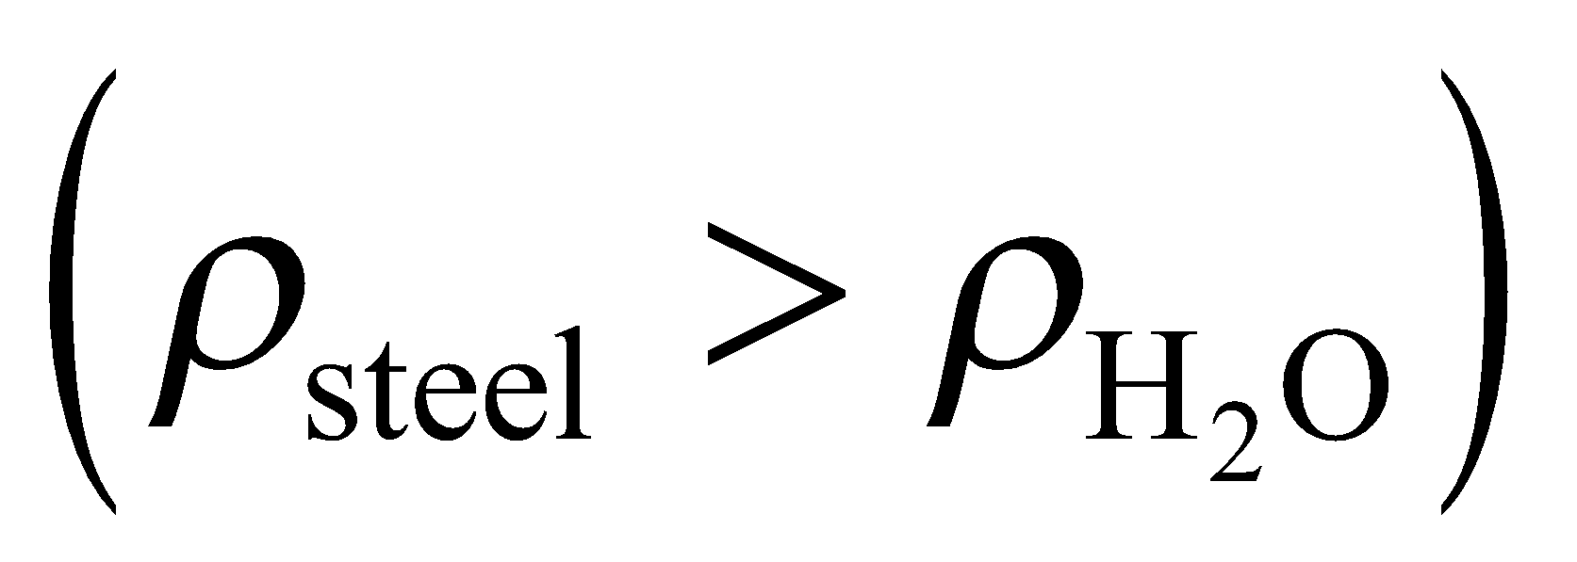and water will have a higher density than pure water, so the drum will sink.

(b) When the drum is filled with gasoline, its average density is

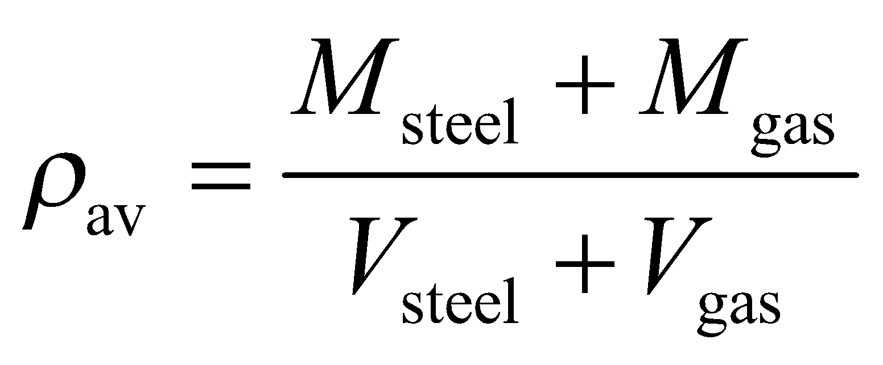

We'll assume that the volume of the steel shell is negligible compared to the volume of the gasoline 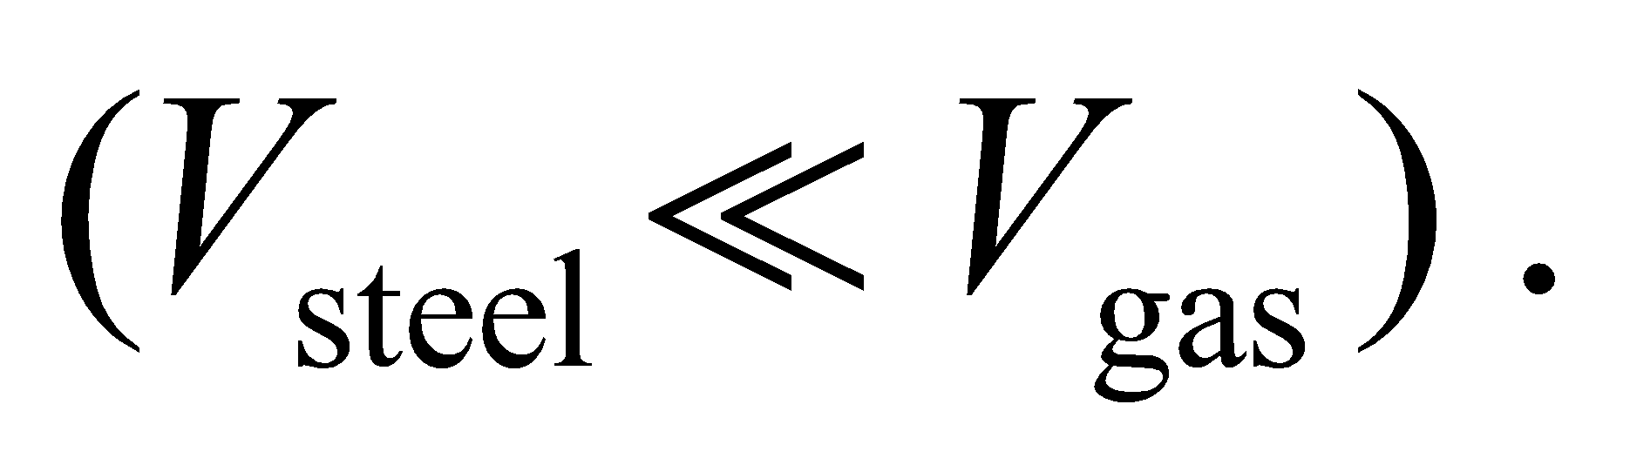 Since 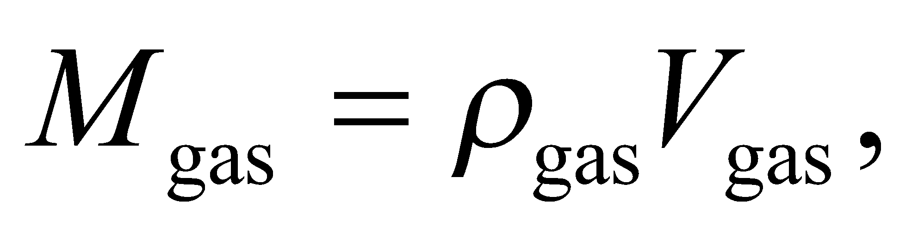

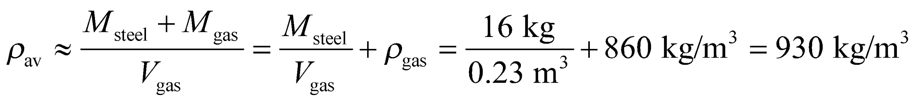

which is less than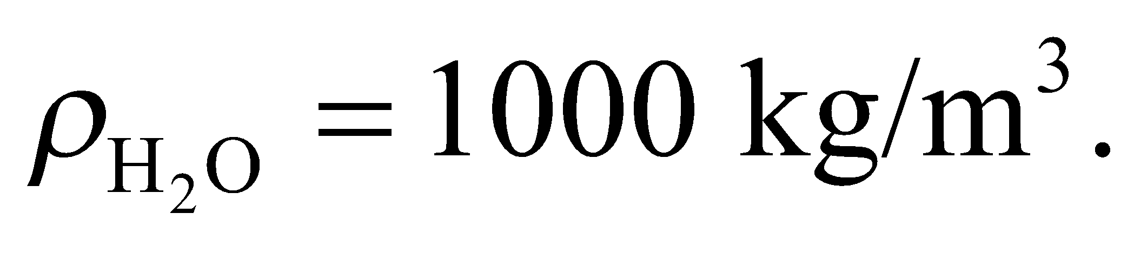Therefore, the drum will float in this case.

**Assess** Even though steel has greater density than water, the effective volume of the steel drum includes all of the liquid inside it. Thus, when filled with gasoline, its average density is then less than that of water, and hence it will float.

**Sections 15.4 and 15.5 Fluid Dynamics and Applications**

**33. Interpret** This problem involves calculating the flow rate of an incompressible fluid in a pipe with a varying cross section. We use the principal of conservation of mass to find the speed of fluid flow in the narrow section, given the speed of flow in the wide section and the diameters of each section.

**Develop** The continuity Equation 15.5 for a liquid is *vA* = constant. Applied to the pipe in question gives *v*1*A*1 = *v*2*A*2, where *A*1 = *π*(*d*1/2)2 and *A*2 = *π*(*d*2/2)2, with *d*1 = 2.5 cm and *d*2 = 2.0 cm. Given that the speed in the wide section is *v*1 = 1.8 m/s, we can solve for *v*2.

**Evaluate**Inserting the given quantities into the expression derived using the continuity equation gives

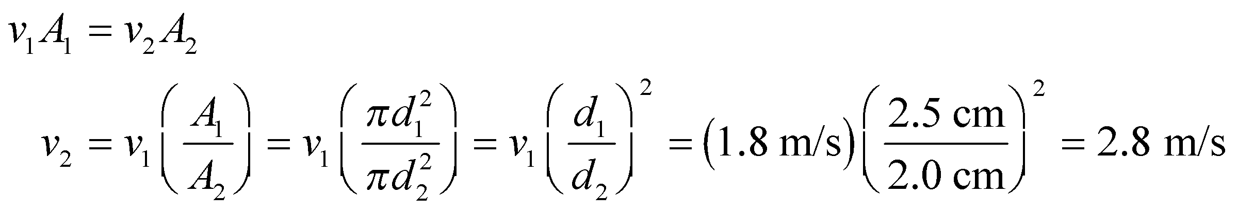

**Assess** As expected, the speed increases in the narrow section.

**34. Interpret** This problem is an exercise in dimensional analysis. We are asked to show that pressure has units of energy density.

**Develop** Analogous to mass density, energy density has units of energy per unit volume. In SI units, this is J/m3. The units of pressure are force per unit area, which in SI units is N/m2. Use the fact that 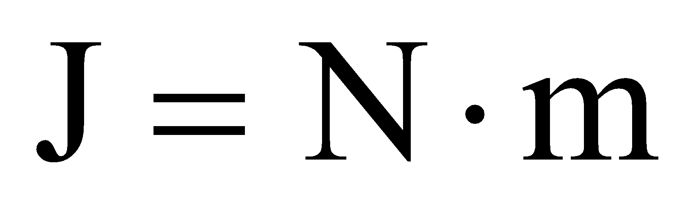 to show that N/m2 = J/m3.

**Evaluate** Multiplying both numerator and denominator by units of length gives

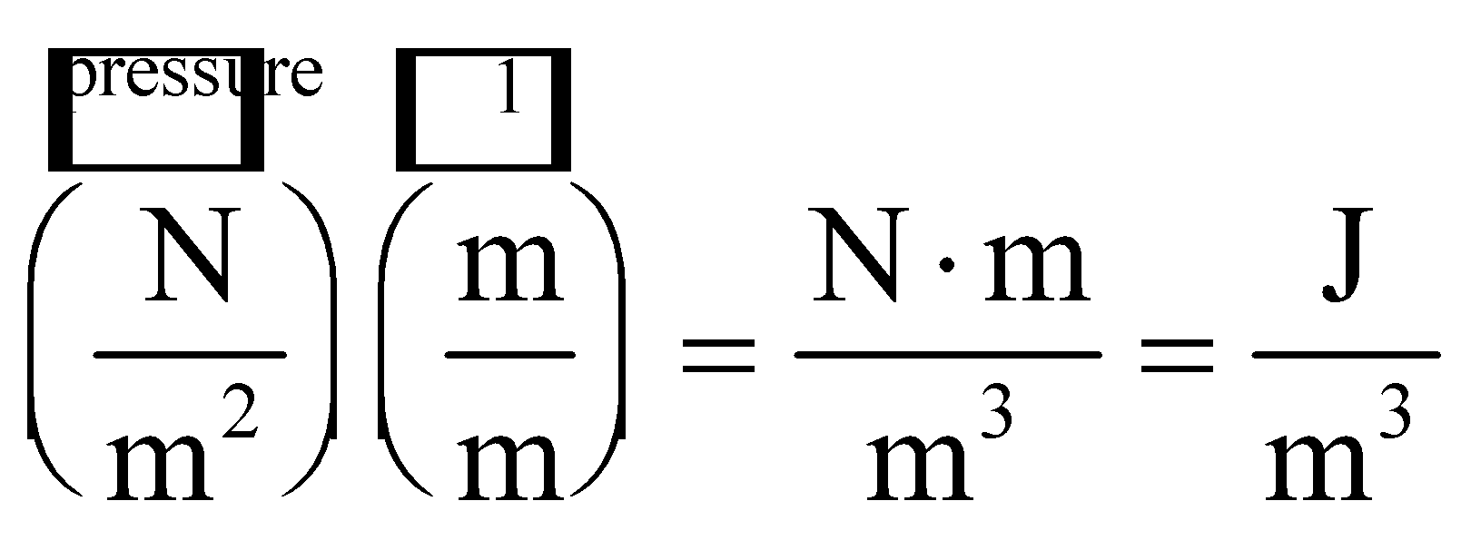

which is energy density.

**Assess** Thus, we find that the pressure can be considered an expression of the internal energy density in a fluid, as implied by Bernoulli’s Equation 15.6.

**35. Interpret** This problem deals with fluid flow rate. The key concepts involved are conservation of mass and the continuity equation.

**Develop** The mass flow rate is given by Equation 15.4, *R*m = *ρvA* and the volume flow rate is given by Equation 15.5: *R*V = *vA*. The speed *v* of the flow can be determined once the flow rate *R*m and *R*V and the corresonding cross-sectional areas *A* are known.

**Evaluate** **(a)** Inserting the given quantities, the volume flow rate for the Mississippi River is

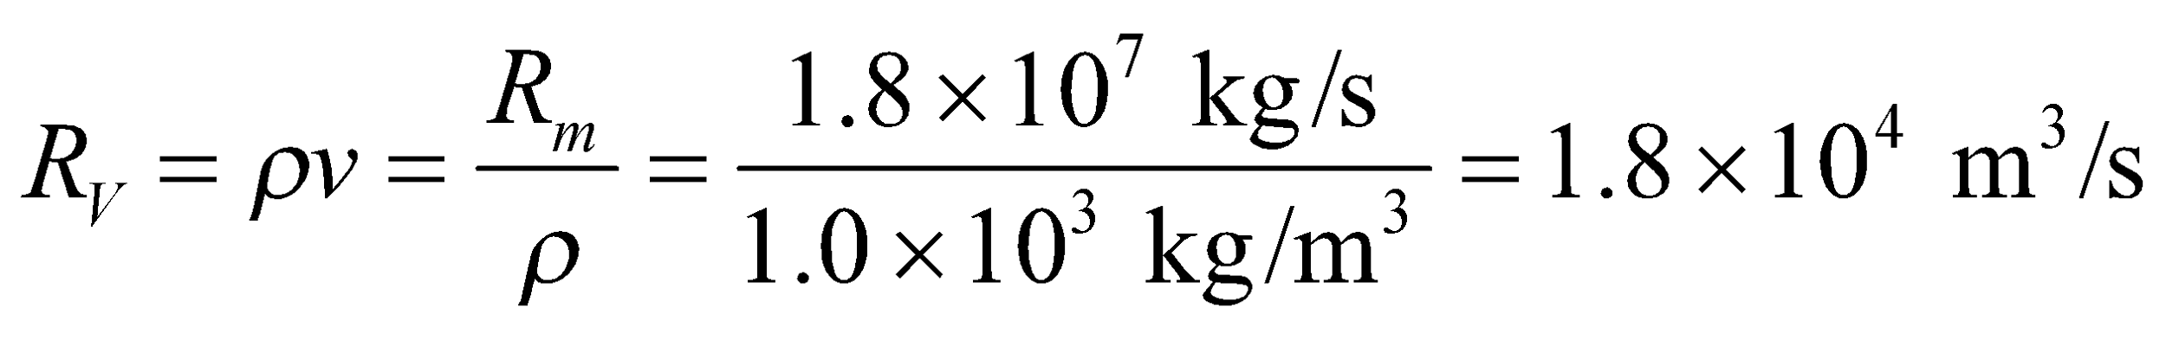

**(b)** At a point in the river where the cross-sectional area is given, the average speed of flow is

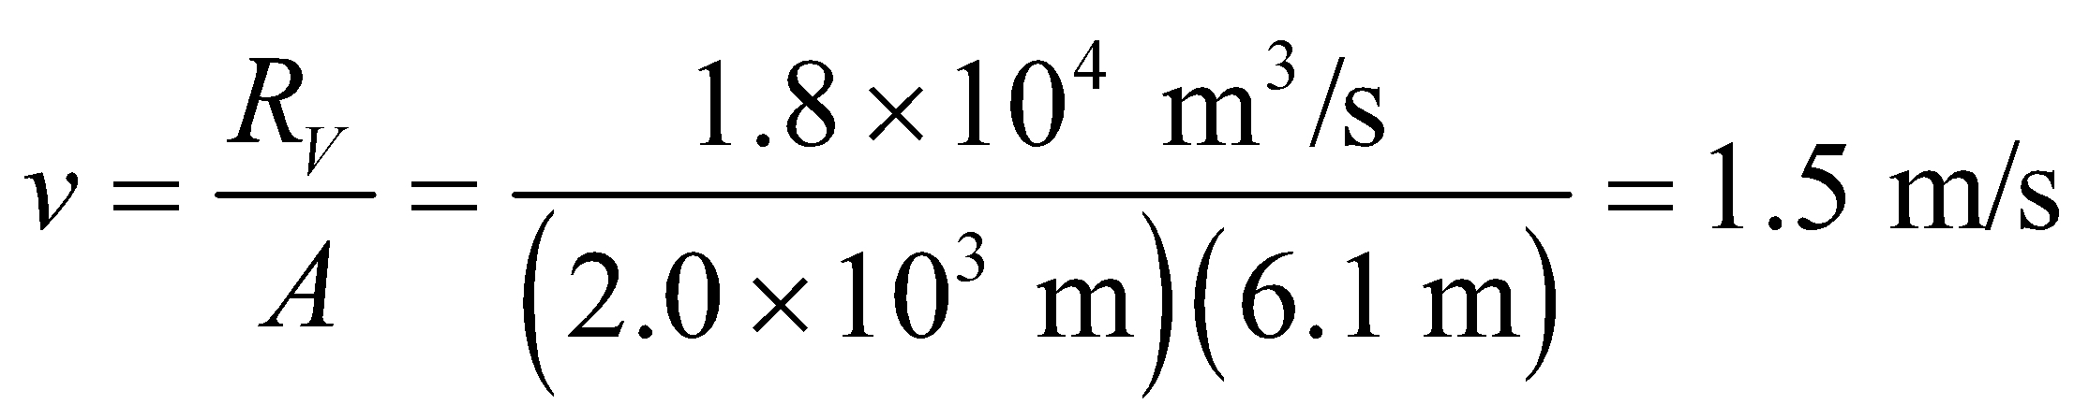

**Assess** The flow speed we find is reasonable. Note that the actual flow rate of any river varies with the season, local weather, vegetation conditions, human water consumption, etc.

**36. Interpret** This problem involves conservation of mass, as expressed by the continuity Equations 15.4 and 15.5. We can use this to find the flow speeds in the hose and in the nozzle.

**Develop** Applied to the hose, Equation 15.4 gives

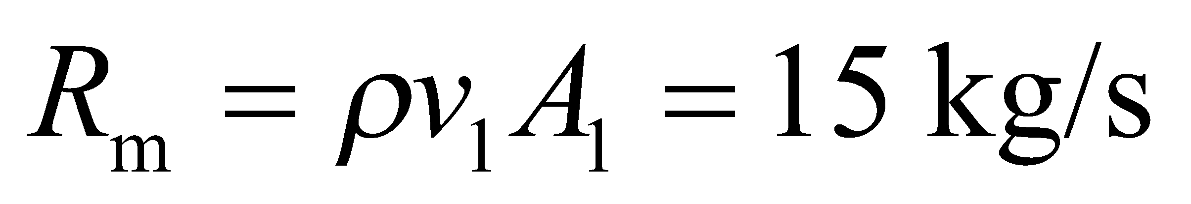

where *v*1 is the flow speed in the hose, *A1* = *π*(*d*1/2)2, with *d*1 = 10 cm, and *ρ* = 1.0 × 103 kg/m3 is the density of fresh water. Applying Equation 15.5 to the hose and to the nozzle gives

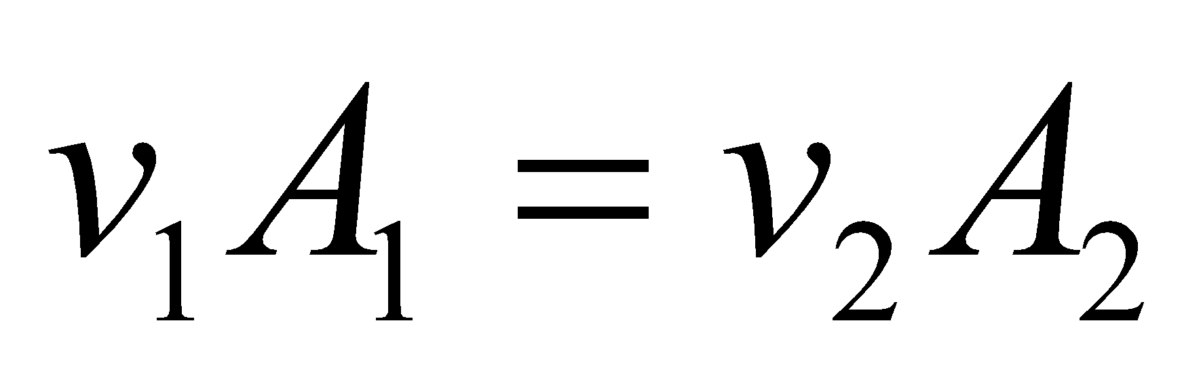

which allows us to solve for the flow speed *v*2 at the nozzle.

**Evaluate** (a) In the hose, the flow speed is

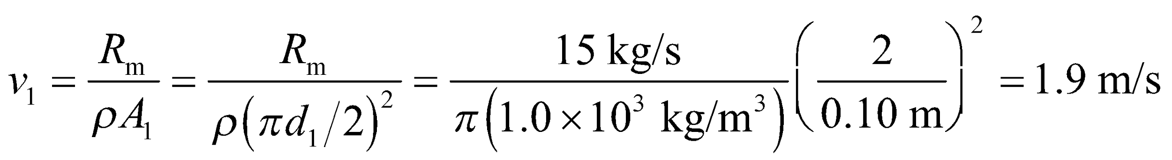

(b) In the nozzle, the flow speed is

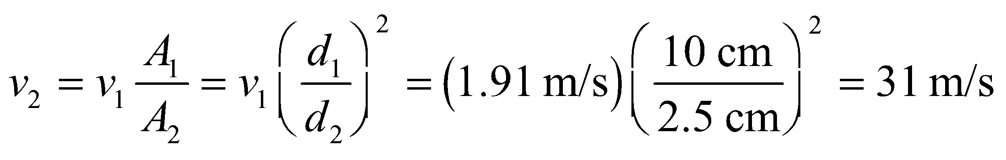

**Assess** By narrowing the nozzle, the exit speed of the fluid is increased by over an order of magnitude, which gives the exiting water greater linear momentum so that it travels farther through the air.

**37. Interpret** This problem deals with flow speed of a fluid, which in this case is the blood in the artery. The key concepts involved are mass conservation and the continuity equation.

**Develop** Apply the continuity Equation 15.5 *vA* = constant. Without the clot, we have *v*1*A*1 = constant. With the clot, we have *v*2*A*2 = constant, where *A*2 = 0.20*A*1. Because the constant is the same, we can equate these two expressions for the volume flow rate and solve for *v*2.

**Evaluate** Solving for *v*2 and inserting the given quantities gives

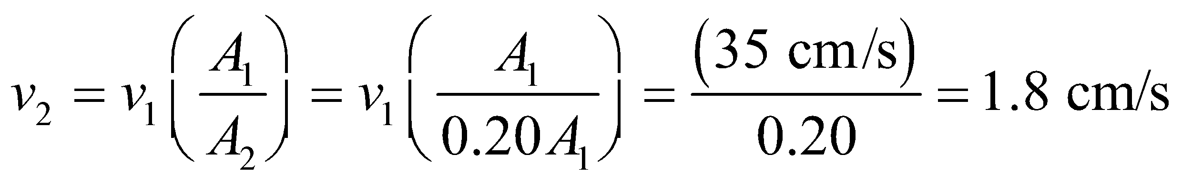

**Assess** The flow speed of blood increases in the region where the cross-sectional area of the artery has been reduced due to clotting. Notice that the initial diameter of the artery is not needed to solve this problem; it suffices to know the ratio of the arterial cross sections.

**Problems**

**38. Interpret** This problem involves calculating the surface area required for the given force to produce the given pressure. The force in question is the force exerted by gravity on the two people lying on the bed, and the pressure is the pressure the water exerts on the bed lining.

**Develop** Pressure is the force per unit area, or *p* =*F*/*A* (Equation 15.1). When the two people lie on the bed, they exert a pressure due to gravity given by *F* = *mg*, where *m* = 120 kg. Given that this leads to a pressure increase of *Δp* = 4700 Pa, we can solve for the area over which their bodies are in contact with the bed.

**Evaluate** The area is

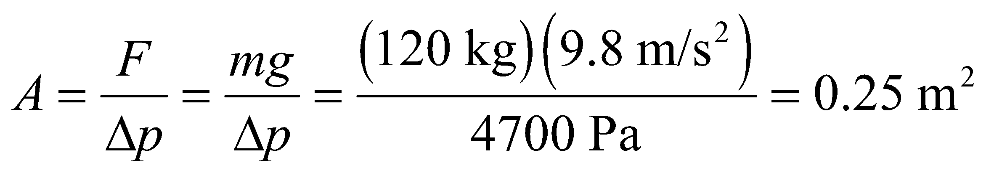

**Assess** Considering that a typical height for a female is 1.6 m and for a male is 1.8 m, the width over which their bodies are in contact with the bed is estimated to be

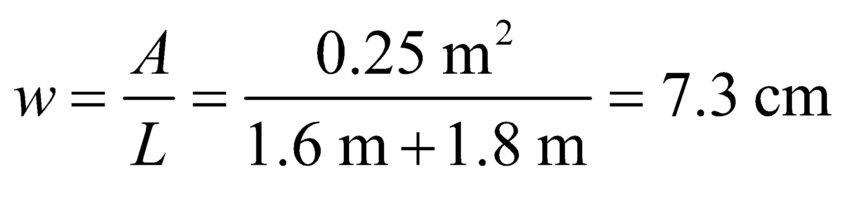

which seems reasonable, given that this is an average width (it is no doubt greater at the shoulders and less at the feet).

**39. Interpret** This problem involves calculating the area needed for a given pressure to produce a given force. We are given the mass and the gauge pressure of the tires, and we want to find the total tire area that’s in contact with the road.

**Develop** As shown in Equation 15.1, pressure measures the normal force per unit area exerted by a fluid. For this problem, the fluid is air. The force exerted on the road by the tires is the weight of the car, *F* = *mg*.

**Evaluate** With a gauge pressure of *p* = 230 kPa, the contact area is

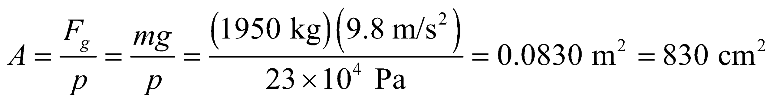

**Assess** Our result implies that the contact area of each wheel is about 200 cm2, or the area of a 25 × 8 cm2 rectangular surface, which seems reasonable.

**40. Interpret** You want to know if your seatmate could potentially pull the emergency window inward, given that the pressure inside the plane is higher than outside.

**Develop** The force from the outside air pushing in on the window is 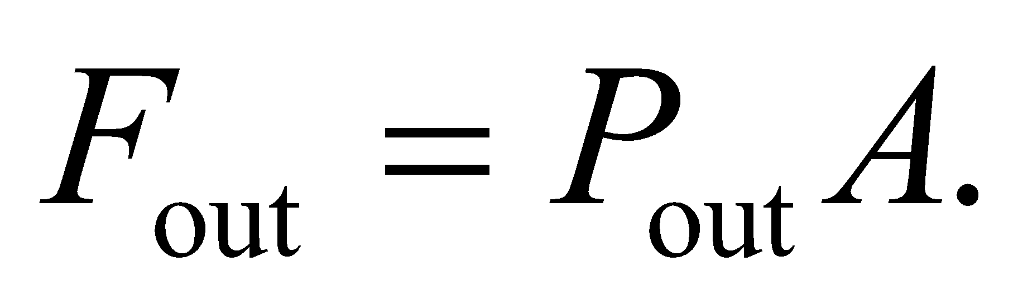The force from the inside air pushing out on the window is 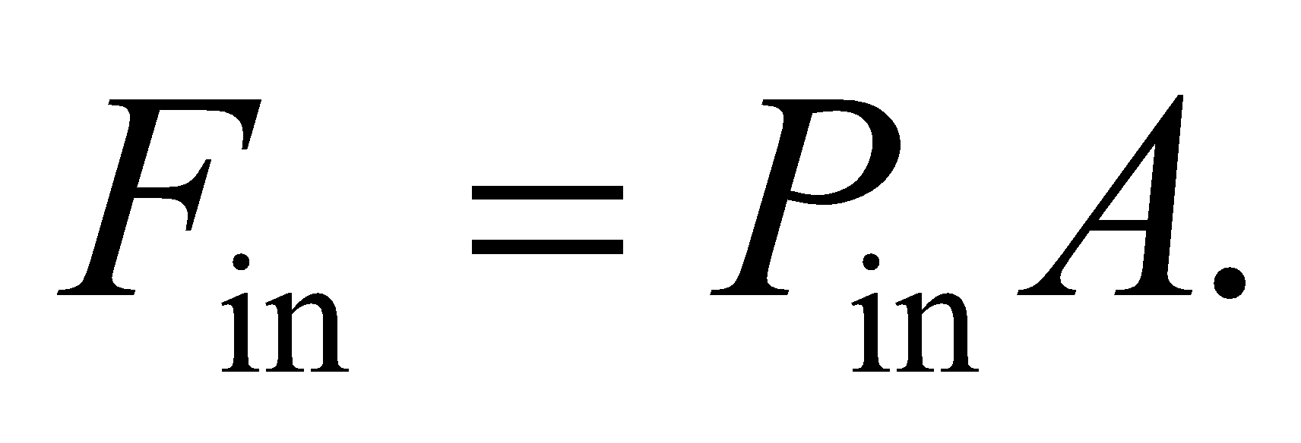 Since the inside pressure is higher, there will be a net force pushing out on the window, and your seatmate will have to overcome that force to open the window.

**Evaluate** The minimum force needed to pull in the window is



This would be like trying to lift over 2000 kg, so it's not likely that your seatmate will be able to open the window.

**Assess** The pressure difference between the inside and outside of a plane exerts a large outward force. That's why a sudden breach of an airplane's hull can suck objects out of the plane.

**41. Interpret** We have an open tube filled with water on the bottom and oil on the top of water. The two fluids do not mix. We want to find the gauge pressures at the oil-water interface as well as at the bottom of the tube.

**Develop** The pressure pushing down on the oil at the top of the tube is atmospheric pressure, *p*atm. The gauge pressure at the interface of the oil and water is the difference between the absolute pressure and the atmospheric pressure, or 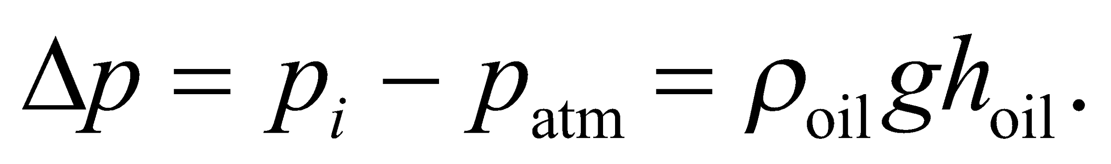 To find *h*oil, note that

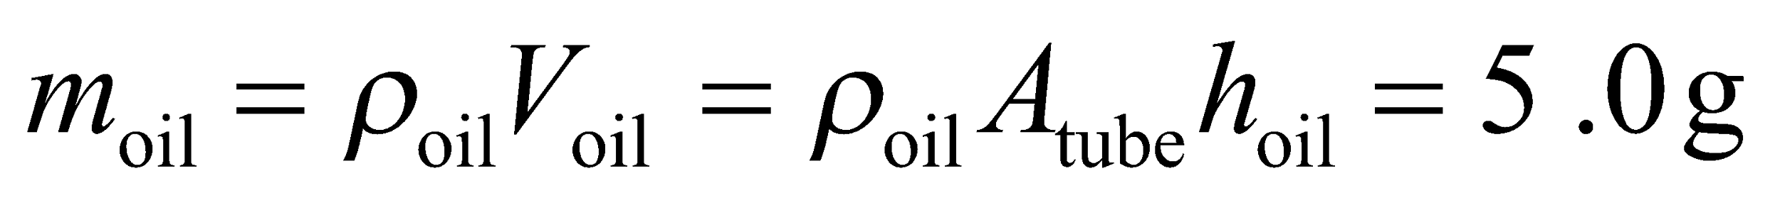

where *V*oil is the volume of oil and *A*tube is the cross-sectional area of the tube. The gauge pressure at the bottom is the total weight of fluid divided by the cross-sectional area of the tube, which is

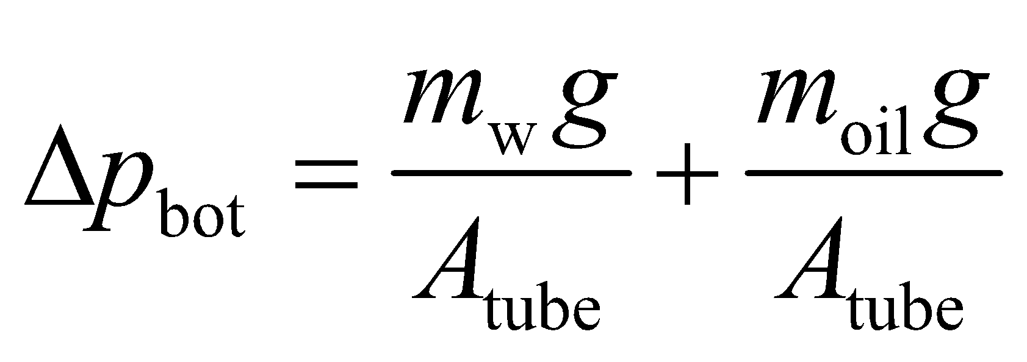

**Evaluate** **(a)** The gauge pressure at the interface is

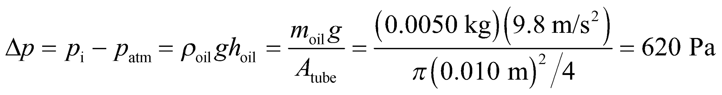

**(b)** The gauge pressure at the bottom is the total weight of fluid divided by the cross-sectional area of the tube,

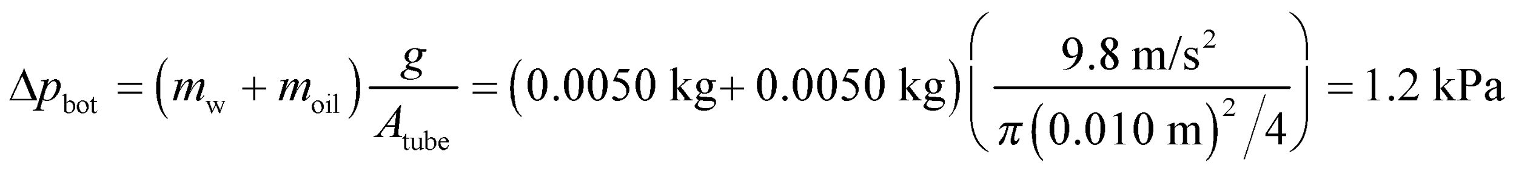

**Assess** Oil floats on top of water because its density is lower than that of water. The gauge pressure at the bottom of the tube is due to the weight of both the oil and the water. The absolute pressure there would be equal to the sum of the gauge pressure and the atmospheric pressure. Note that because *m*w = *m*oil in this problem, the gauge pressure at the bottom is just twice that at the interface.

**42. Interpret** You must determine the total force on a dam from the water in a lake. In this case, the pressure from the water is not constant, but varies with depth.

**Develop** The water pressure is given by Equation 15.3: 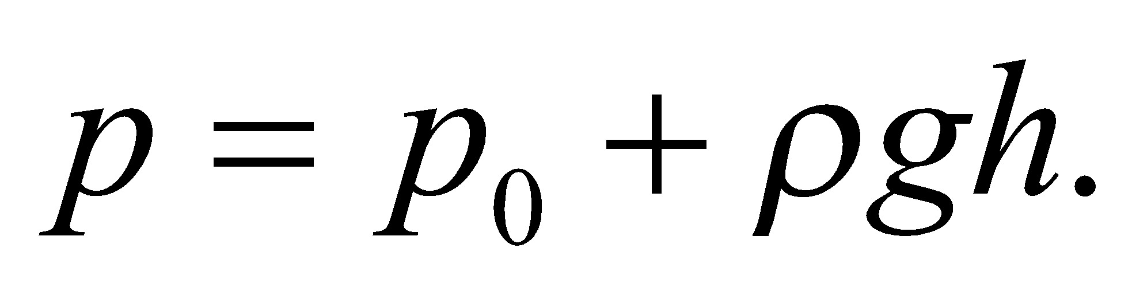 You can assume the pressure at the surface is 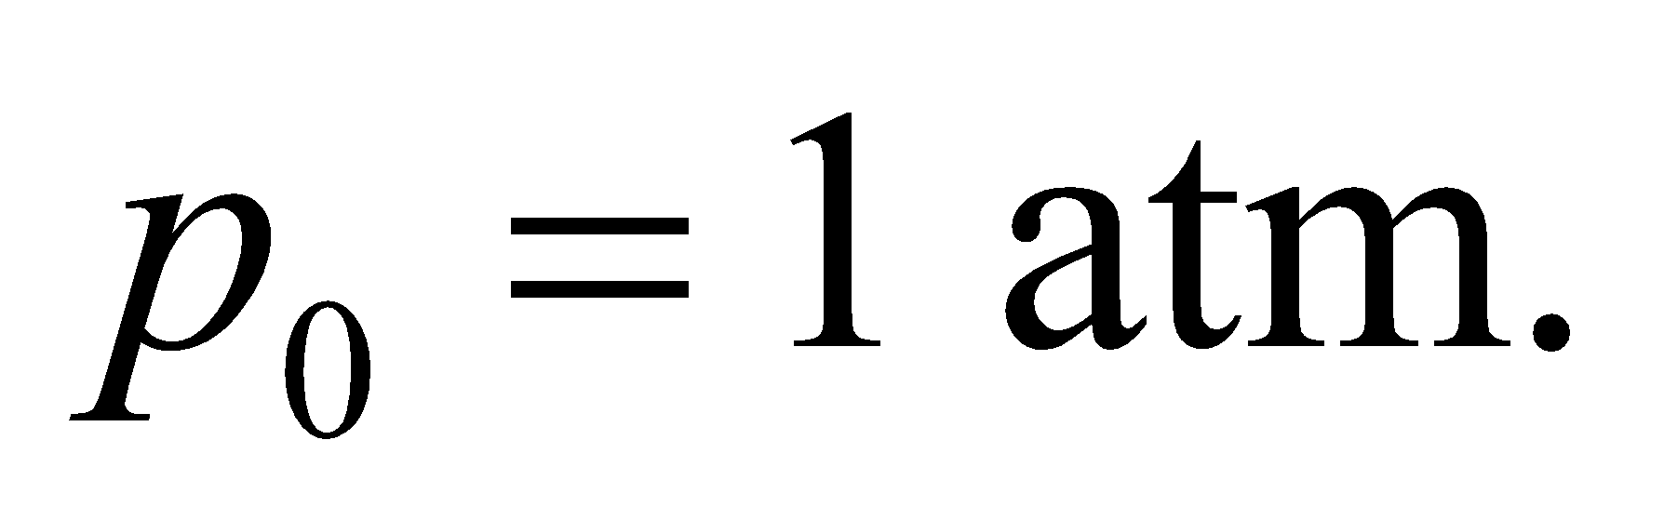To find the total force of the water on the dam, divide the dam into thin strips of height *dh* that stretch along the dam's width *L*. The force on a given strip is 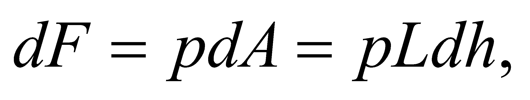 and the total force is the integral over the full depth of the lake, *H*.

**Evaluate** The water exerts a force on the dam of

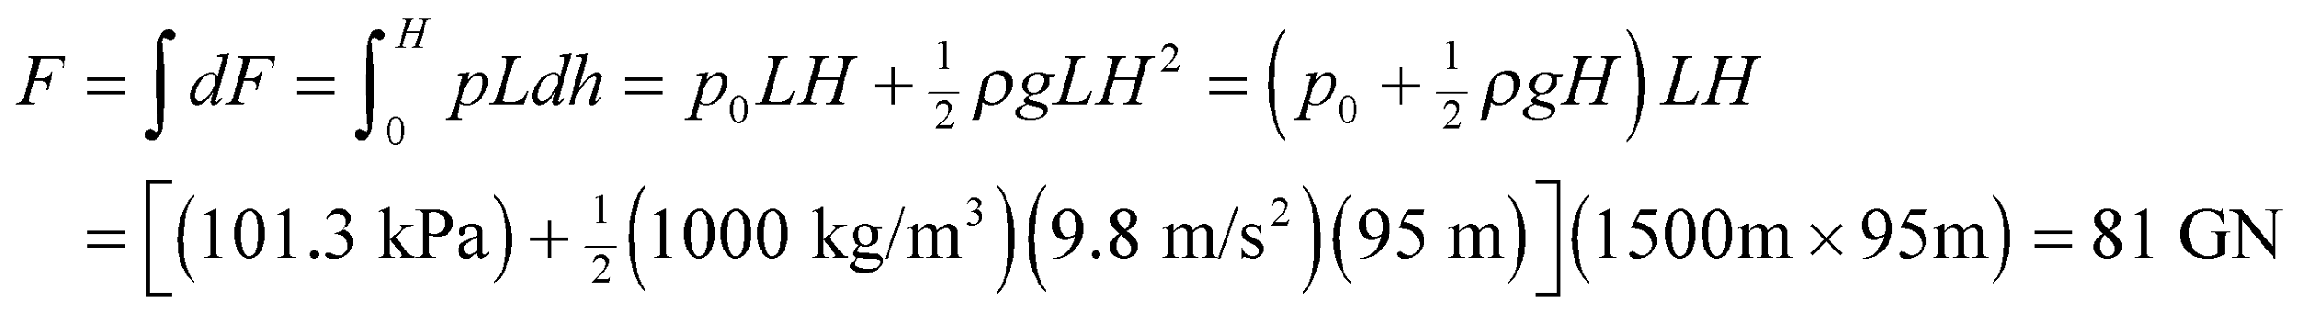

If the force increased by 50%, it would be 120 GN. Therefore, the dam needs to be reinforced to withstand 20 GN more.

**Assess** The calculated force is equivalent to the pressure at a depth of 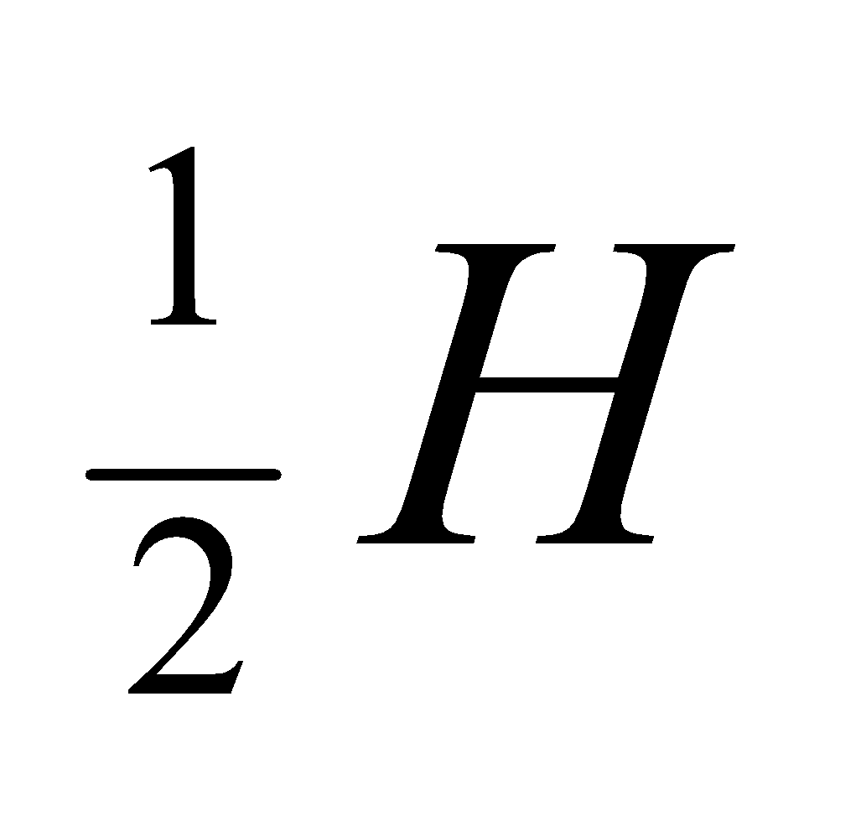multiplied by the total area of the dam, *LH*. In other words, the linear dependence of pressure with depth implies that the average pressure is equal to the pressure at the midpoint.

**43. Interpret** The U tube contains two liquids, oil and water, in hydrostatic equilibrium. We want to find their height difference.

**Develop** The pressure at point 2 in the figure below, which is the oil-water interface, is

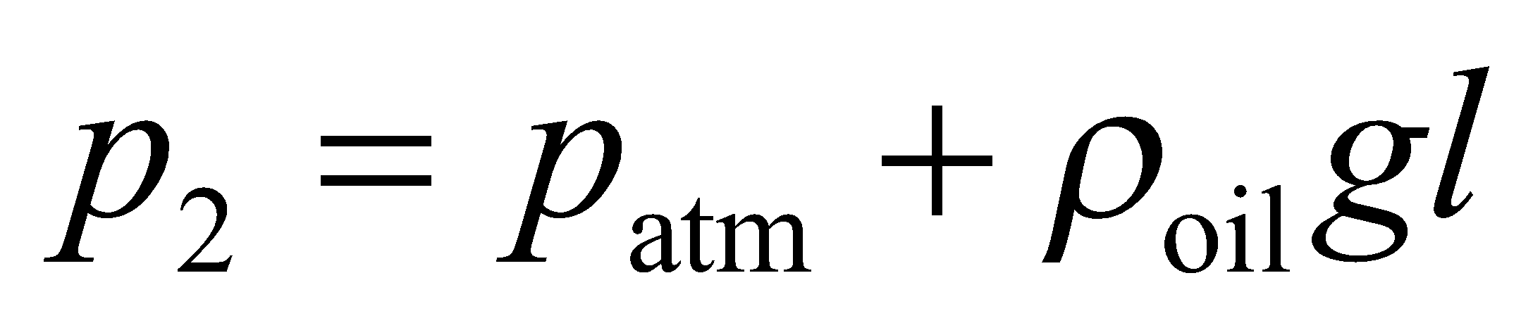

where *l* = 2.0 cm. The pressure at point 1, which is at the same height as point2, is

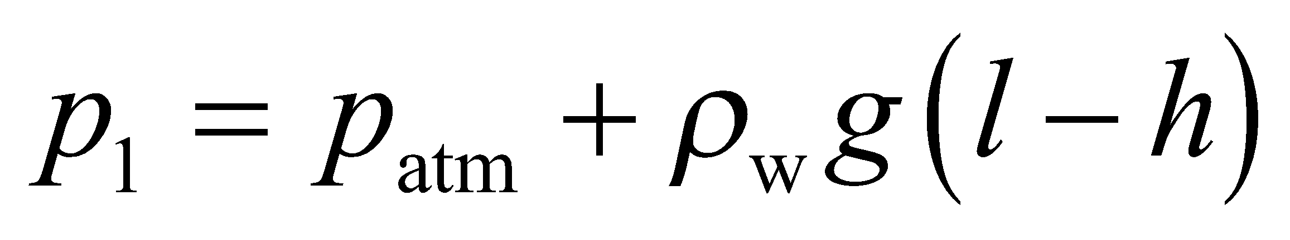

From Equation 15.3, 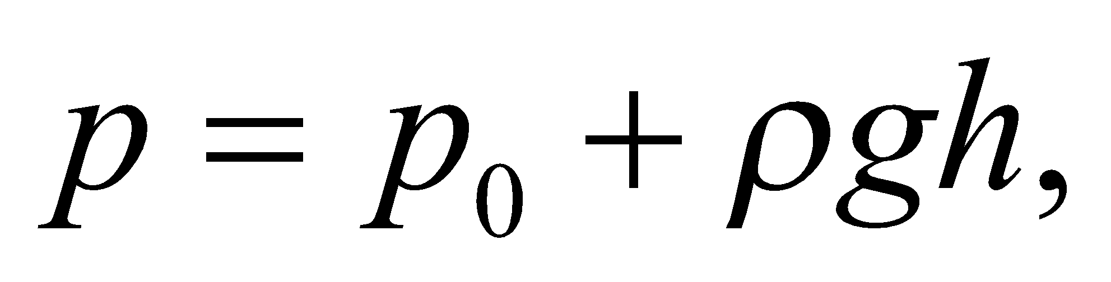 we see that the pressure at points at the same height are the same, so *p*1 = *p*2. Using the information that *ρ*oil = 0.82*ρ*w allows us to solve for *h*.



**Evaluate** Equating the two pressures leads to 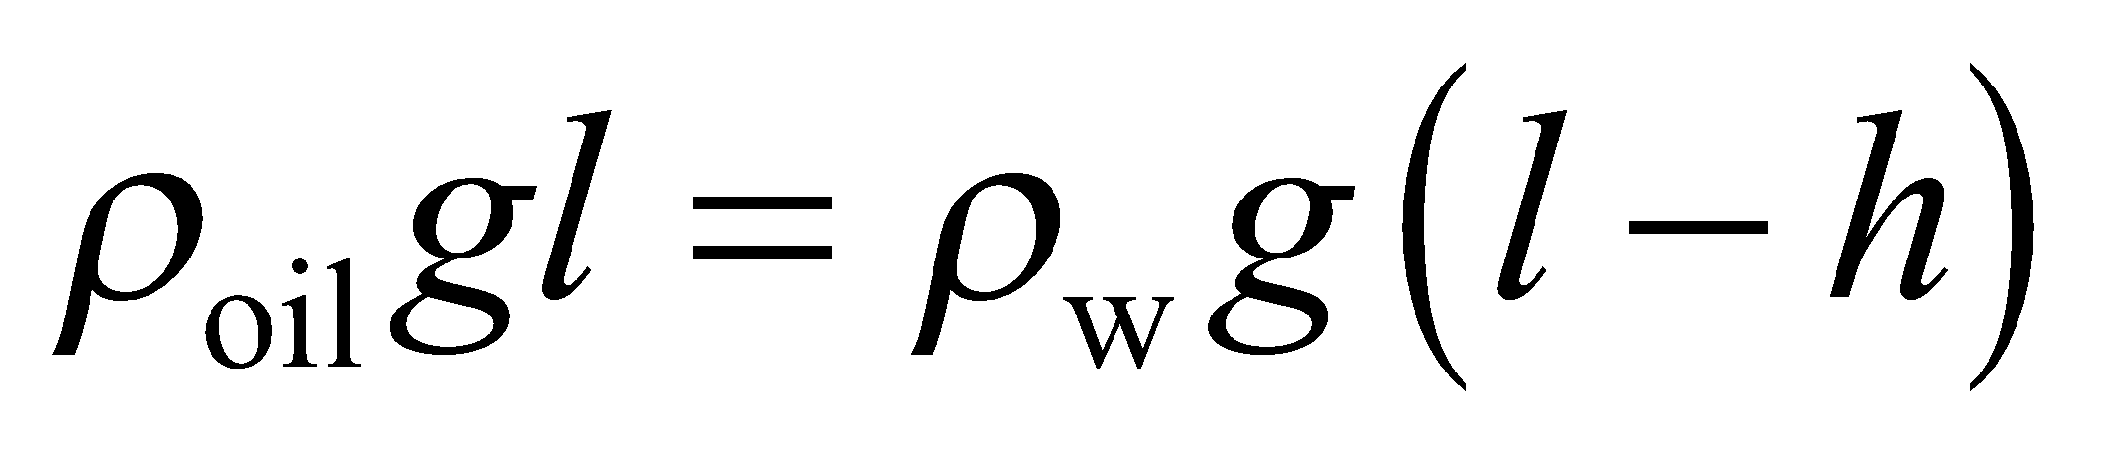 or

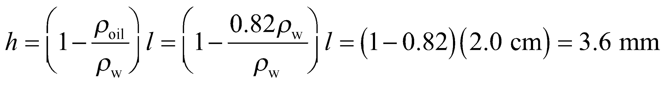

**Assess** Note that the final answer does not depend on the atmospheric pressure, *p*atm, because this pressure pushes down equally on both the oil and the water. The U tube can be used to measure the density of a fluid, if we know the height difference *h* and the density of the other fluid.

**44. Interpret** The hydraulic system you are designing must have tubes that support a certain amount of pressure when the fluid inside them is compressed by the hydraulic cylinder.

**Develop** Given the force from the cylinder, the pressure in the fluid will be 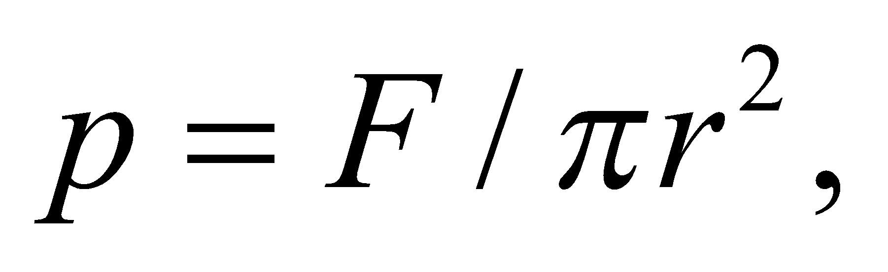 where *r* is the radius of the cylinder 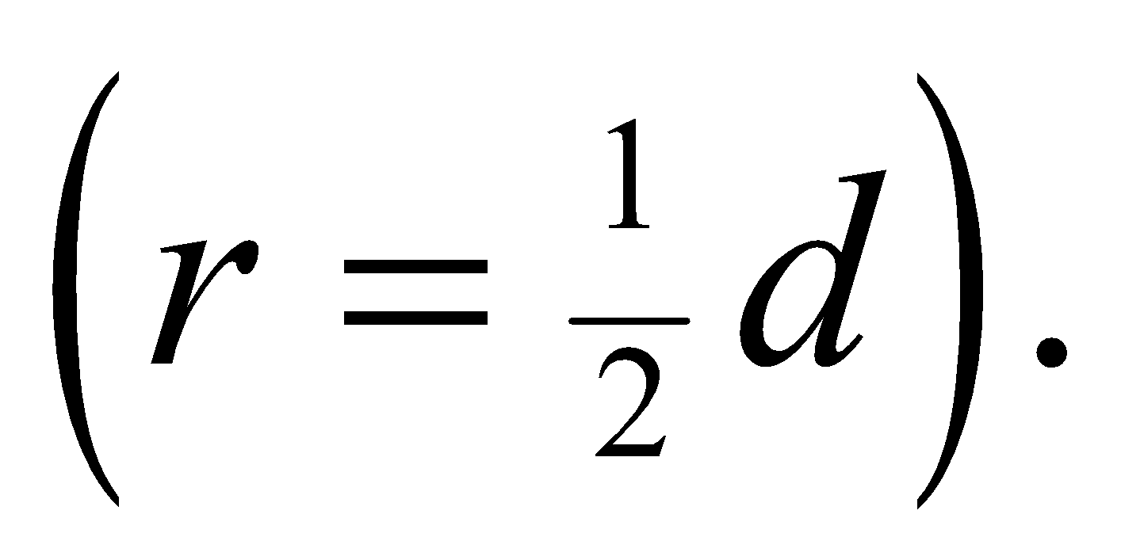

**Evaluate** The pressure of the fluid in the hydraulic system will be

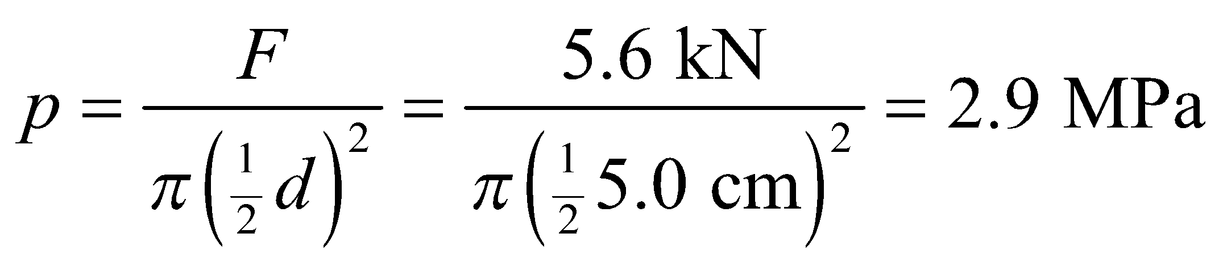

To be safe, you choose tubing that can withstand at least 50% more pressure than calculated: i.e., 4.3 MPa. Since the tubing is only sold in multiples of ½ MPa, you choose 4.5 MPa.

**Assess** The answer seems reasonable. The units work out since 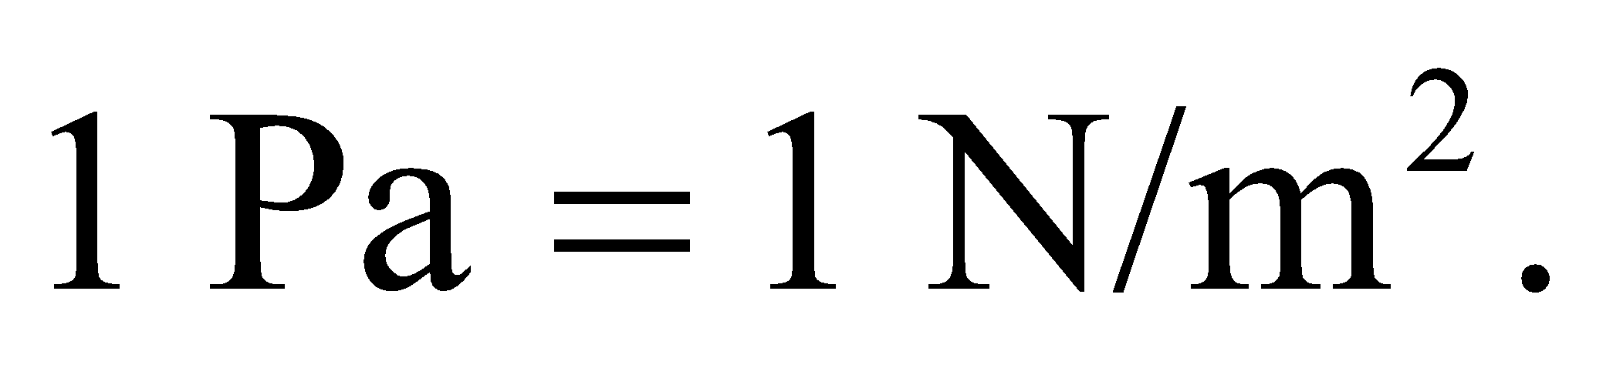

**45. Interpret** This problem involves Pascal’s law, which we can use to calculate the maximum mass the hydraulic lift can support.

**Develop** If we neglect the variation of pressure with height in the hydraulic system (which is usually small compared to the applied pressure), the fluid pressure is the same throughout the system:

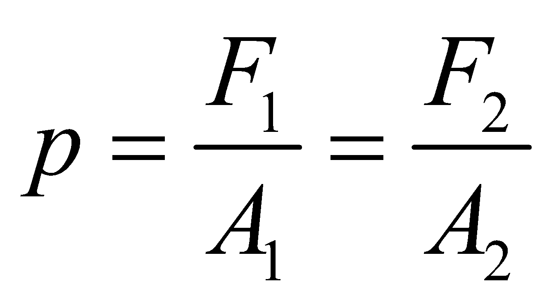

where *F*1 is the applied force and *F*2 is the resulting force. The mass the system can support is

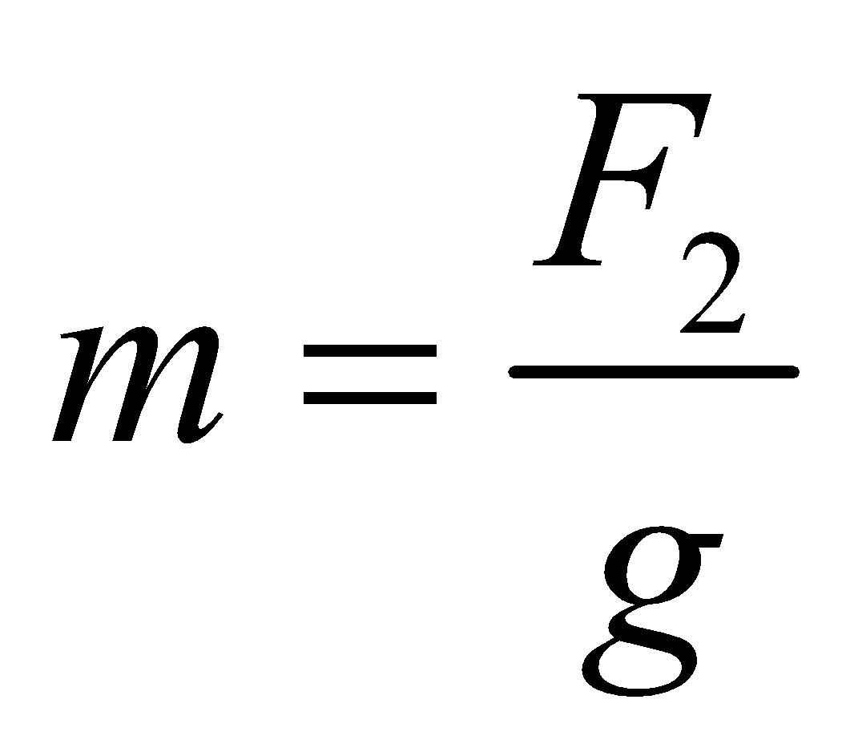

**Evaluate** Solving the equations above for *m* gives

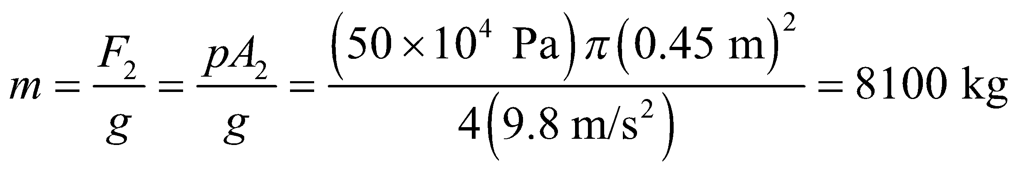

**Assess** Because the fluid pressure is essentially constant throughout the system, the force is scaled by the ratio of the surface areas in question. Energy, however, is conserved in this process.

**46. Interpret** This problem involves using Archimedes’s principle to calculate the apparent weight of an object in water given its composition.

**Develop** This problem is similar to Problem 15.30, where we found the following result for the apparent wait of an object in water:

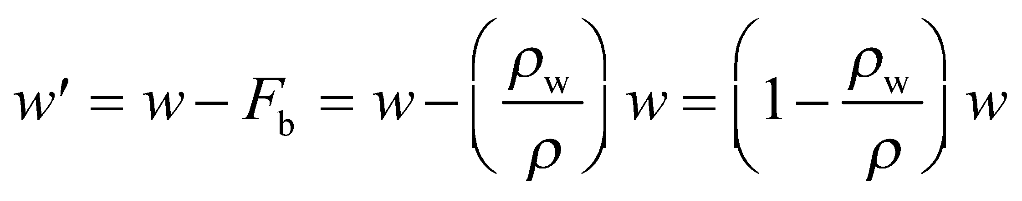

where *w* and *w*′ are the true weight and apparent weight, respectively. For the alloy crown, the density is

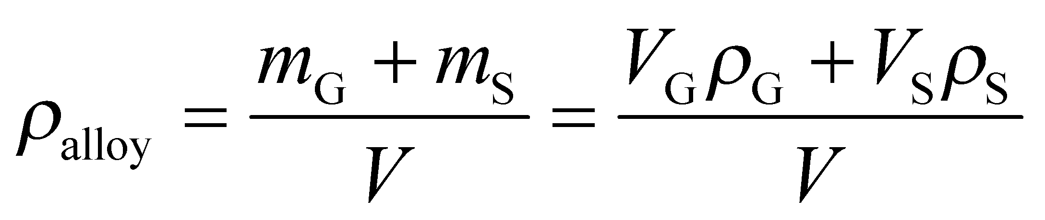

where the subscripts G and S refer to gold and silver, respectively. Using the information that *V*G = 0.75*V* and *V*S = 0.25V, this gives

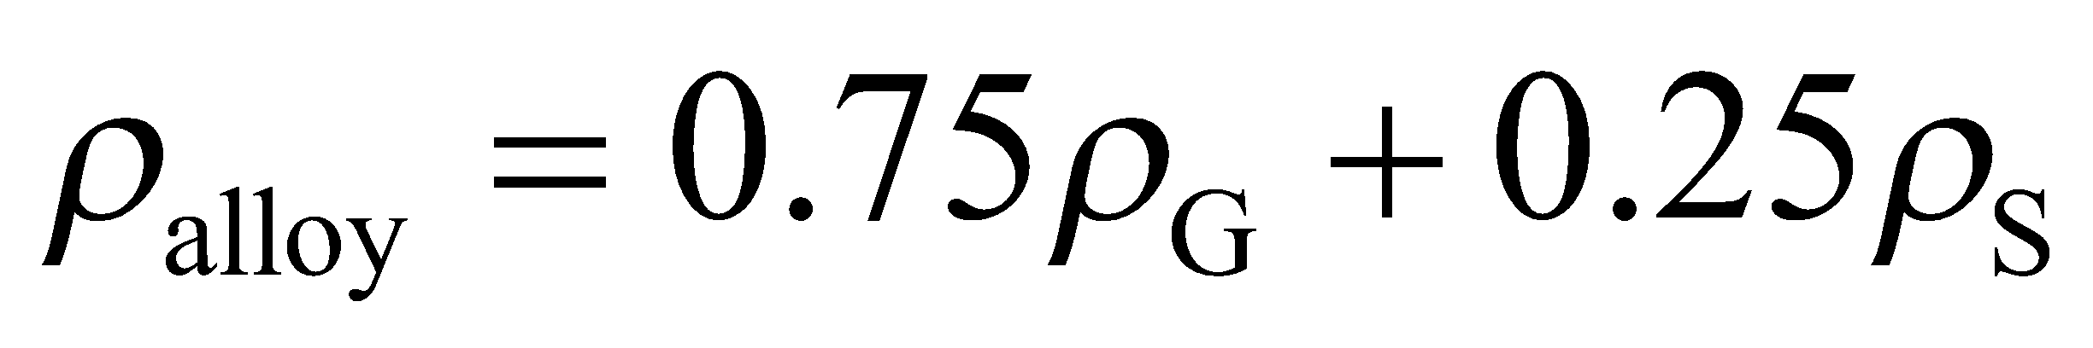

which we can use in the expression above for the apparent weight.

**Evaluate** (a) For the pure gold crown, the apparent weight is

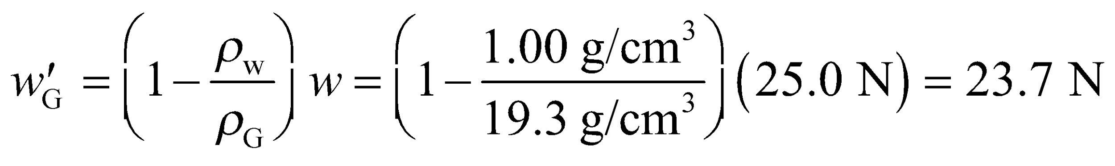

(b) The apparent weight of the alloy crown is

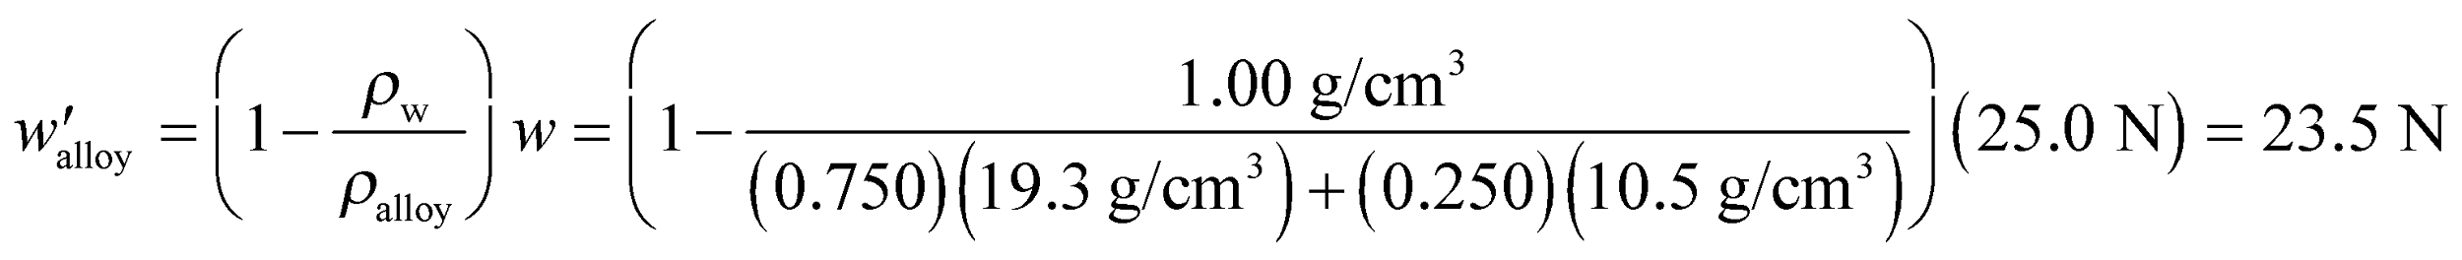

**Assess** This corresponds to ~0.8% difference.

**47. Interpret** You're asked to determine how much the accused person drank, given the change in the buoyant force of a keg of beer.

**Develop** By Archimedes' principle, the buoyant force on the keg is equal to the weight of the fluid displaced. The keg is probably made of aluminum and is filled with a mixture of beer and air. Let's assume that the level of the beer in the keg was initially 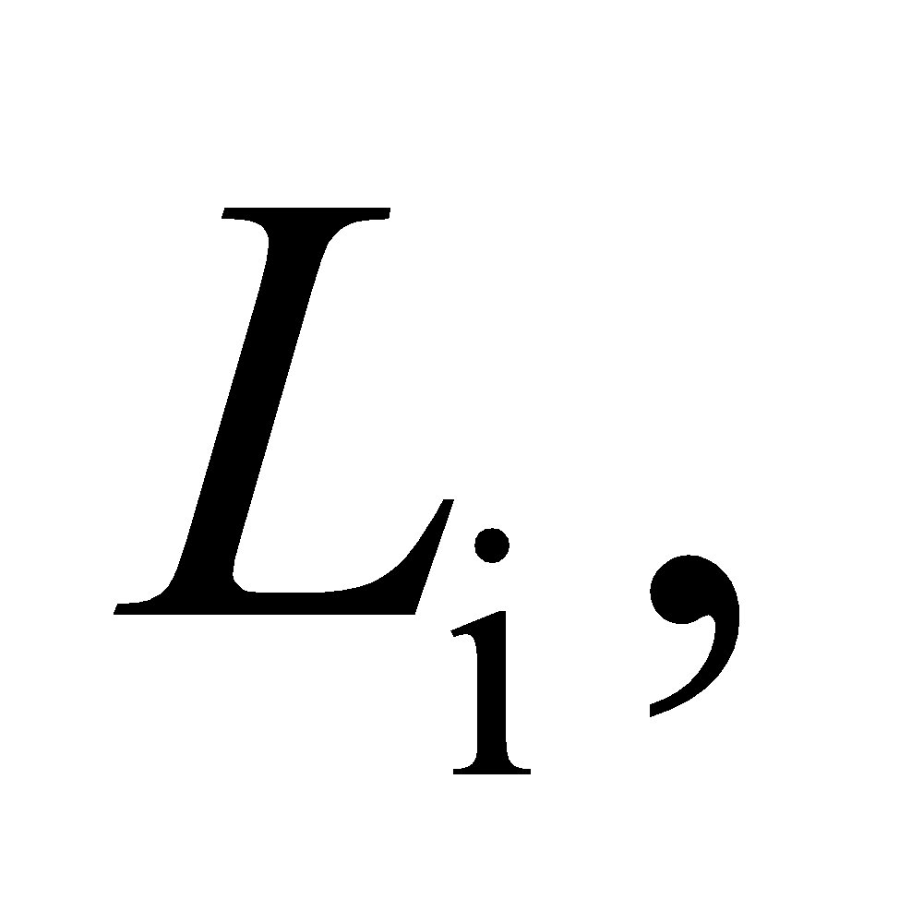and the keg was submerged in the water to a depth of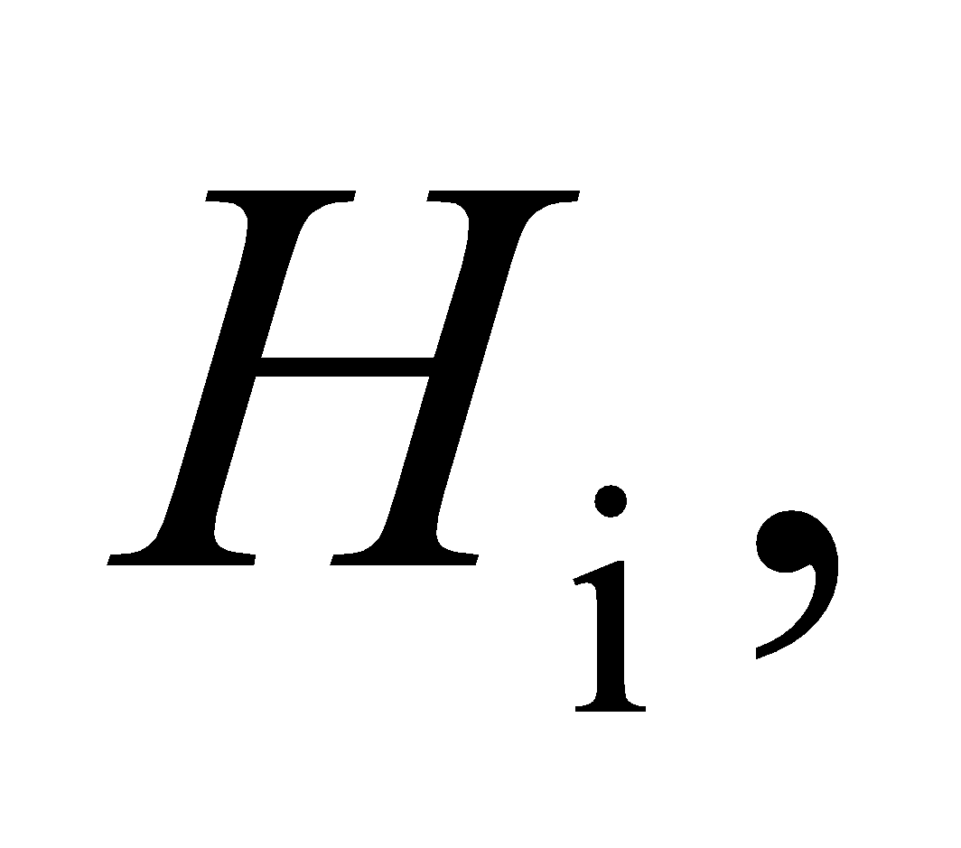 as shown in the figure below.



As such, the initial volume of beer would be 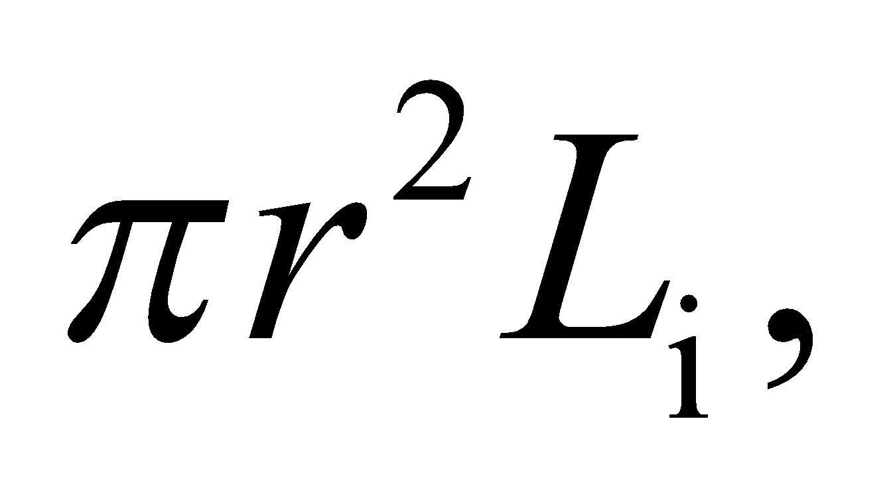and the initial volume of water displaced would be 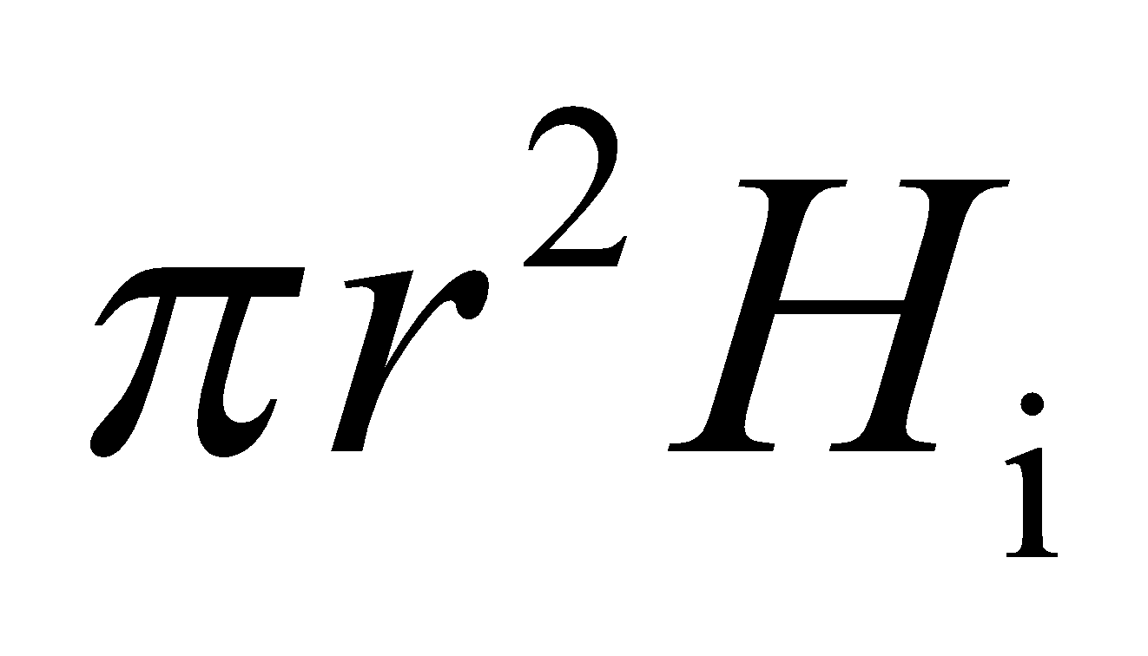 (where we have assumed the aluminum shell is thin enough that the interior and exterior radii are essentially the same). The total weight of the keg and beer (neglecting the weight of the air) is balanced by the buoyant force, which equals the weight of the water displaced.

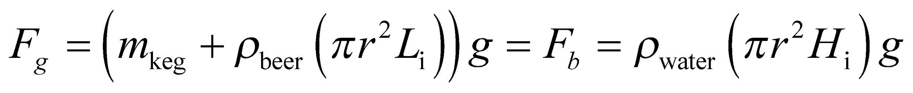

A similar equation can be written for the keg at the end of the day, using 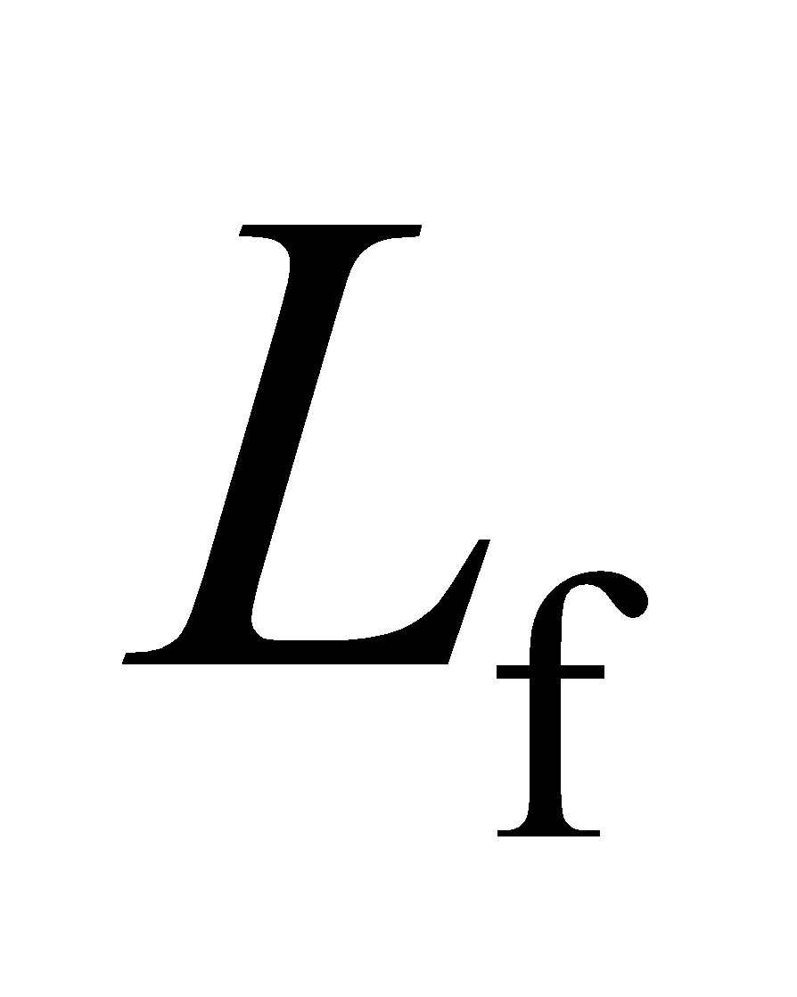for the final level of beer and 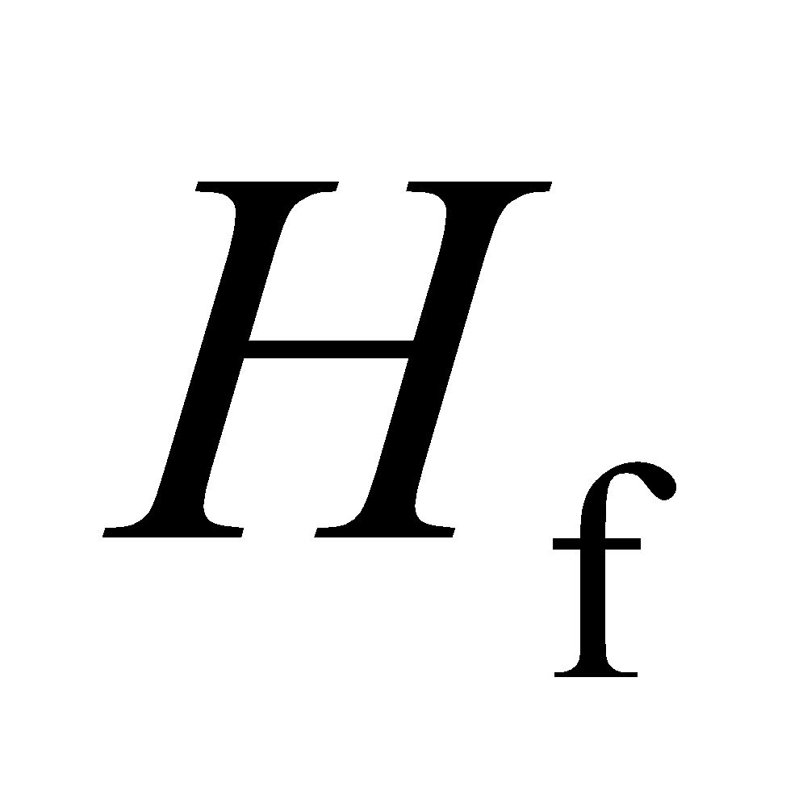for the final depth. Subtracting these two equations gives

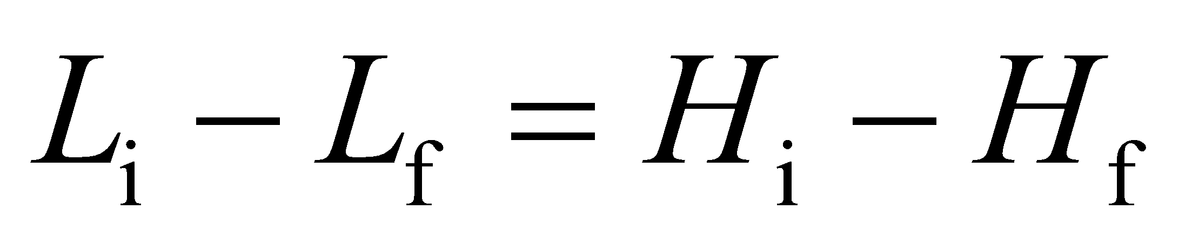

where we have used the fact that 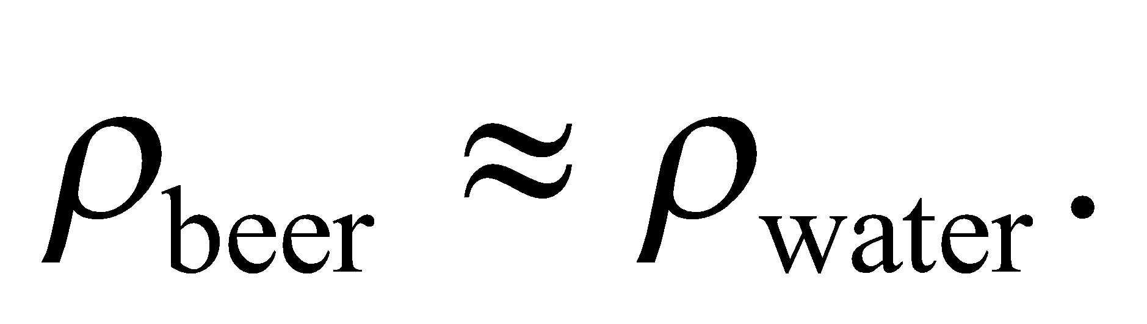

**Evaluate** You are told that the keg rose by 1.2 cm, so the level of beer fell by that same amount. This corresponds to a volume of beer:

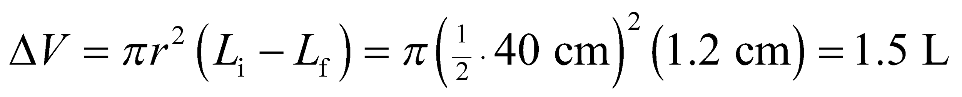

where we've used the conversion 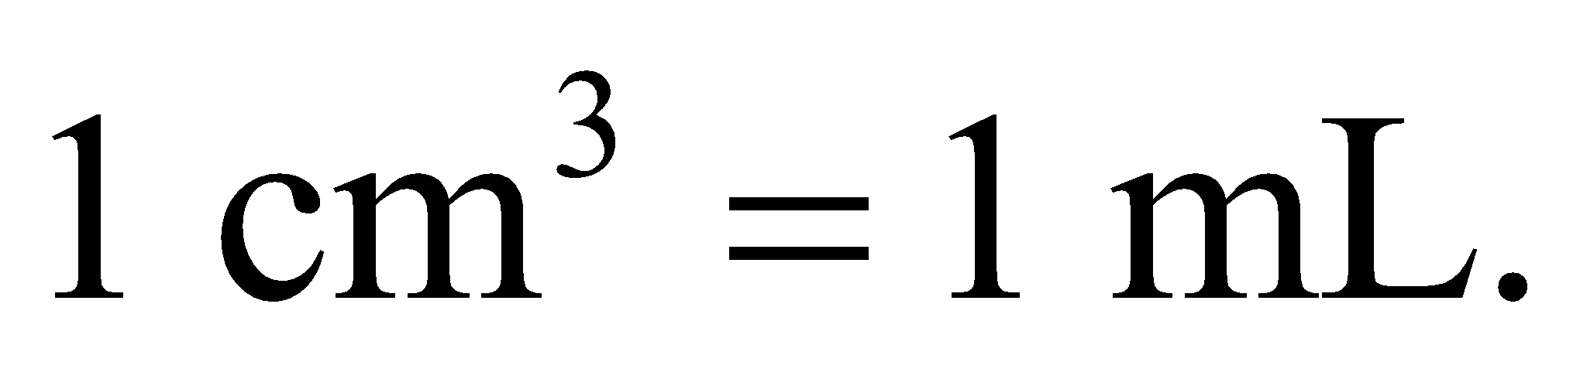 In terms of English units 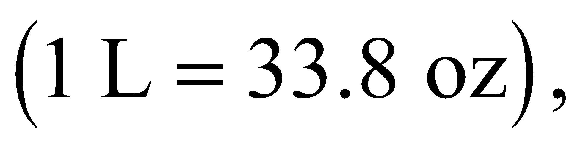the accused drank 51 oz, which would imply that he/she was legally impaired.

**Assess** The defendant may want a more careful analysis, taking into account the thickness of the keg's outer shell, but this would actually increase the estimated beer volume that he/she drank.

**48. Interpret** This problem involves Archimedes’s principle for floating objects, which we can use to find the mass of the beaker, and subsequently the number of 15-g rocks we can put in the beaker before it sinks.

**Develop** Archimedes’s principle for floating objects tells us that the weight of the beaker equals the weight of water displaced by one-third of its volume, so the maximum weight of rocks the beaker can carry and still float is equal to the weight of water displaced by two-thirds of the beaker’s volume, or

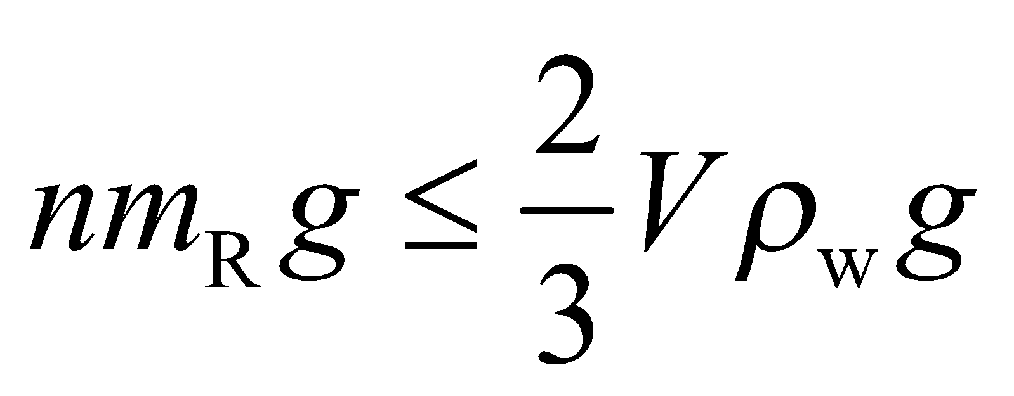

where *m*R = 15 g is the mass of each rock.

**Evaluate** Solving the expression above for n gives

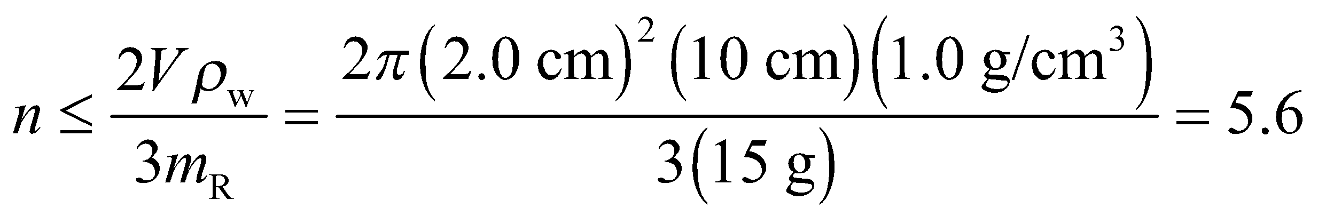

so 5 rocks is the maximum number the beaker can support before sinking.

**Assess** Because *n* is an integer, we do not need to report it to the 2 significant figures that is warranted by the data.

**49. Interpret** This problem involves applying Archimedes’ principle to find the minimum water depth for the load-carrying ship to navigate.

**Develop** Archimedes’ principle states that the buoyancy force is equal to the weight of the water displaced by the floating supertanker:

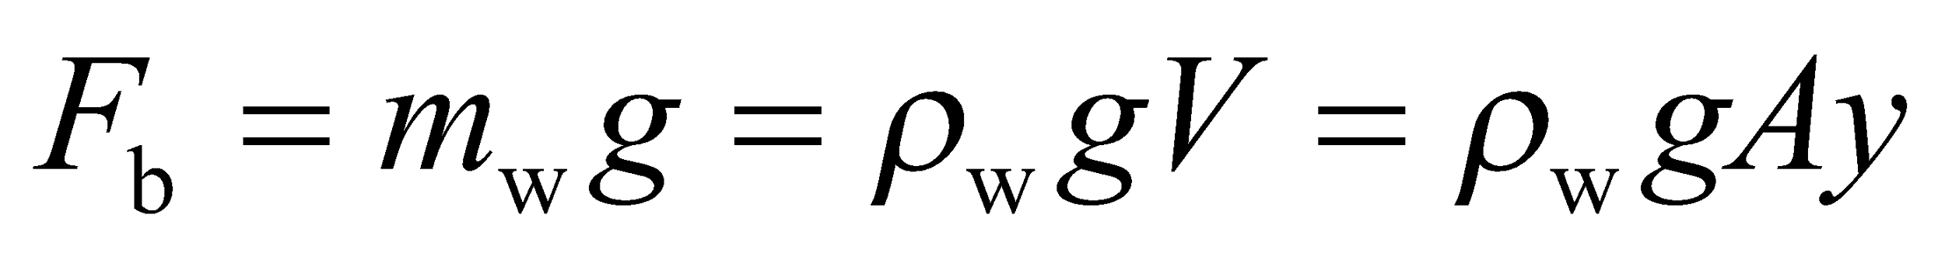

where we have used the fact that the volume *V* of water displaced is proportional to its draft (depth *y* in the water); *V* = *Ay*, where *A* is the cross-sectional area (see figure below).



**Evaluate** Because the total mass of the full supertanker is three times that when empty, three times the buoyancy force is needed to support the ship. From the expression above, we see that the buoyancy force is proportional to the draft *y*, so the *y* must increase three fold. Thus, *y*full = 3*y*empty = 3(9.0 m) = 27 m.

**Assess** Our result is independent of the mass of the supertanker. The heavier the supertanker plus load, the deeper it will submerge.

**50. Interpret** This problem is about the buoyancy force provided by a balloon filled with gas.

**Develop** By Archimedes' principle, the balloon's buoyant force will be equal to the weight of air it displaces. We want this force to be greater than the weight of the mass *M* plus the mass *m* of the gas:

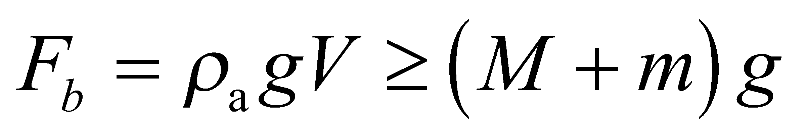

We aren't given the volume of the balloon, but if we neglect the thickness of the balloon's outer shell, then we can assume 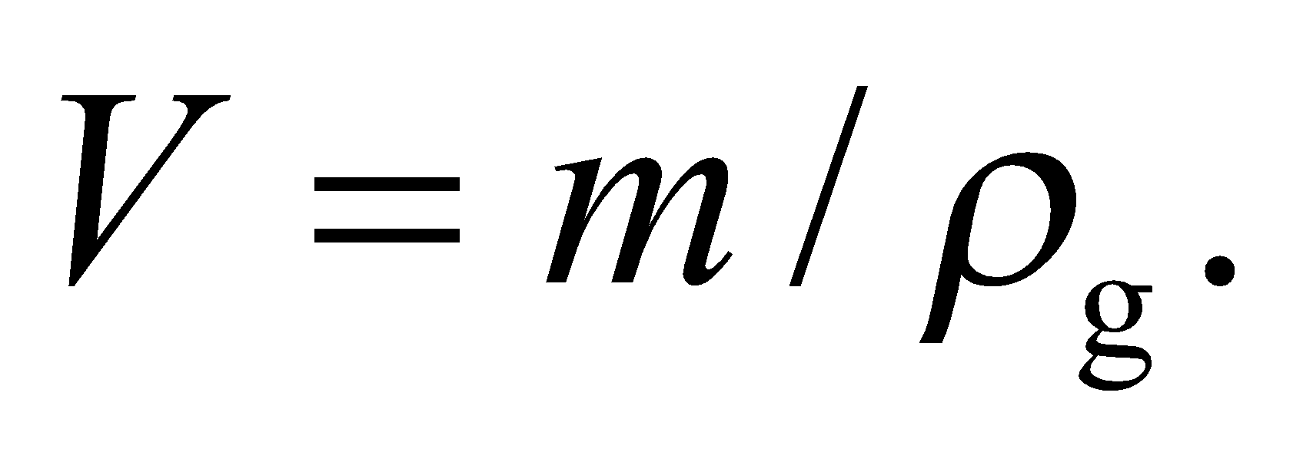

**Evaluate** Solving for the minimum mass, m, gives

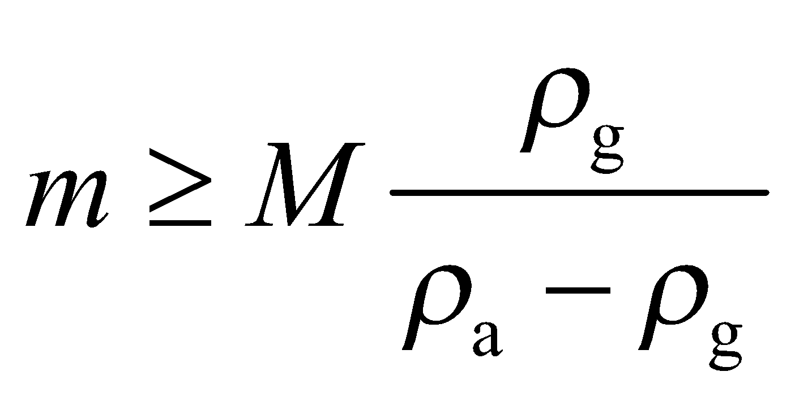

**Assess** The less dense the gas, the less of it we need. But note that the balloon cannot lift up if 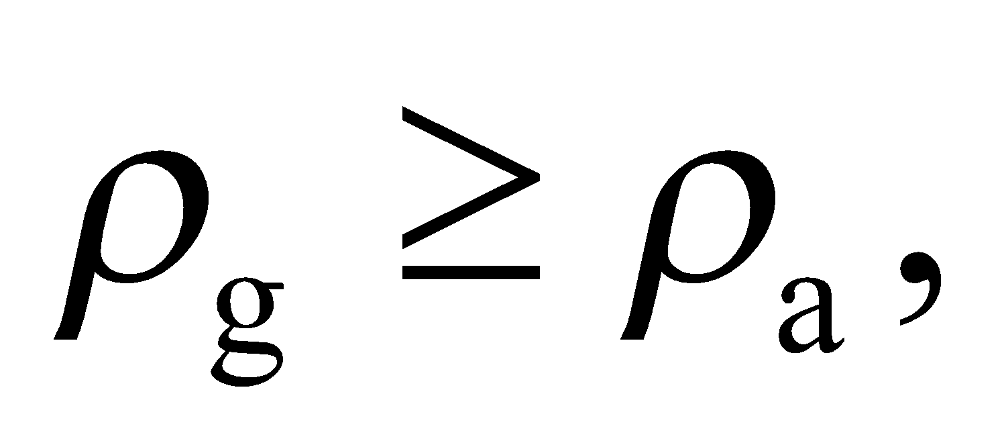 as we would imagine.

**51. Interpret** This problem is about the buoyancy force provided by the helium balloon and the hot-air balloon, which we can use to calculate how much He is needed to lift a given mass.

**Develop** For the balloon to lift off, the buoyancy force must exceed the weight of the load (mass *M*, including the balloon) plus the gas (mass *m*):

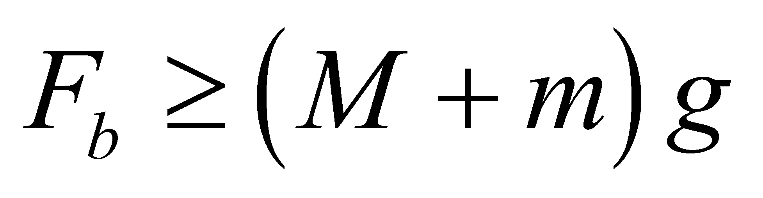

where the buoyancy force is simply equal to 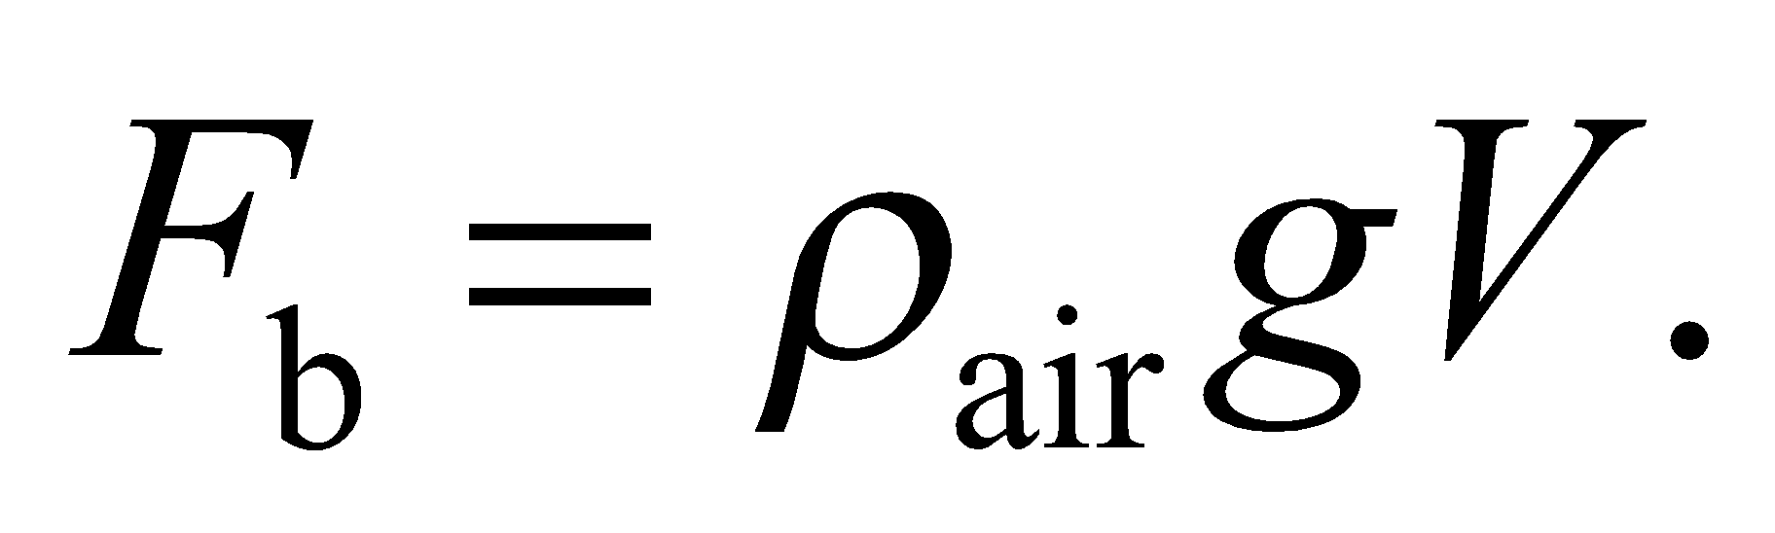 If we neglect the volume of the balloon’s skin etc. compared to that of the gas it contains, then 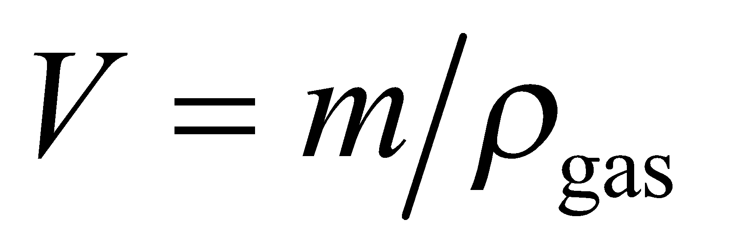. Therefore,

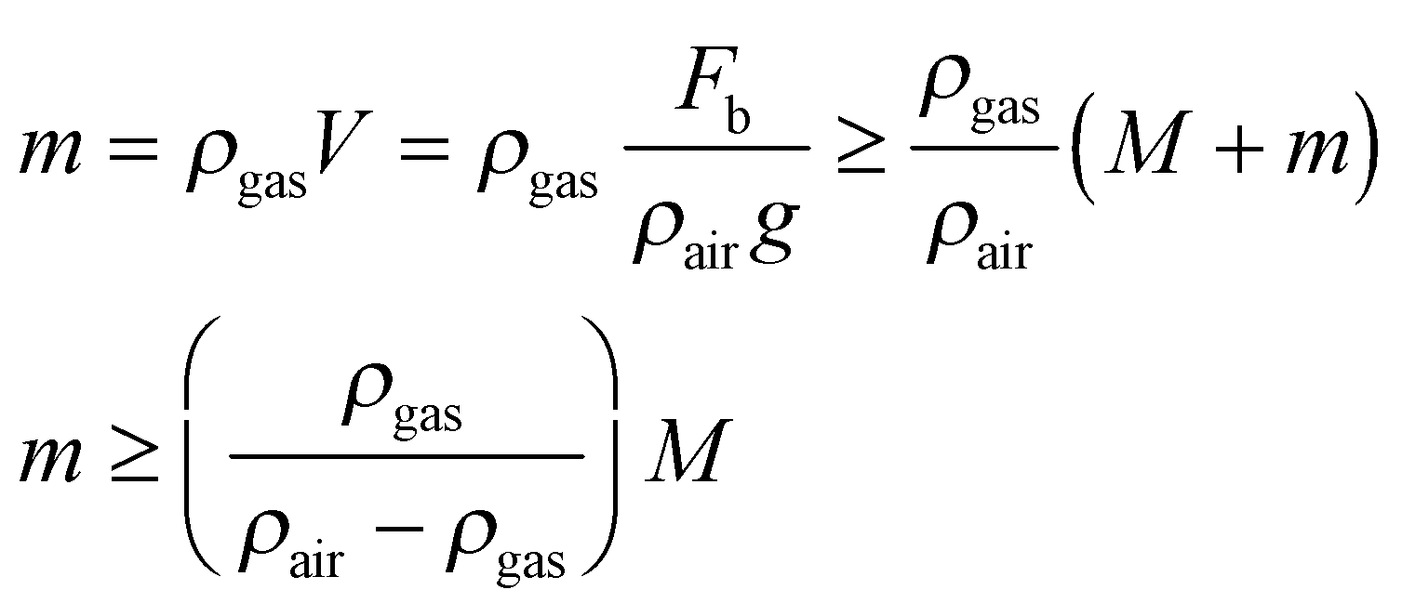

**Evaluate** **(a)** When the gas is helium, the density ratio is 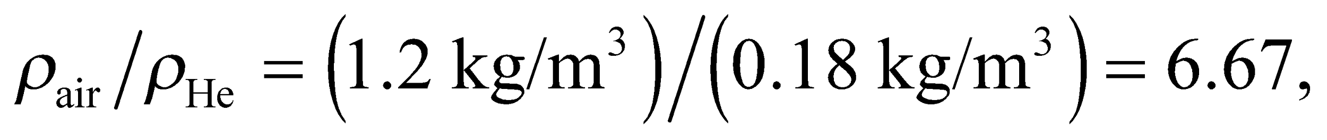 and

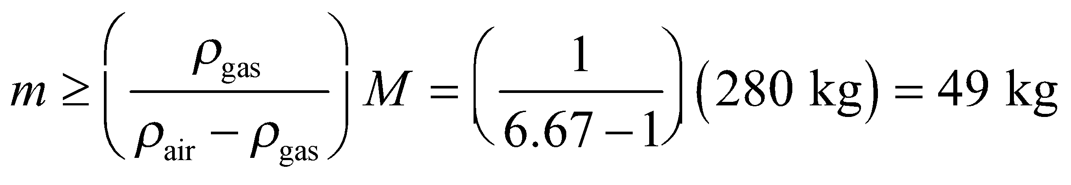

**(b)** For hot air, 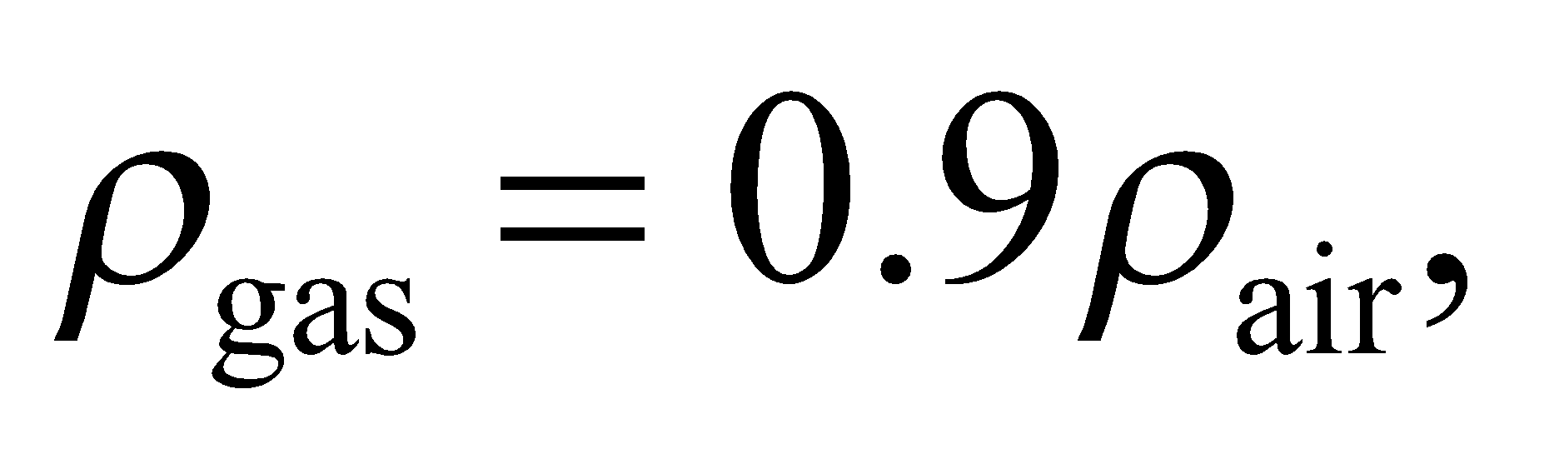 and

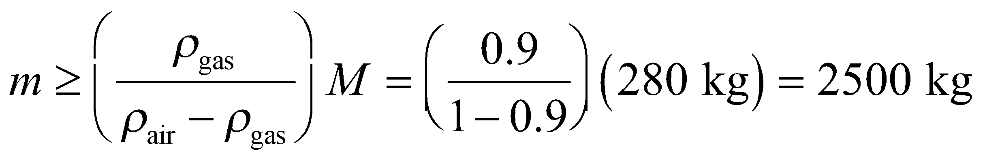

**Assess** These masses correspond to gas volumes of 275 m3 for helium and 2330 m3 for hot air, which are reasonable for a helium-filled balloon and a hot-air balloon.

**52. Interpret** This problem involves Archimedes’ principle for a floating object, which we can use to find the volume of the Styrofoam block needed to support the block and the swimmer.

**Develop** Archimedes’ principle says that the weight of the water displaced by the volume of the Styrofoam block must equal the weight of the block plus the swimmer. Thus, 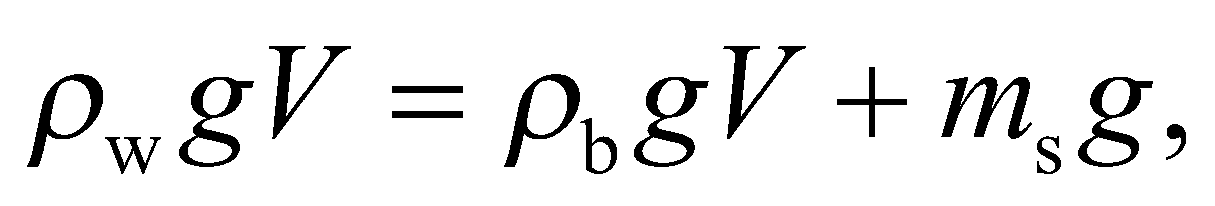where the subscripts w, b, and s refer to the water, the block, and the swimmer, respectively.

**Evaluate** Solving the expression above for *V* gives

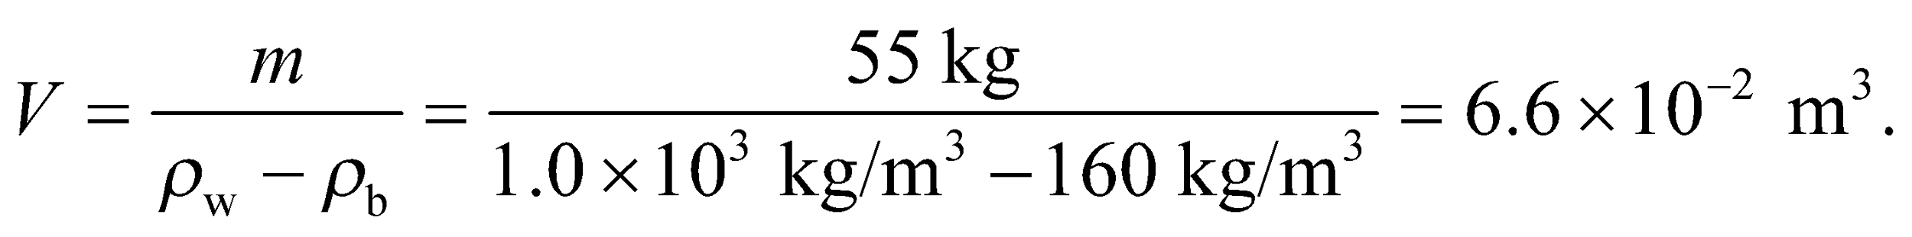

**Assess** This volume corresponds to a block about 40 × 40 × 40 cm3, which seems a reasonable size.

**53. Interpret** This problem deals with flow speed of a fluid, which in this case is the blood in the artery. The key point involved here is Bernoulli’s equation.

**Develop** The continuity equation,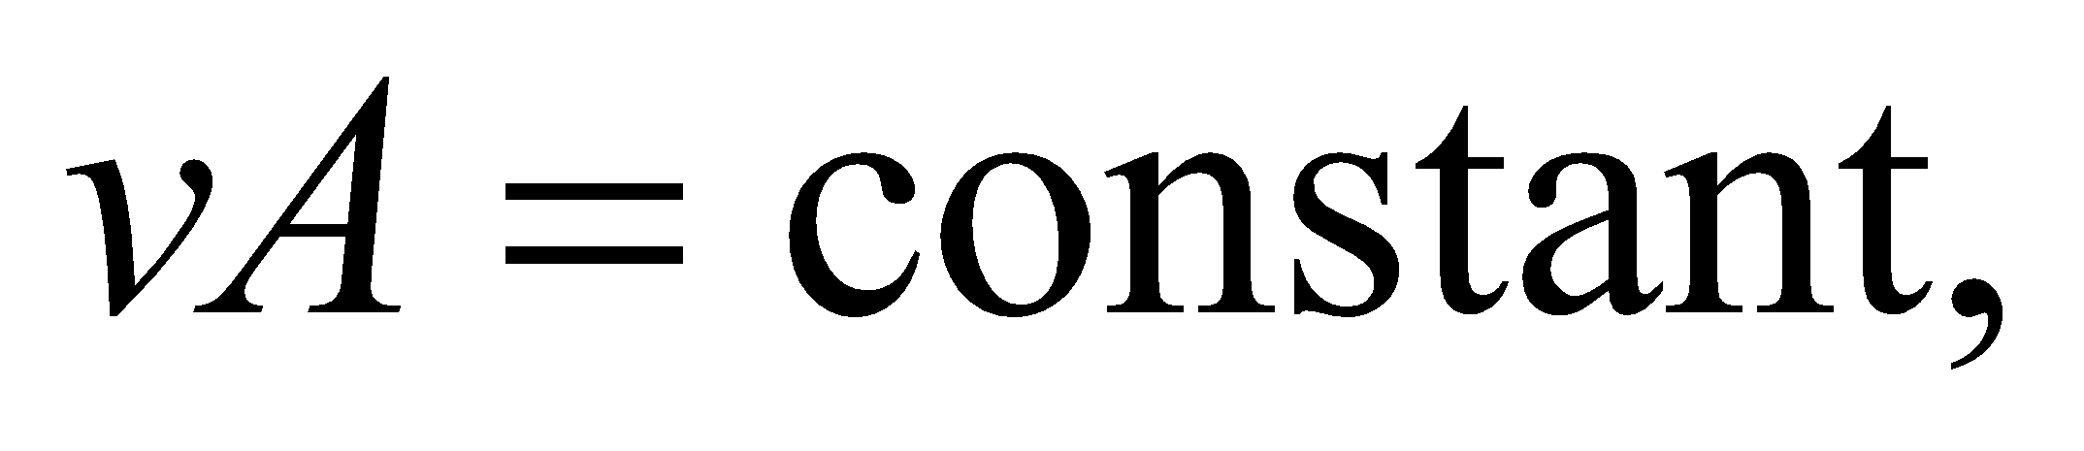 as given in Equation 15.5, is a reasonable approximation for blood circulation in an artery. Neglecting any pressure differences due to height, we find, from Bernoulli’s equation, that

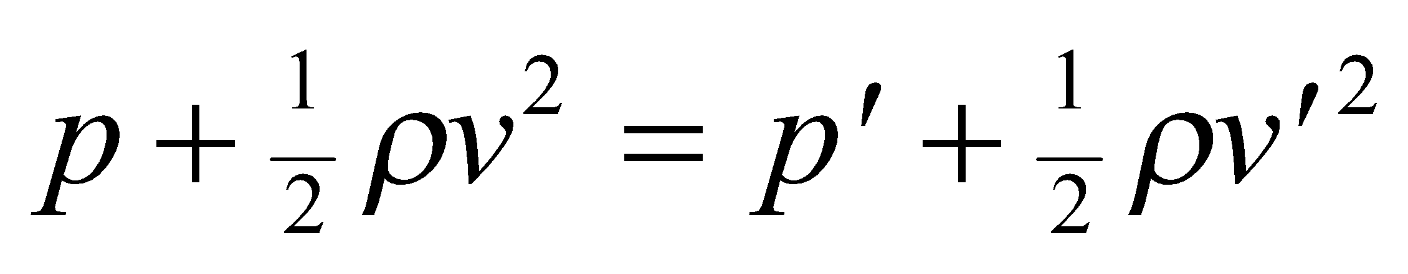

**Evaluate** We're told that the clot reduces the cross-sectional area by 80%, so 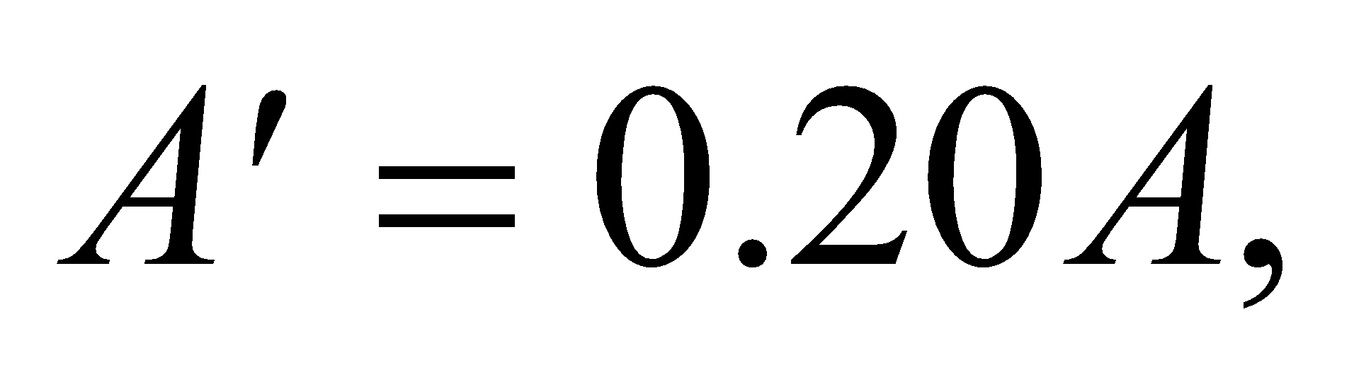and

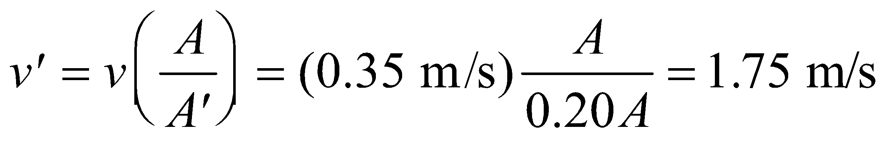

From Bernoulli’s equation, the gauge pressure at the clot is



**Assess** The flow speed of blood increases in the region where the cross-sectional area of the artery has been reduced due to clotting. Since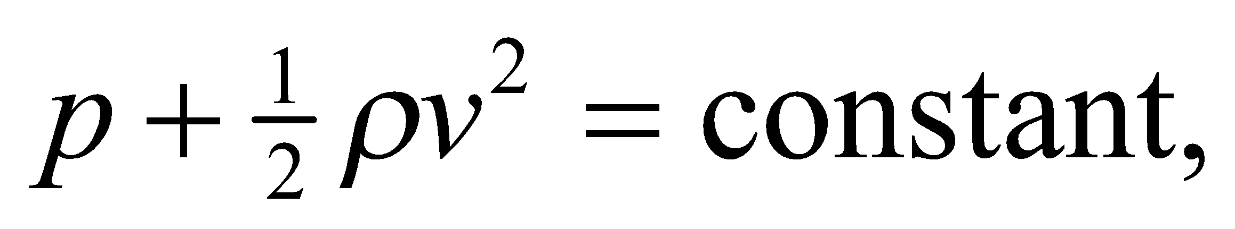the gauge pressure must decrease.

**54. Interpret** You're consulting a maple syrup company. Their system has a thin vertical tube that acts as a kind of barometer. They've asked you to derive a formula relating the height in the tube to the volume flow rate.

**Develop** The Bernoulli equation relates the syrup flow through the pipe at the height 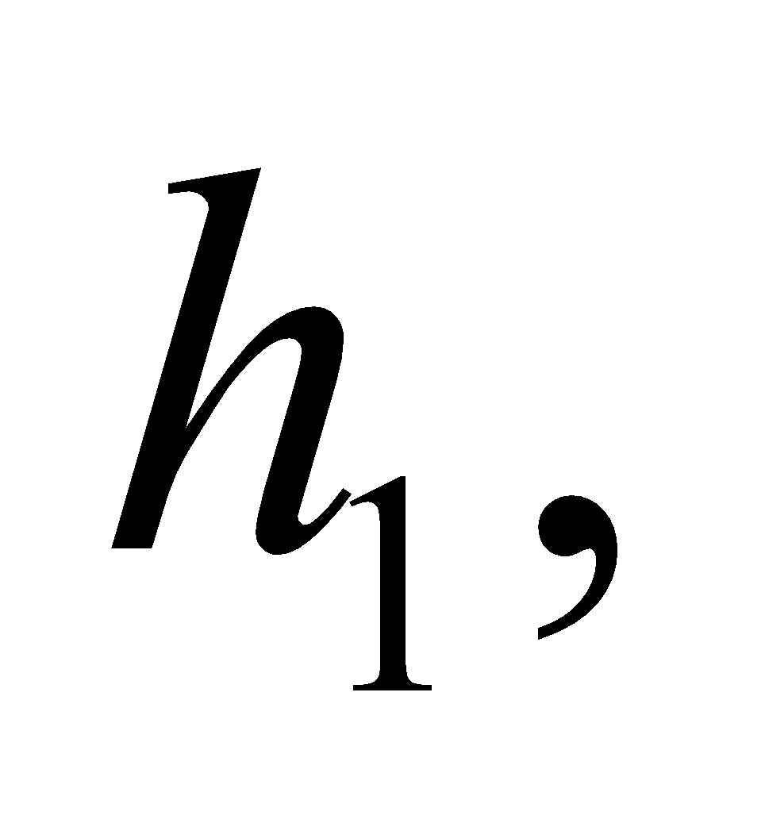to the syrup flow at the base of the thin glass tube:

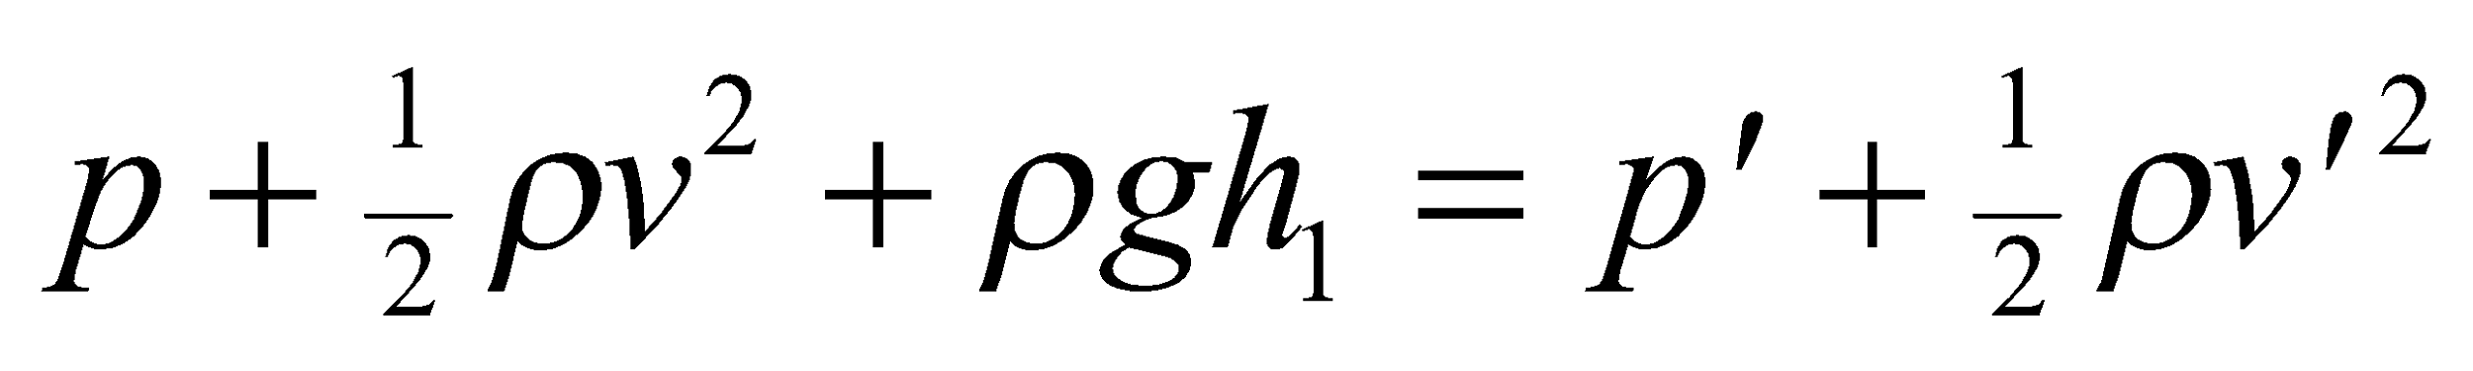

The pressure at height 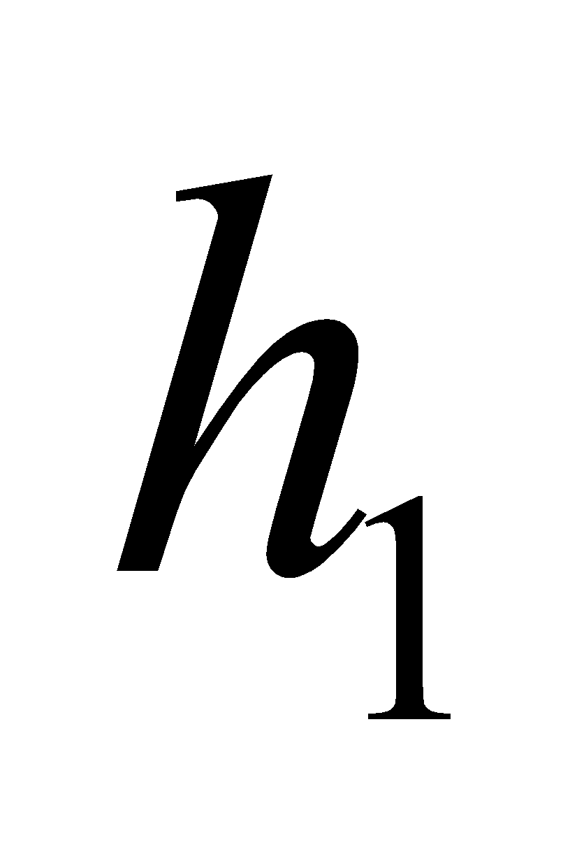is equal to atmospheric pressure: 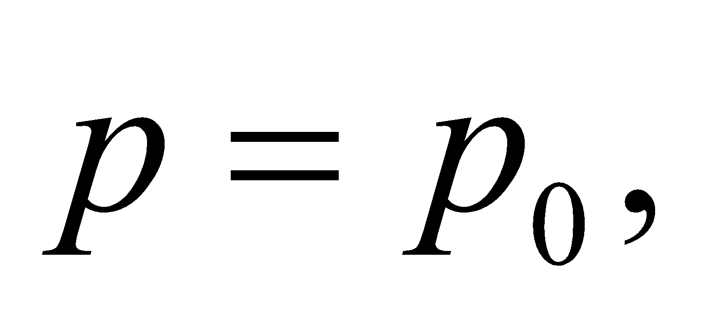while the pressure at the base of the thin glass tube satisfies Equation 15.3: 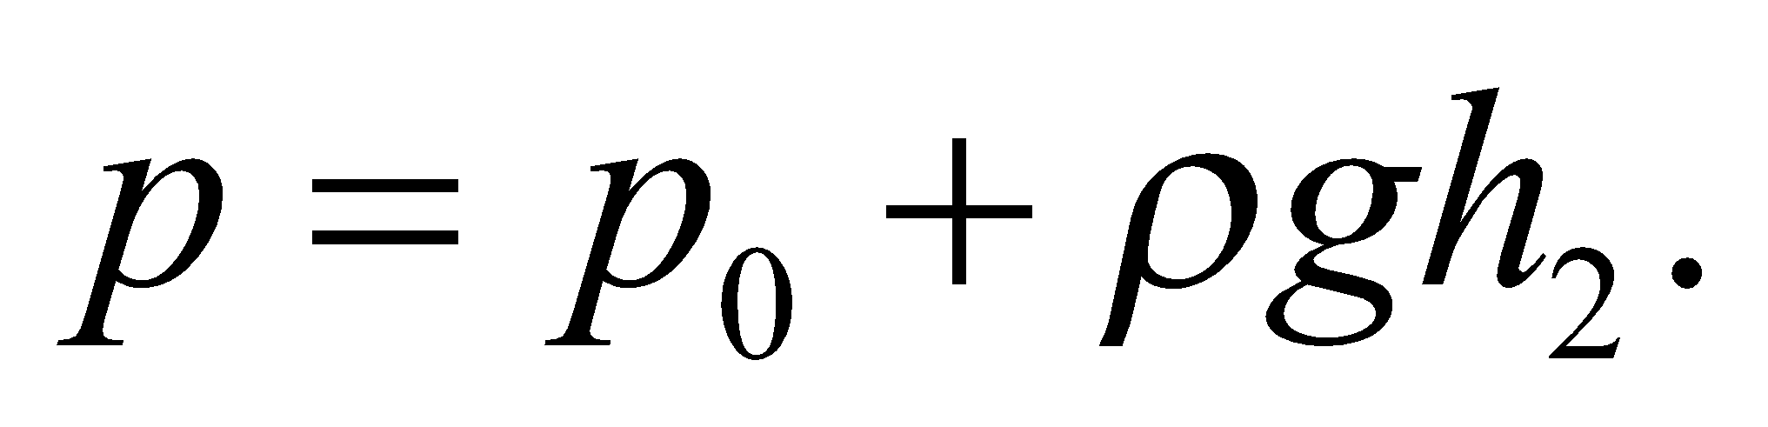Because the syrup is essentially incompressible, the volume flow rate, *Av*, is constant through the pipe, which means the speeds are related by:

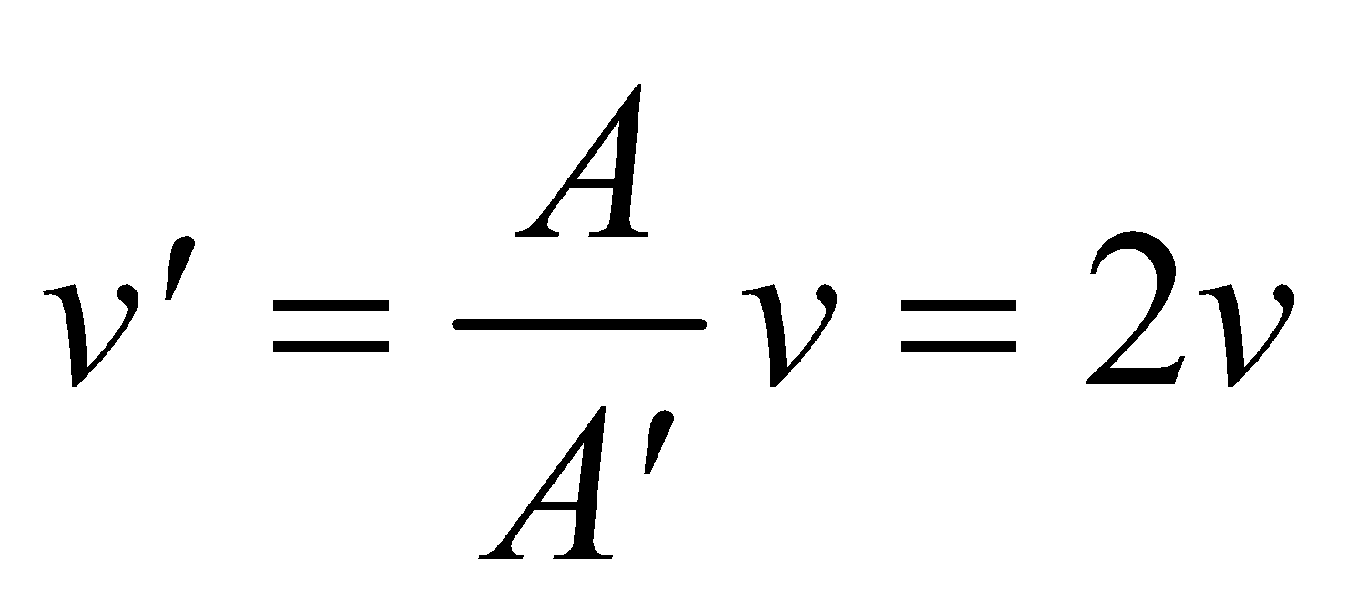

**Evaluate** Putting together the information above, the Bernoulli equation simplifies to:

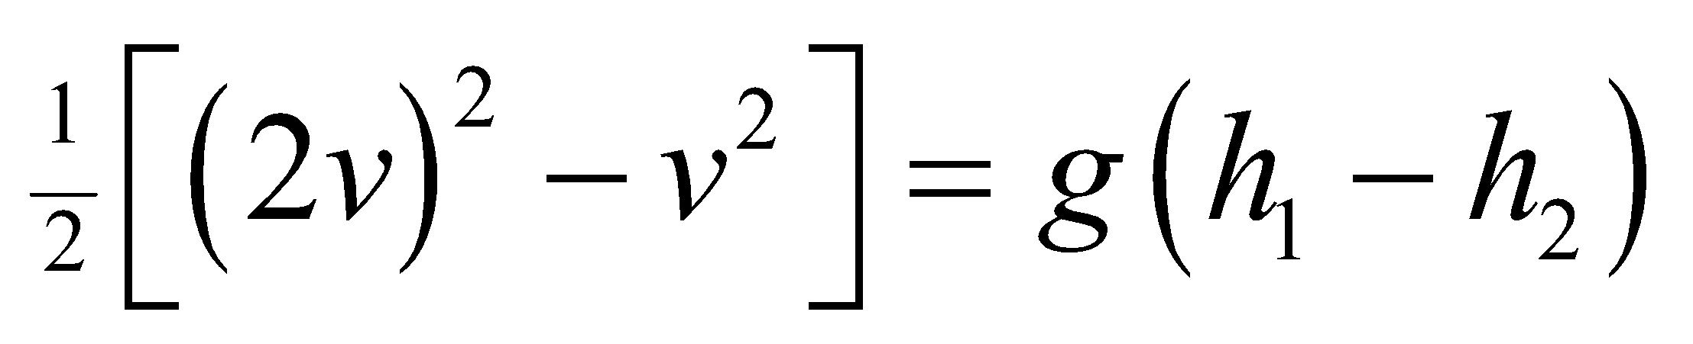

The volume flow rate is therefore:

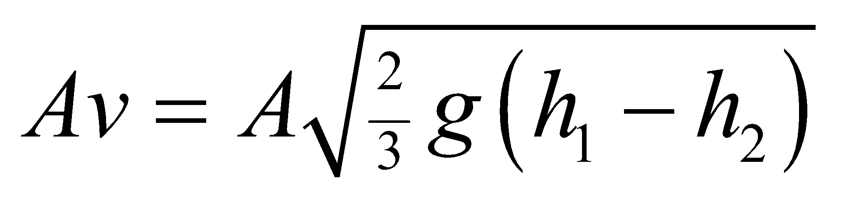

**Assess** If the height in the vertical tube were equal to then the volume flow rate would be zero. The maximum volume flow rate would correspond to 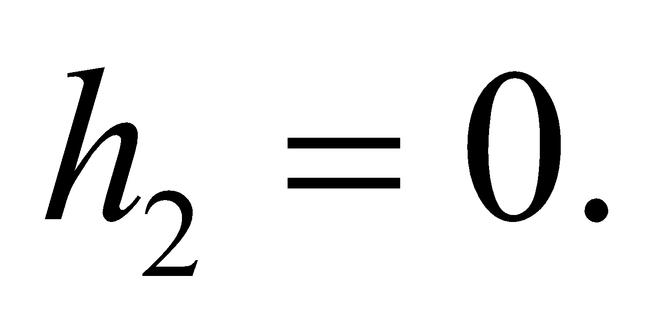

**55. Interpret** This problem involves the flow of water, which we can consider to be an incompressible fluid. Bernoulli’s equation allows us to find the maximum height reached by the water coming out from the hose.

**Develop** Make a sketch of the situation (see figure below). The flow of water in the hose can be described by Bernoulli’s equation (Equation 15.6):

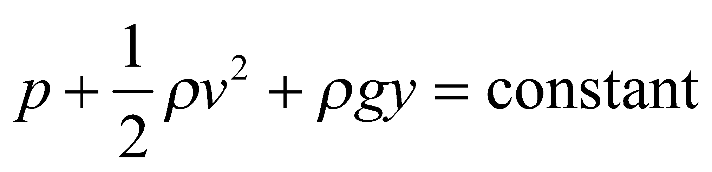

The pressure, velocity, and height of the water in the hose (point 1) are 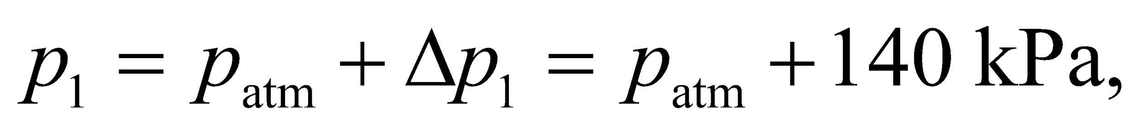 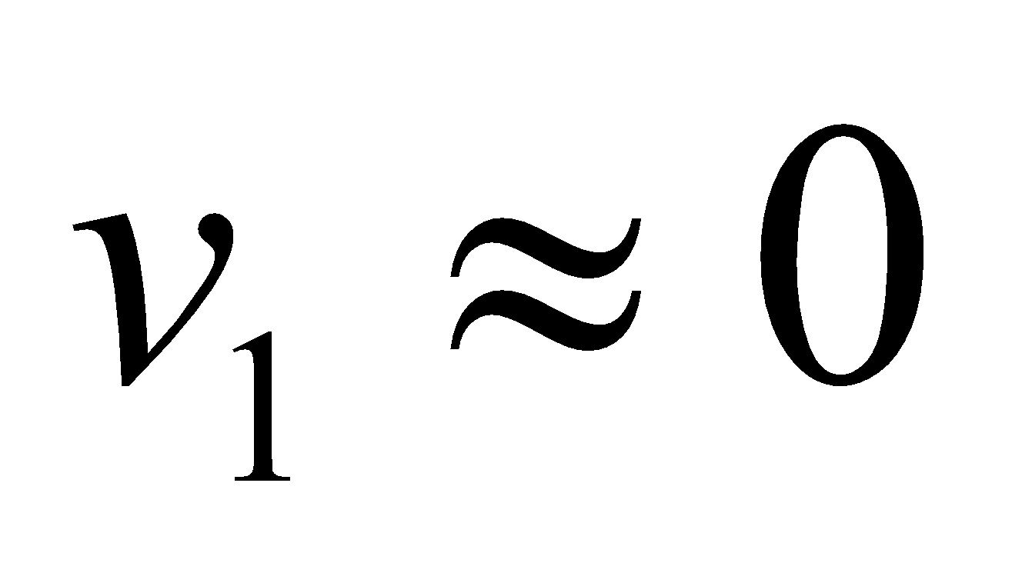 and *y*1 = 0. At the highest point attained by a jet of water emerging from a hole (point 2), 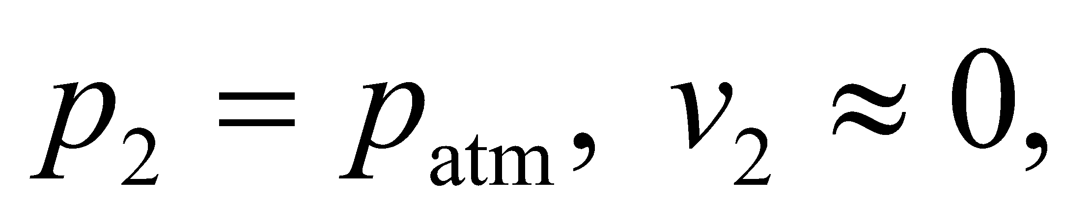 and *y*2 = *h*. We can equate the result of Bernoulli’s equation at points 1 and 2 to find *h*.



**Evaluate** Using Bernoulli’s equation we have

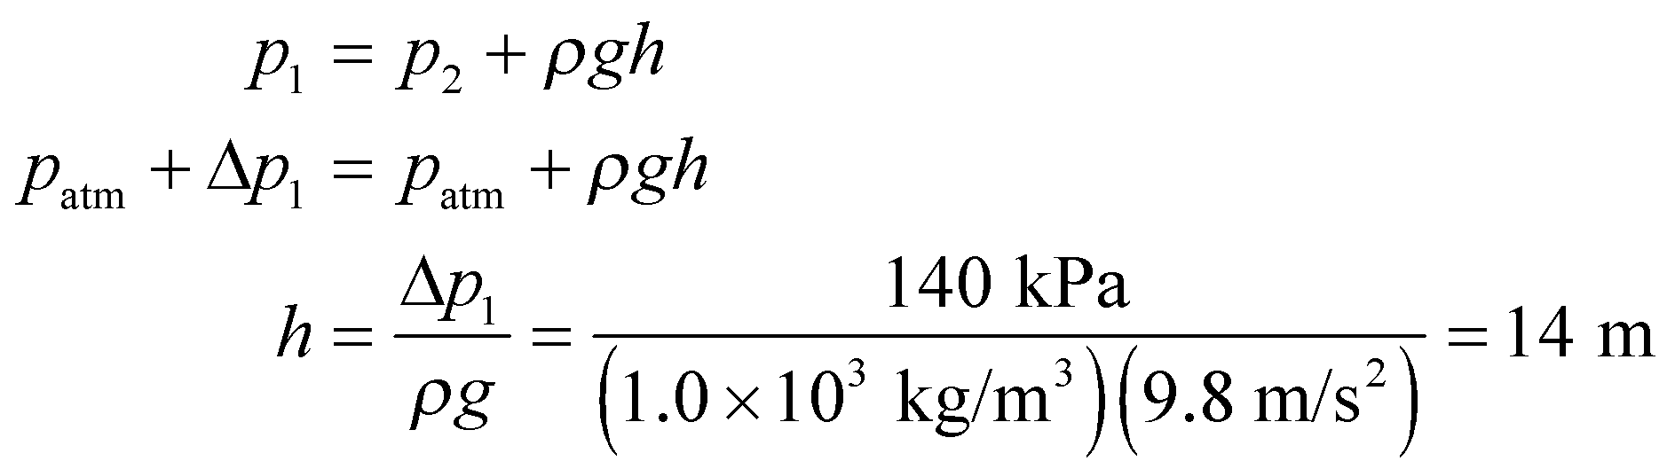

**Assess** At the maximum height, all the work done by pressure has been converted to potential energy of the fluid. Energy is conserved in the process (ignoring dissipative forces such as air resistance).

**56. Interpret** This problem involves the flow of an (essentially) incompressible fluid, so we can apply Bernoulli’s equation to find the volume flow rate of water through the solar collector pipe.

**Develop** Make a sketch of the situation (see figure below) Applying Bernoulli’s equation (Equation 15.6) and the continuity equation (Equation 15.5) to points 1 and 2 in the flowmeter, we can calculate the volume rate of flow:

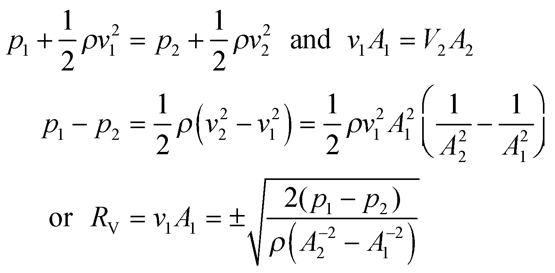

where the positive or negative sign indicates that the flow rate can go in either direction. This is the same calculation as Example 15.7. Note that pressure variation with height in the flowmeter is assumed to be negligible. The pressure difference *p*1 − *p*2 is related to the difference in height *h* and the density of oil *ρ*oil in the manometer (where the fluid is assumed to be stagnant). In terms of the pressure at point 3 (on the left-hand side), the pressure at point 1 may be written as *p*1 = *p*3 + *ρgy*1. Likewise, the pressure at point 2 may be written as *p*2 = *p*3+*ρgy*2 + *ρ*oil*gh*. Subtracting these two expressions gives

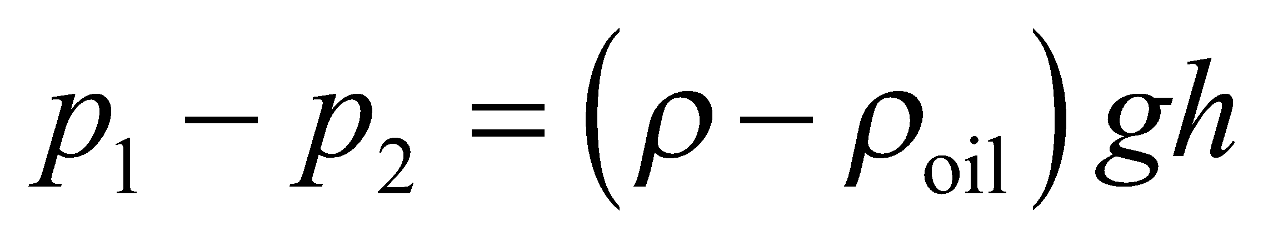

where we have used the fact that *y*1 − *y*2 = *h*.



**Evaluate** Equation Using *A* = *πd*2/4, we find the volume flow rate to be

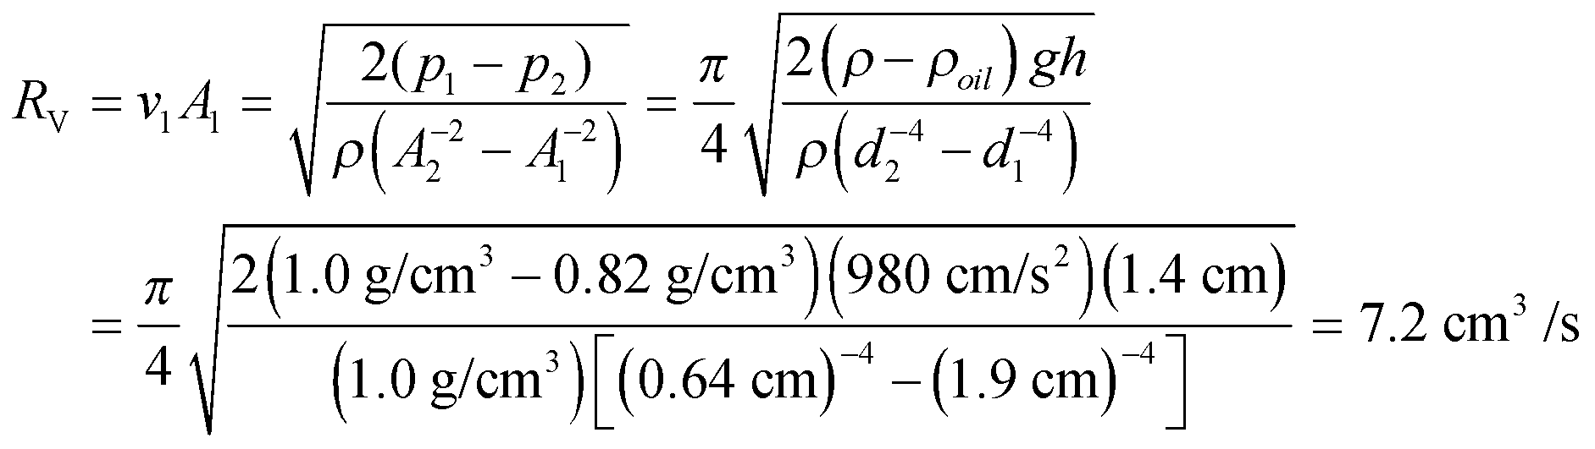

**Assess** Can you convince yourself that the units of this expression are correct?

**57. Interpret**A narrower section is placed in a pipe carrying an incompressible fluid. We are to find the flow speed in the pipe and the volume flow rate, given the pressure difference between the fluid in the pipe and the fluid in the narrow section. We will assume that the flow is non-turbulent, and use Bernoulli’s equation. The velocity is related to the cross-sectional area by the continuity equation.

**Develop** The pressure difference between the venturi and the unrestricted pipe is 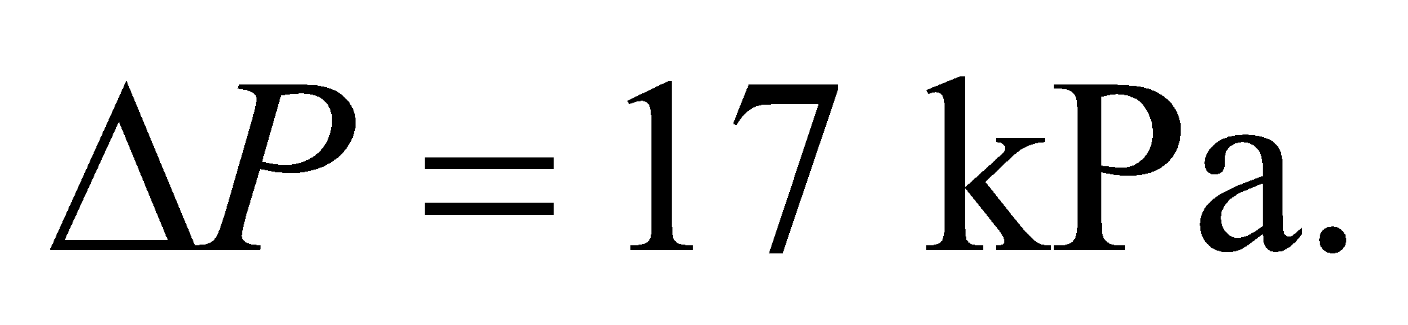 The radius of the unconstricted pipe is 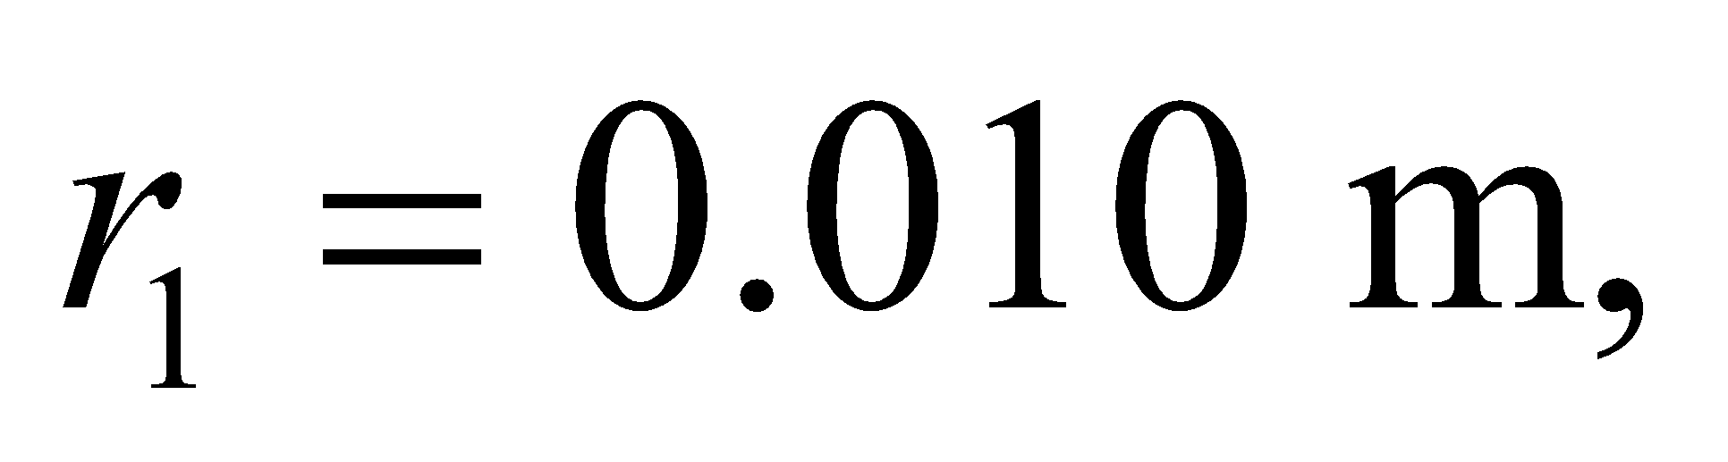 and the radius of the constricted region is 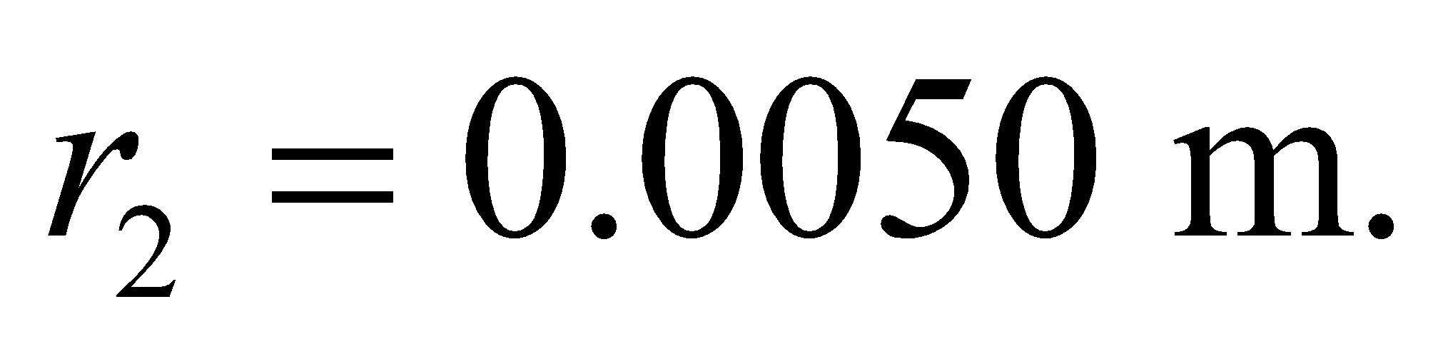 We will assume that any height changes are negligible, and take the density of water to be 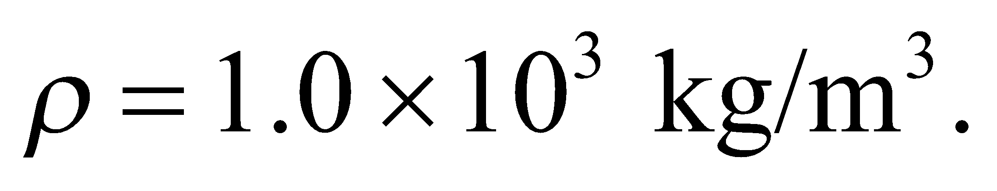 Bernoulli’s equation is 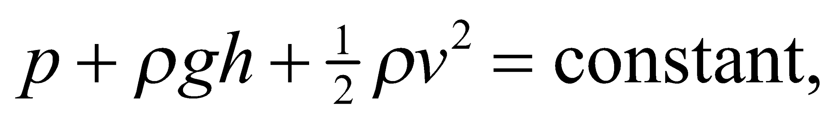 and the continuity equation for incompressible fluids such as water is 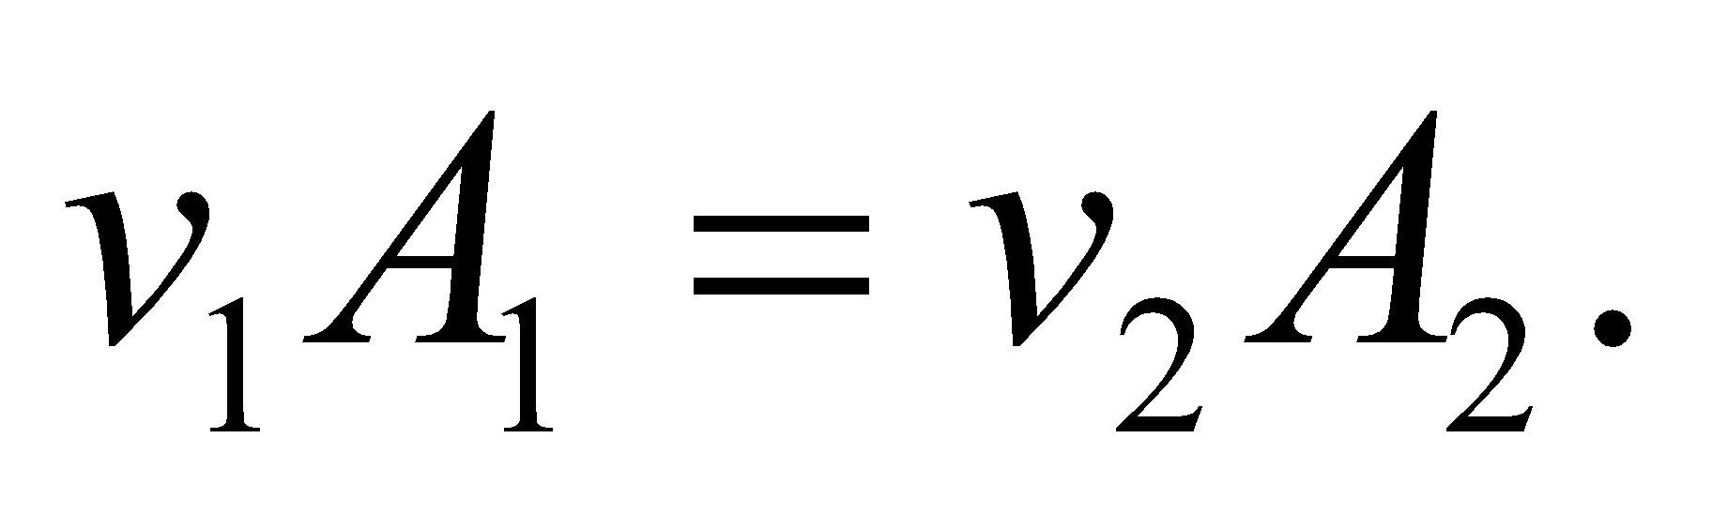 We equate the result of Bernoulli’s equation for the unrestricted pipe equal to that for the restricted pipe, with *h*1 = *h*2.

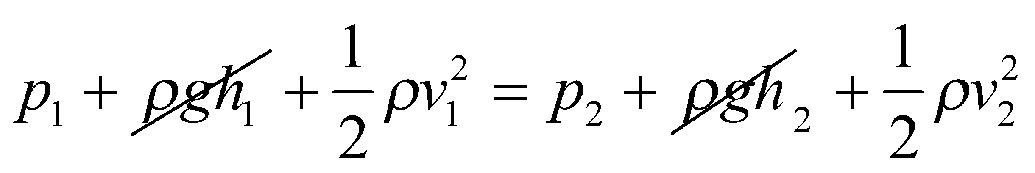

Use the continuity Equaiton 15.5 (for liquid) 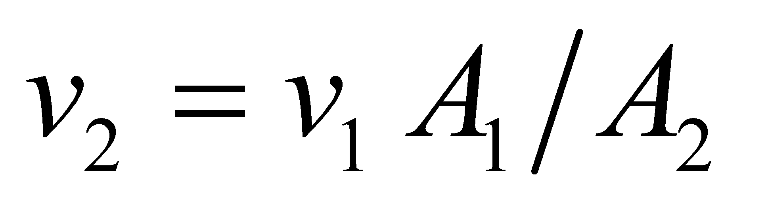 and solve for *v*1:

**Evaluate** **(a)** The flow speed *v*1 of the water is

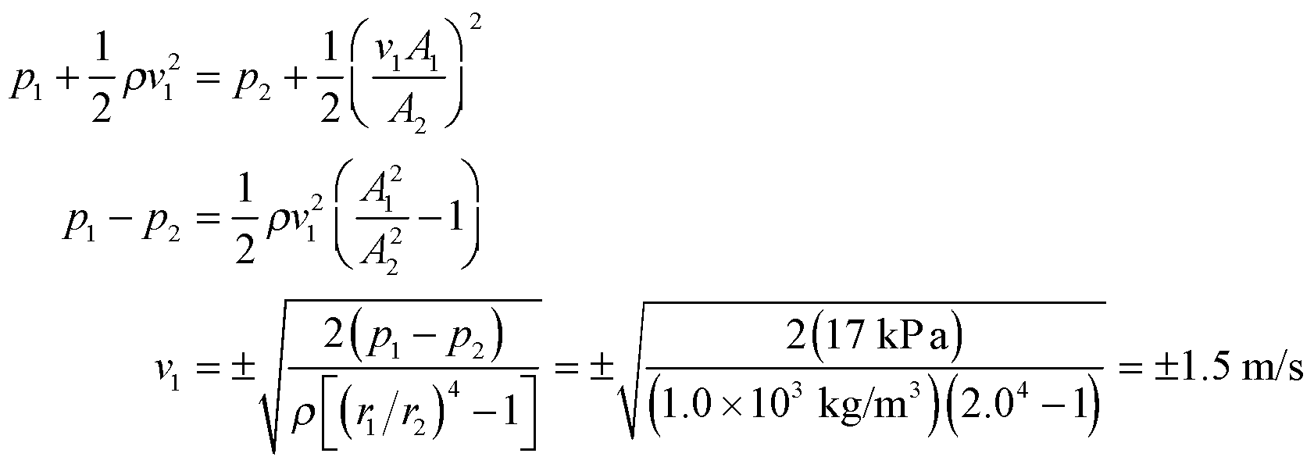

where the positive and negative signs indicate the flow may be in either direction. Without loss of generality, we can use the positive value.

**(b)** To find the volume flow rate, in m3/s, we multiply the flow speed by the area of the pipe, which gives

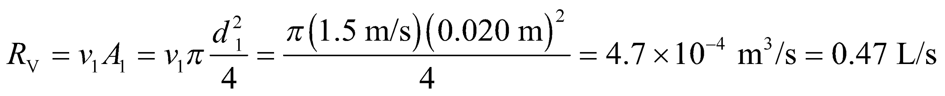

**Assess** Both the flow speed and volume flow rate seem reasonable for a small pipe such as this.

**58. Interpret** This problem involves Archimedes’ principle, which we can apply to the balloon that is submerged in air to find the maximum weight that it can support.

**Develop** For an object submerged in a liquid (we can consider air as a liquid for this problem because there is no motion nearing the speed of sound in air in the problem), the buoyancy force is given by mass of the liquid displaced by the object’s volume, which is

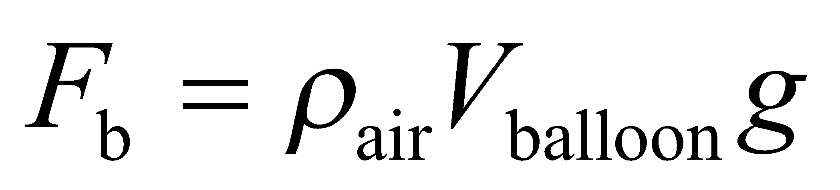

The force due to gravity pulling the balloon toward the Earth is



where *n* is the number of paper clips hanging from the balloon. For the balloon to remain airborne, *F*b > *Fg*, which we can solve for *n*.

**Evaluate** Solving the inequality for n and inserting the given values gives

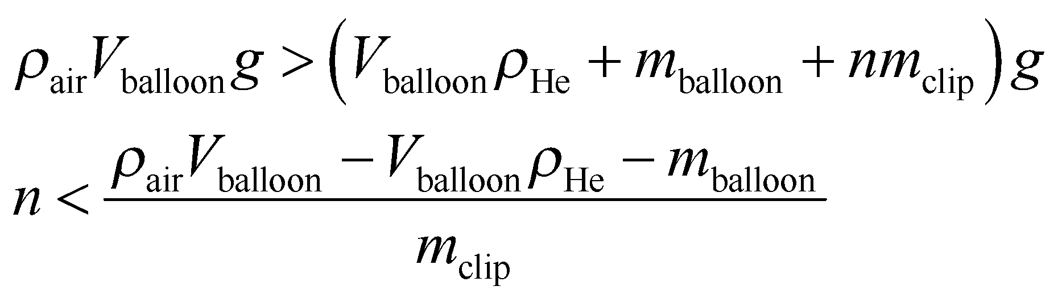

Given that the density of air under standard conditions is *ρ*air = 1.2 kg/m3 and that the *V*balloon = 4*πr*3/3, we have

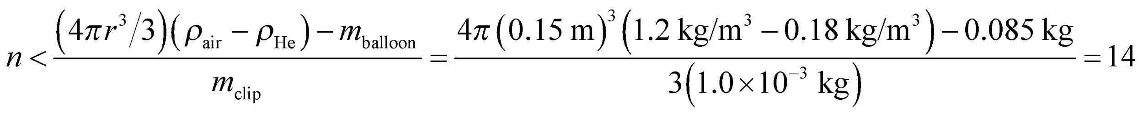

Thus, 14 paper clips will cause the balloon to lose its buoyancy.

**Assess** With 13 paper clips attached, the balloon will rise until its average density equals the density of the surrounding air. Note that we have neglected the volume of the paper clips and of the rubber that makes up the balloon, both of which experience a small buoyancy force of their own.

**59. Interpret** This problem deals with blood flow through an artery that is obstructed by a plaque.

**Develop** We'll assume there's no appreciable change in the gravitational potential, so Bernoulli's equation can be written as:



We're told that the pressure drops by 5%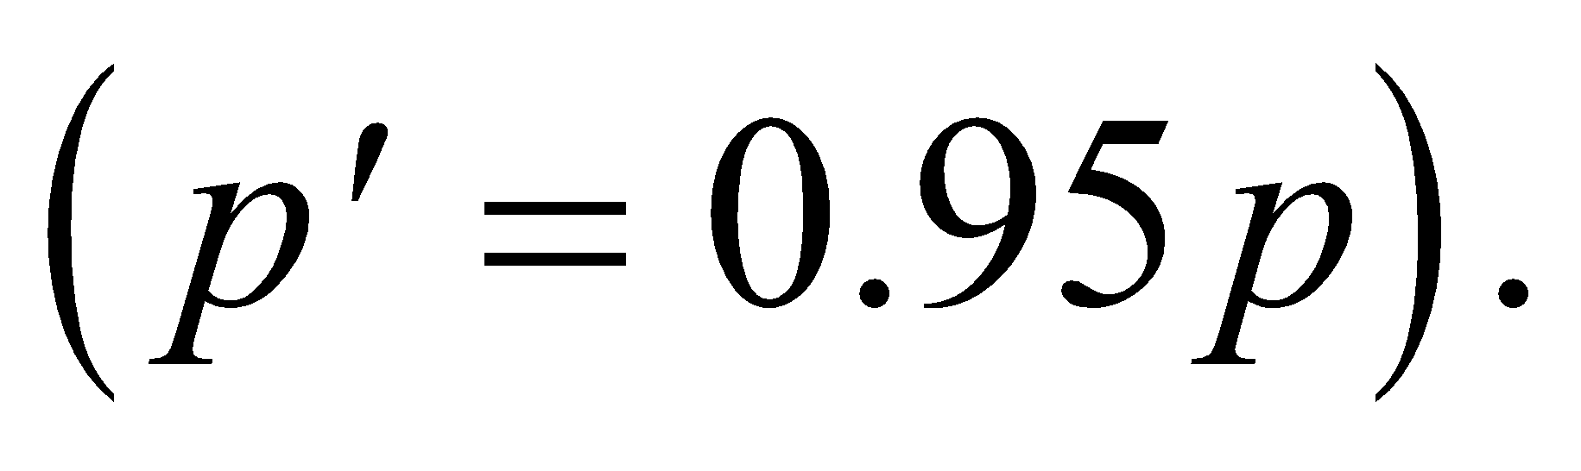 The blood flow can be approximated by the continuity equation,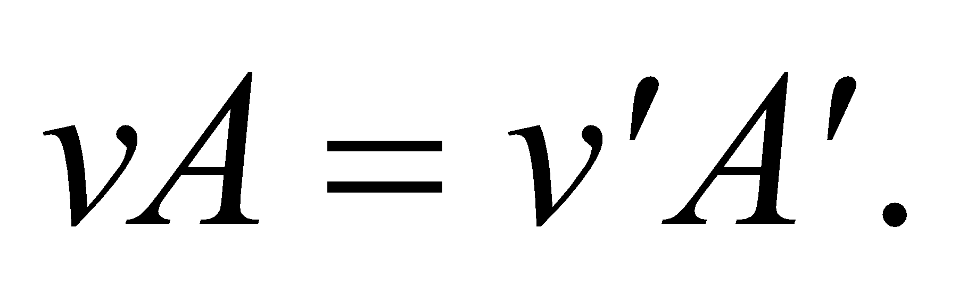 We are given *p*, 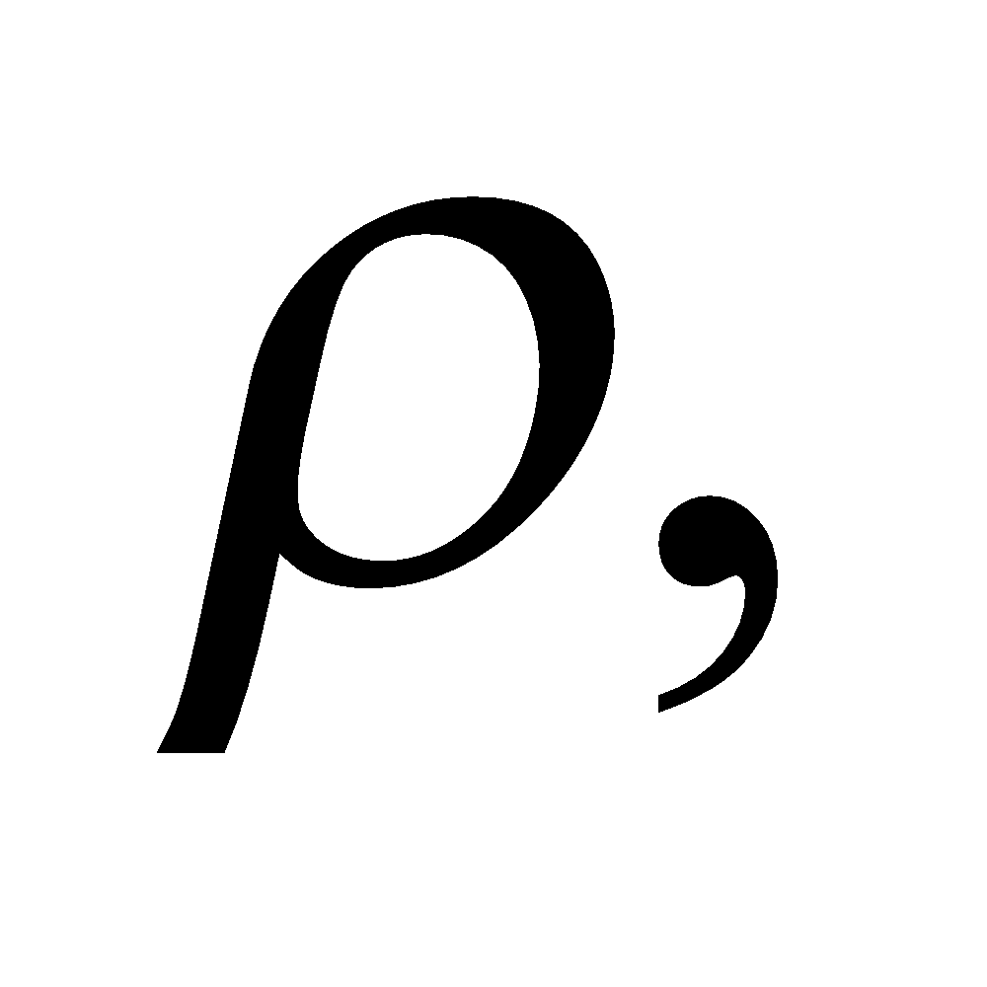and *v*, and we want to find the fraction of the area that is obstructed: 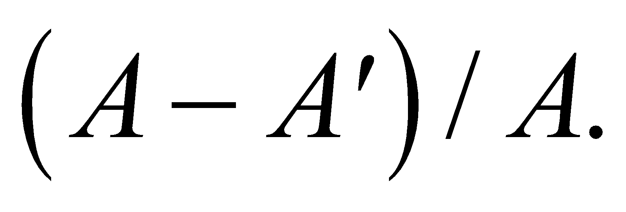

**Evaluate** Putting together the information that we have:

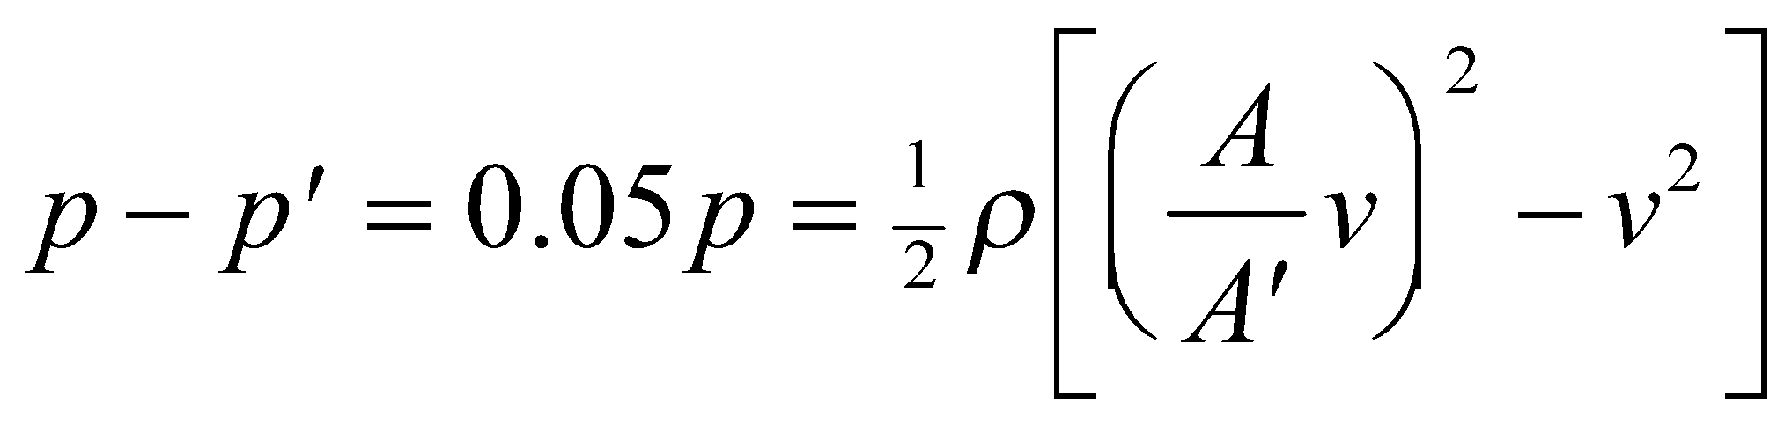

Rearranging the terms, the fraction of the area that is obstructed is

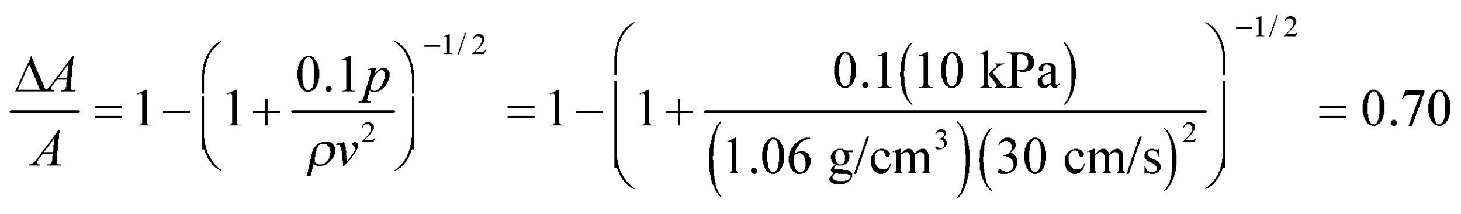

**Assess** This is a rather large blockage, but surprisingly the pressure only drops by 5%.

**60. Interpret** This problem involves the flow of an incompressible fluid through a pipe of varying diameter, so we can apply Bernoulli’s equation to find the density of the fluid.

**Develop** This problem is identical to Problem 15.57, except that we are given the pressure difference p1 − p2 and are asked to find the density of the fluid in the pipe. In that problem, we derived the relationship

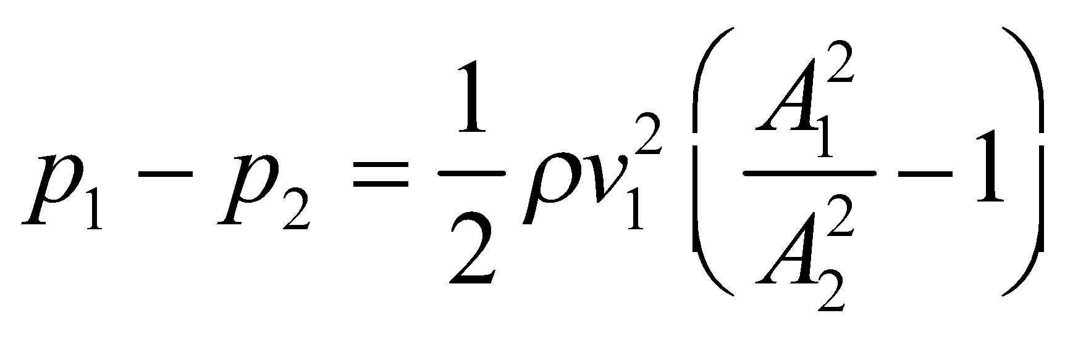

which we can solve for the density *ρ* of the oil. For this problem, the subscripts 1 and 2 refer to the unconstricted pipeline and the venturi, respectively.

**Evaluate** The density *ρ* of the oil is

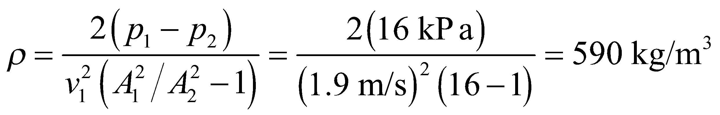

**Assess** This density is about half that of water, which seems reasonable.

**61. Interpret** This problem involves flow of juice which we take to be an incompressible fluid. We apply both the continuity equation and Bernoulli’s equation to solve the problem.

**Develop** For steady incompressible fluid flow, the continuity equation (Equation 15.5) is

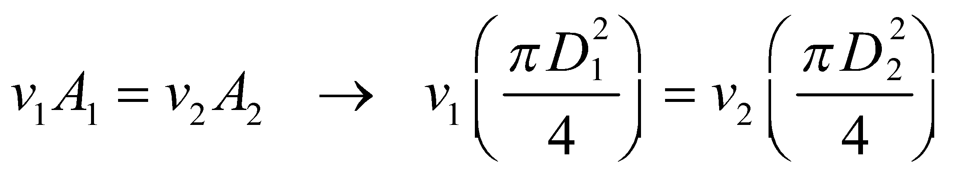

and Bernoulli’s equation reads

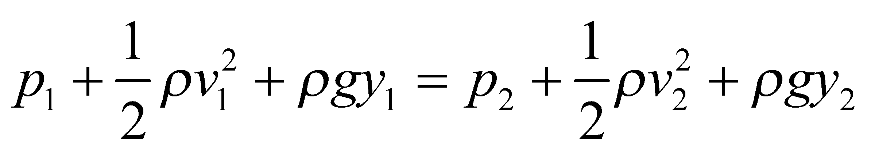

Eliminating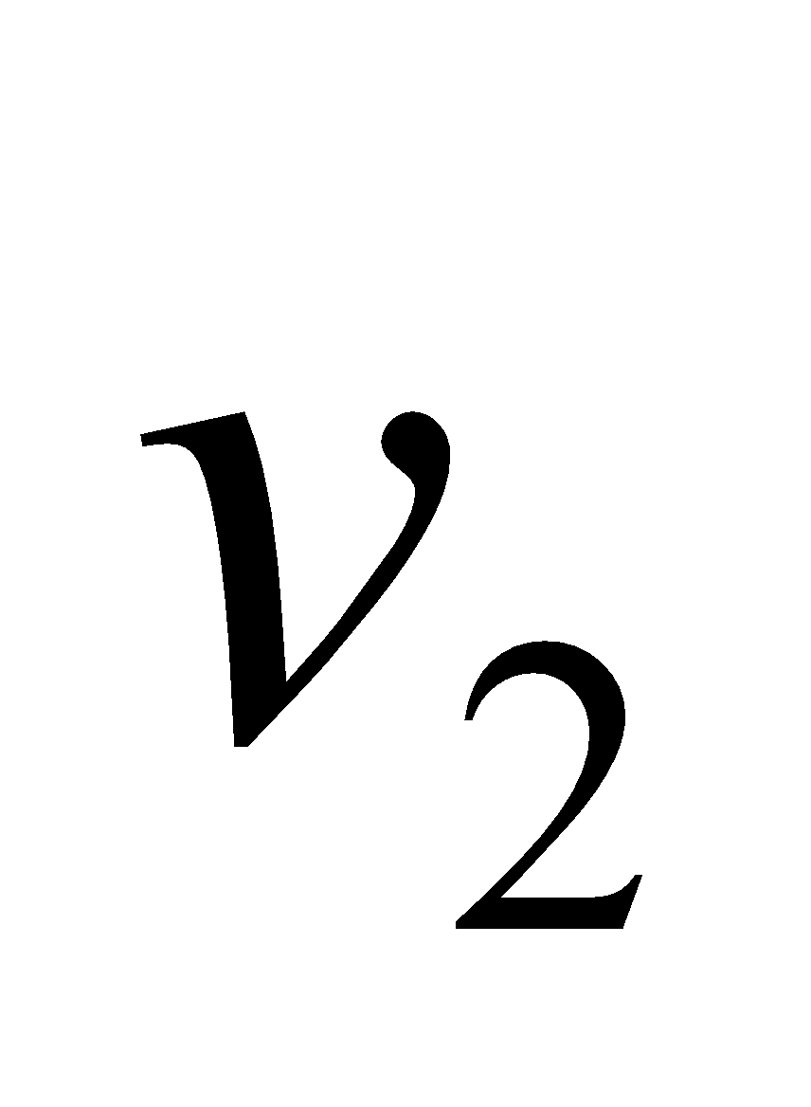using the first equation, we obtain

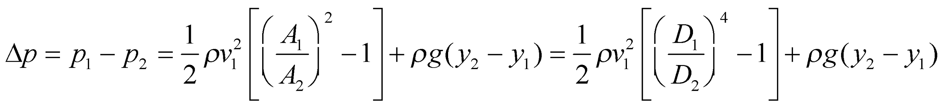

**Evaluate** **(a)** We assume the juice density to be that of water. When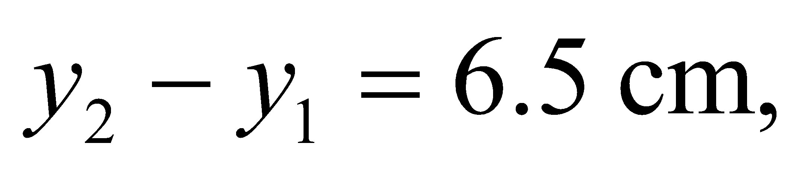the pressure difference is

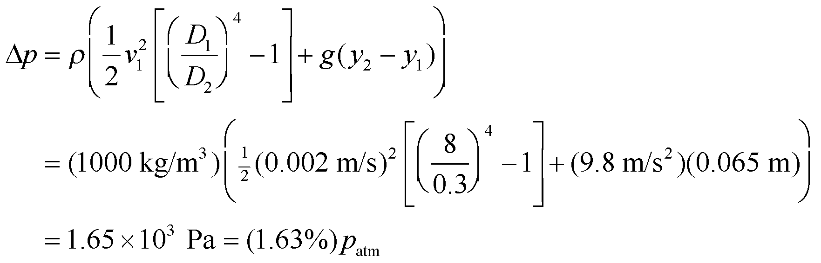

Therefore, the pressure in the mouth is 98% less than atmospheric pressure.

**(b)** For a constant pressure difference, 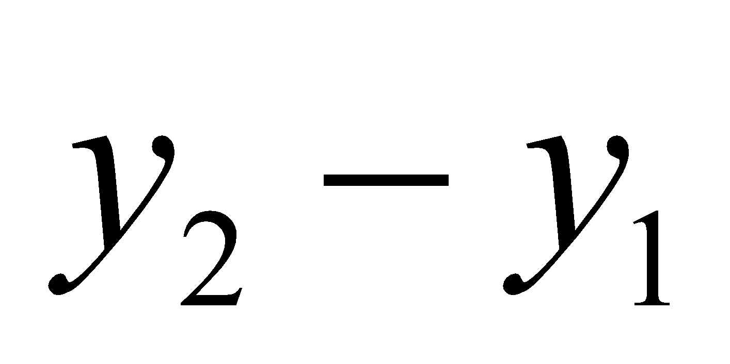attains its maximum value when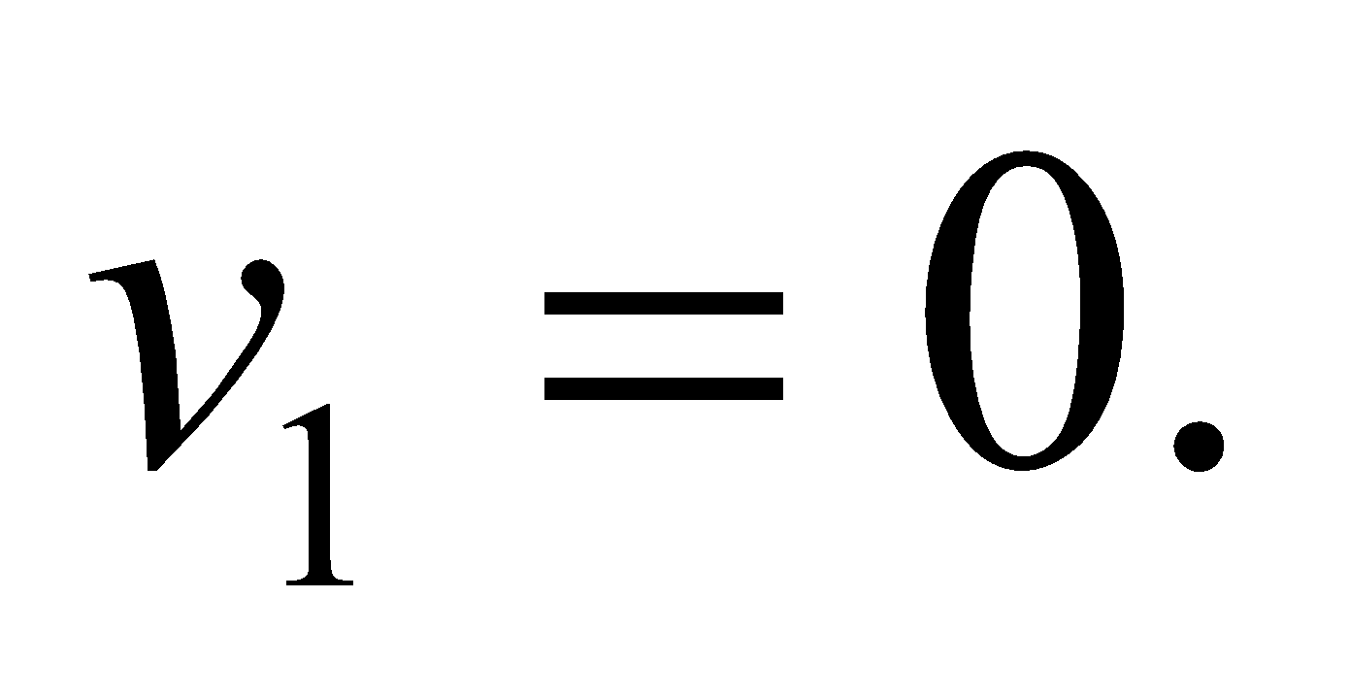Thus,

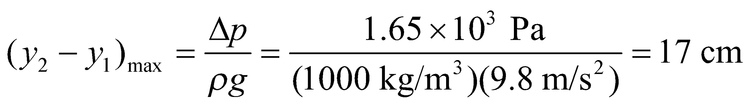



**Assess** As the juice level drops, the pressure difference and/or flow speed may change.

**62. Interpret** This problem involves the continuity equation for liquid flow (i.e., Equation 15.5), which we can use, combined with kinematics, to find the expression for the diameter of the falling water column.

**Develop** The water experiences constant acceleration (ignoring air resistance) due to the force of gravity, and it falls in a straight line, so we can apply Equation 2.11 to describe its speed. For this problem, the acceleration is *a* = *g* (taking the downward direction to be positive) and the distance traveled is *x* − *x*0 = *h*, so the Equation 2.11 takes the form

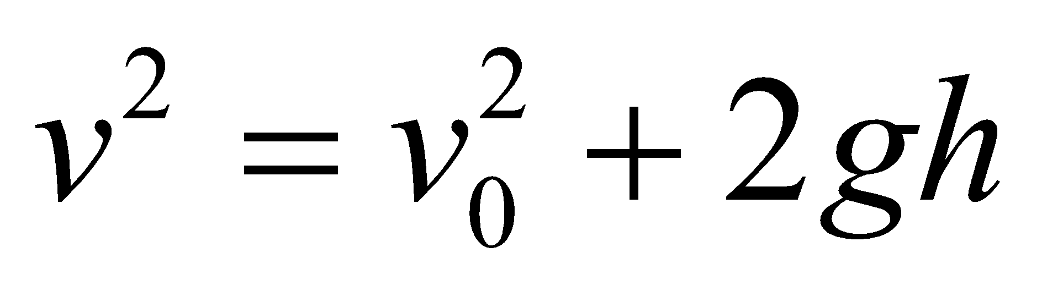

The continuity Equation 15.5 gives

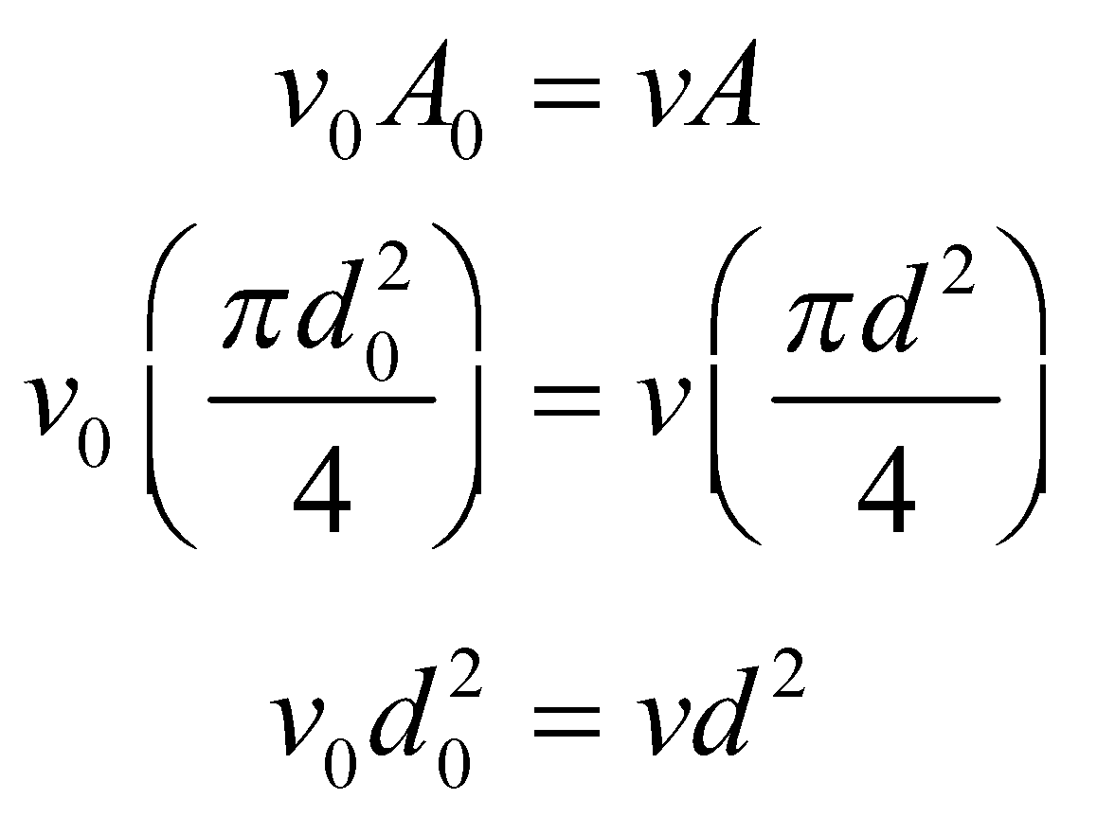

where the diameters are as shown in the sketch below. Combine these expressions and solve for *d*.



**Evaluate** The diameter *d* of the water column is

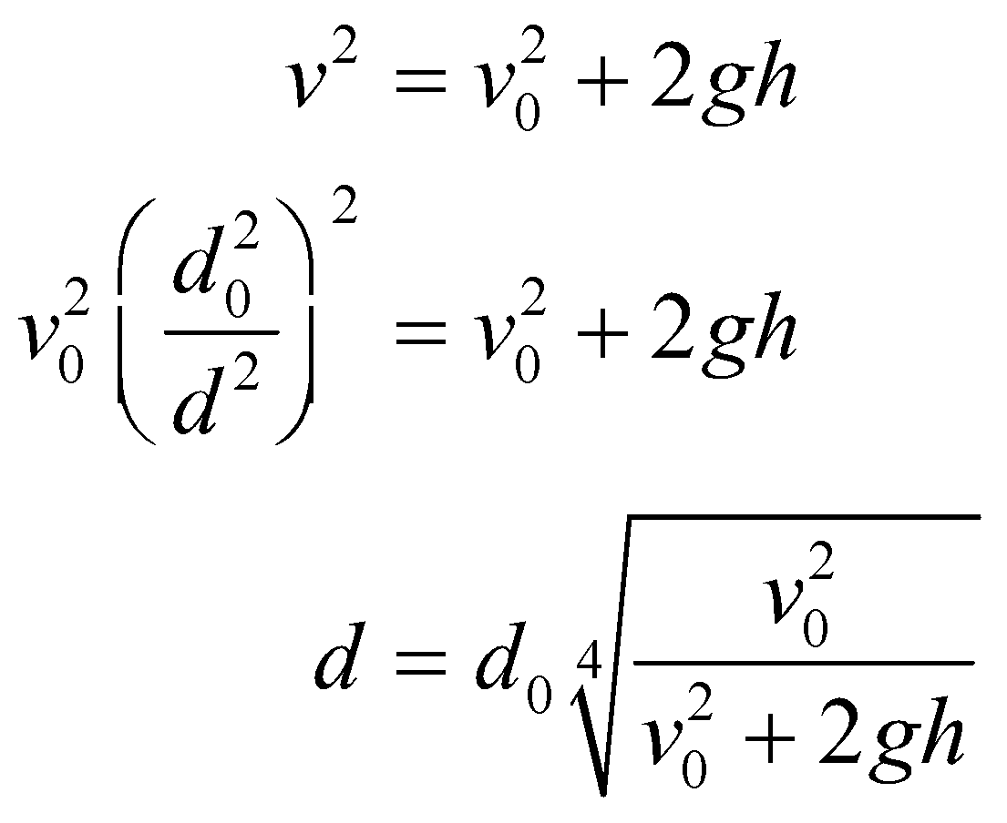

**Assess** If *v*0 = 0, this expression reduces to *d* = 0, which is nonphysical. The reason for this is that the water cannot have zero velocity and still pour out of a fawcet.

**63. Interpret** This problem involves finding the force on a suction cup due to atmospheric pressure. Given this force, we can find the force due to friction that allows the suction cup to support objects.

**Develop** The normal force on the suction cup is the result of atmospheric pressure. We assume a perfect vacuum inside the cup. The force *f*s due to static friction that supports the object of mass *m* must satisfy

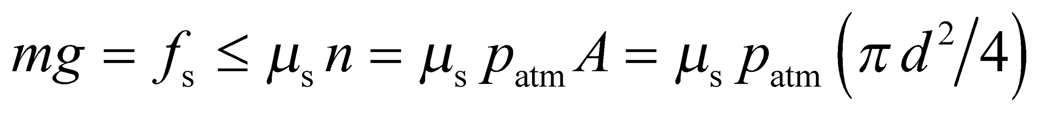

**Evaluate** The maximum mass that can be supported by the suction cup is therefore

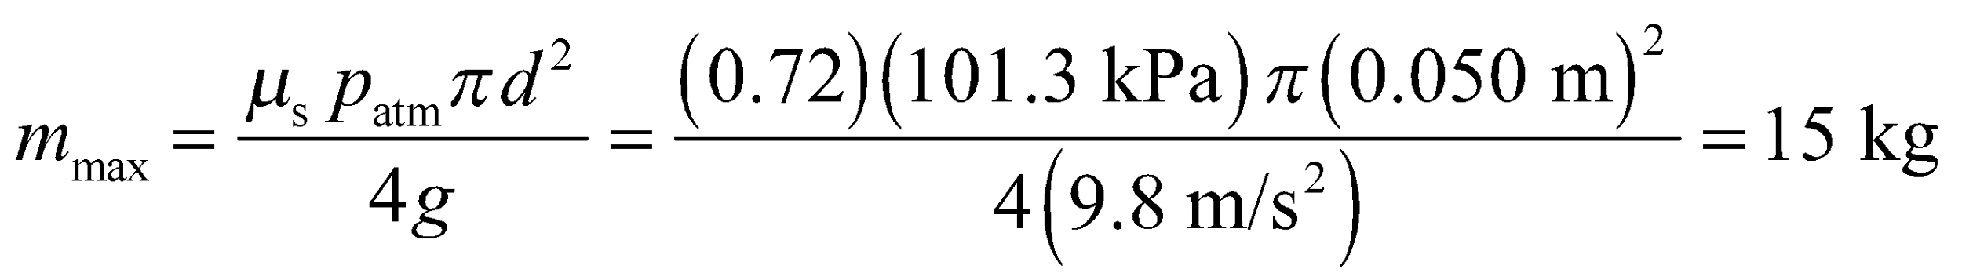

**Assess** The maximum value of 15 kg is about the mass of a toddler. The force on the cup due to the atmospheric pressure is quite large.

**64. Interpret** This problem involves the flow of air at a speed much below the speed of sound in air, so we can apply Bernoulli’s equation to find the speed of the air flowing past point A.

**Develop** We can assume that any difference in height between *A* and *B* is negligible, and we know that *vB* = 0, so applying Bernoulli’s Equation 15.6 to points *A* and *B* and equating the results gives 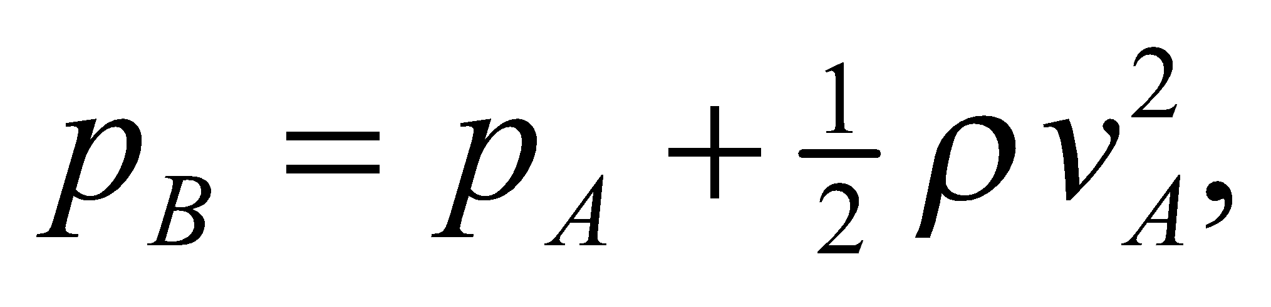 which we can solve for *vA*.

**Evaluate** The air speed at point A is thus 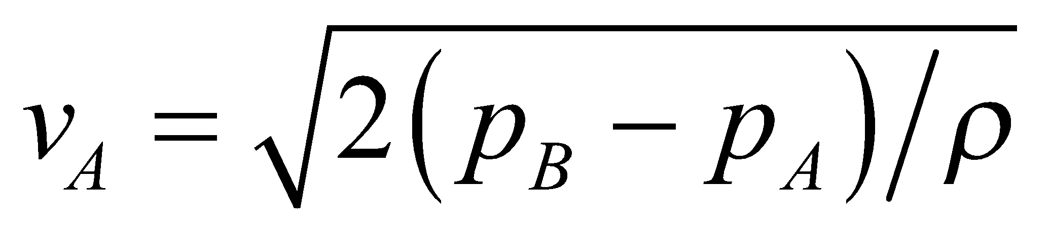

**Assess** Even though Equation 15.6 applies strictly to incompressible steady fluid flow, density variations in a gas are generally insignificant when the flow speed is much less than the speed of sound.

**65.** **Interpret** You want to verify the power output of a proposed wind farm.

**Develop** From the text, you know that the theoretical maximum power per unit area that can be extracted from the with wind is 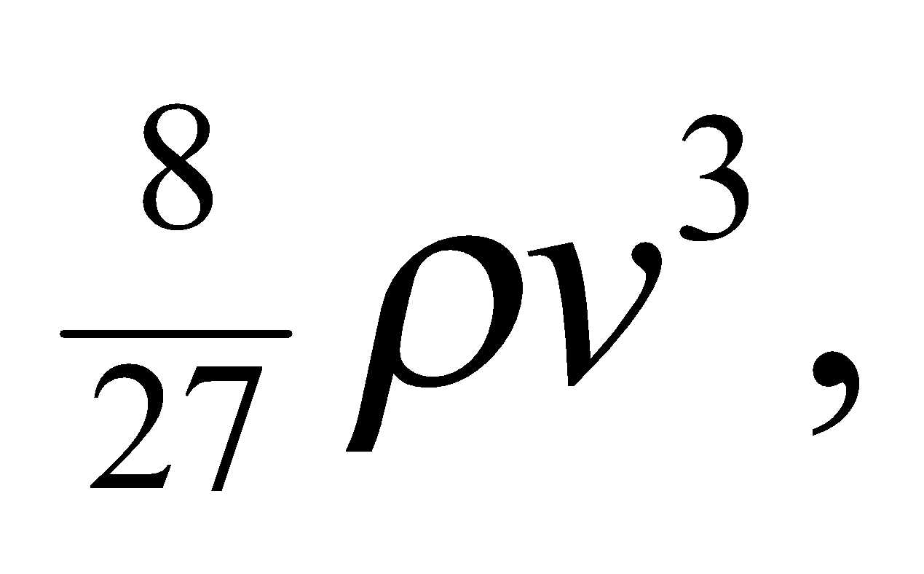where the air density is given by 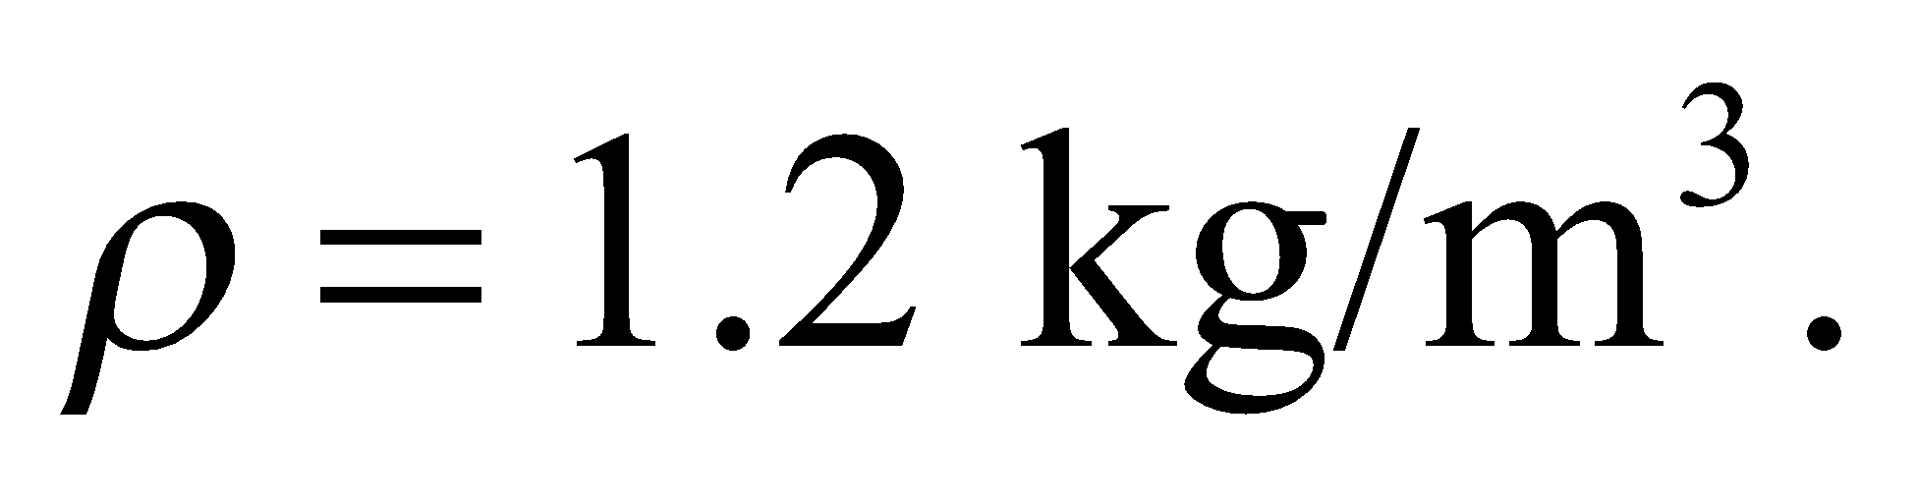The plan is to build a 800 turbines, each with blade diameter of 95 m, in a area where the average wind speed is 12 m/s.

**Evaluate** If you assume that the turbines on average generate 30% of the theoretical maximum power, the total power that the wind farm could produce is



Yes, the wind farm could conceivably replace a 1-GW nuclear power plant.

**Assess** Even if the wind farm can on average generate the desired power, there will be fluctuations in the output due to changing weather conditions. Utility companies are still reluctant to entirely abandon coal and nuclear, which supply a more stable baseline of power.

**66. Interpret** This problem involves the buoyancy force and simple harmonic motion (see Chapter 13). The pencil is never completely submerged, so we can apply Archimedes’ principle for floating objects to calculate the force as a function of submersion depth, then apply the concepts of simple harmonic motion to find the period of the pencil’s oscillation.

**Develop** Make a sketch of the situation (see figure below). The two vertical forces (taking the downward direction to be positive) on the pencil are its weight, *mg*, and the buoyancy force *F*b = −*ρgAy*, where *A* is the cross-sectional area of the pencil and *y* is it submersion depth. Thus, the vertical component of Newton’s second law (for constant mass) is 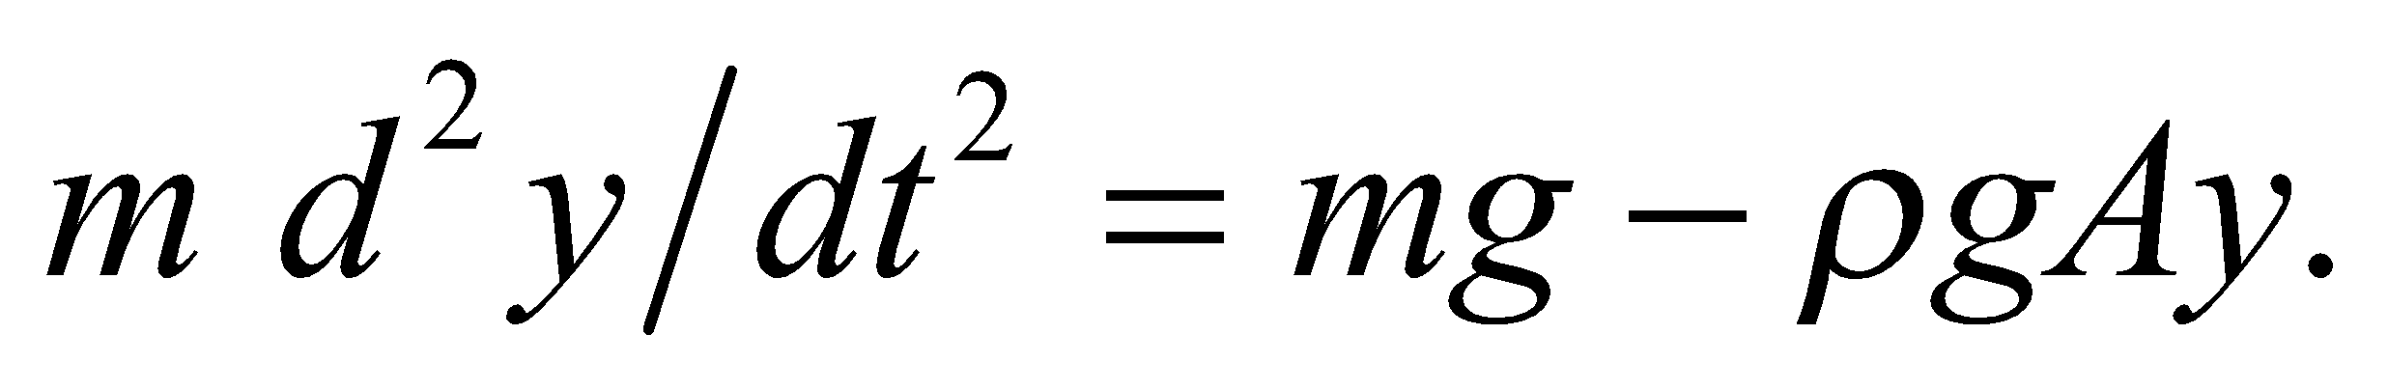 At equilibrium, *mg* = *ρgAL*, so the equation of motion, written in terms of the displacement from equilibrium, is 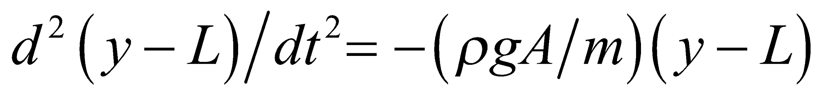. Compare this formula to Equation 13.3 to find the effective force constant and, from that, the period.



**Evaluate** Equation 1.3.3, which is Newton’s second law for simple harmonic motion, reads

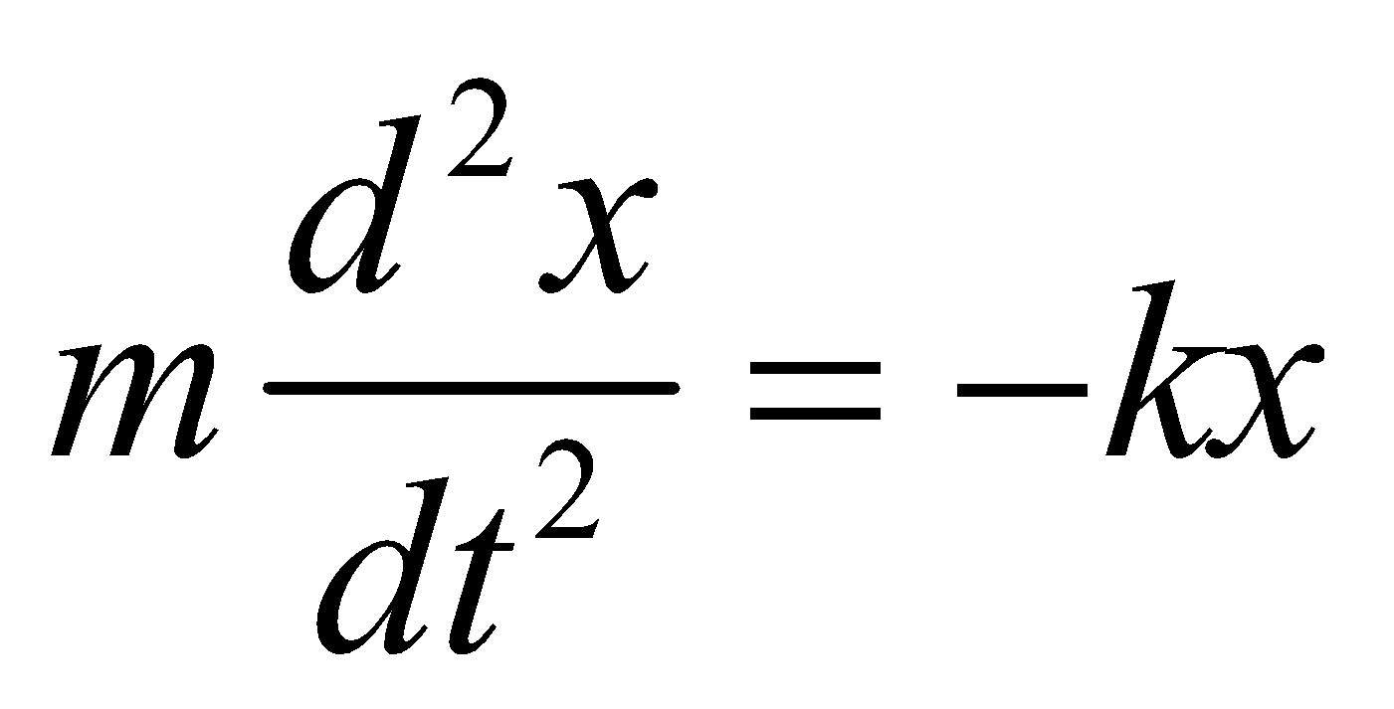

Comparing this to the expression derived for the pencil shows that *x* = *y* − *L* and *k* = *ρgA* = *gm*/*L* because *ρ* = *m*/(*AL*), so from Equation 13.7a and 13.5, we find

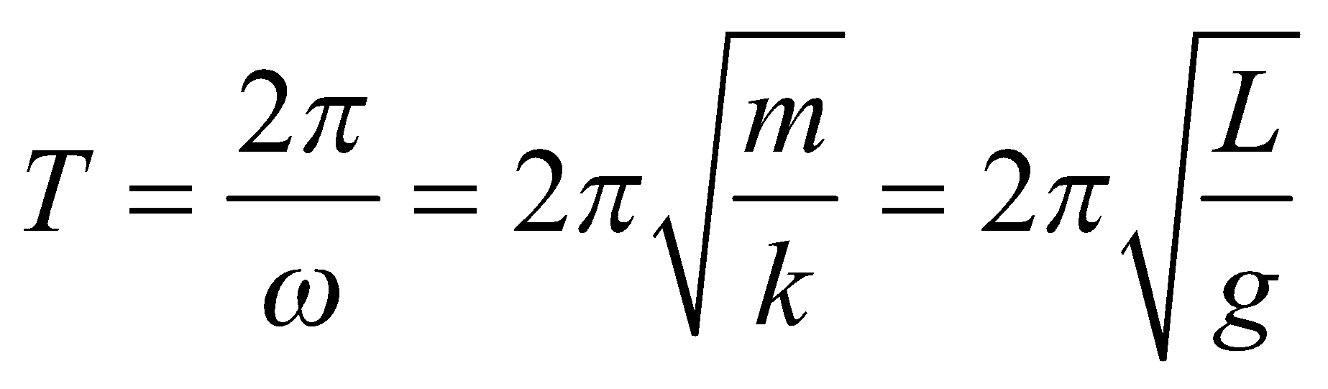

**Assess** This formula says that the period does not depend on the mass of the pencil, nor on its diameter, but only on its length (and the acceleration due to gravity, but that is essentially constant on the surface of the Earth).

**67. Interpret** In this problem we want to find the time it takes for the can to drain out all its water through its hole. An integral is needed since the water level is continuous, from 0 to height *h*.

**Develop** Let *y* be the height of the water above the bottom of the can, then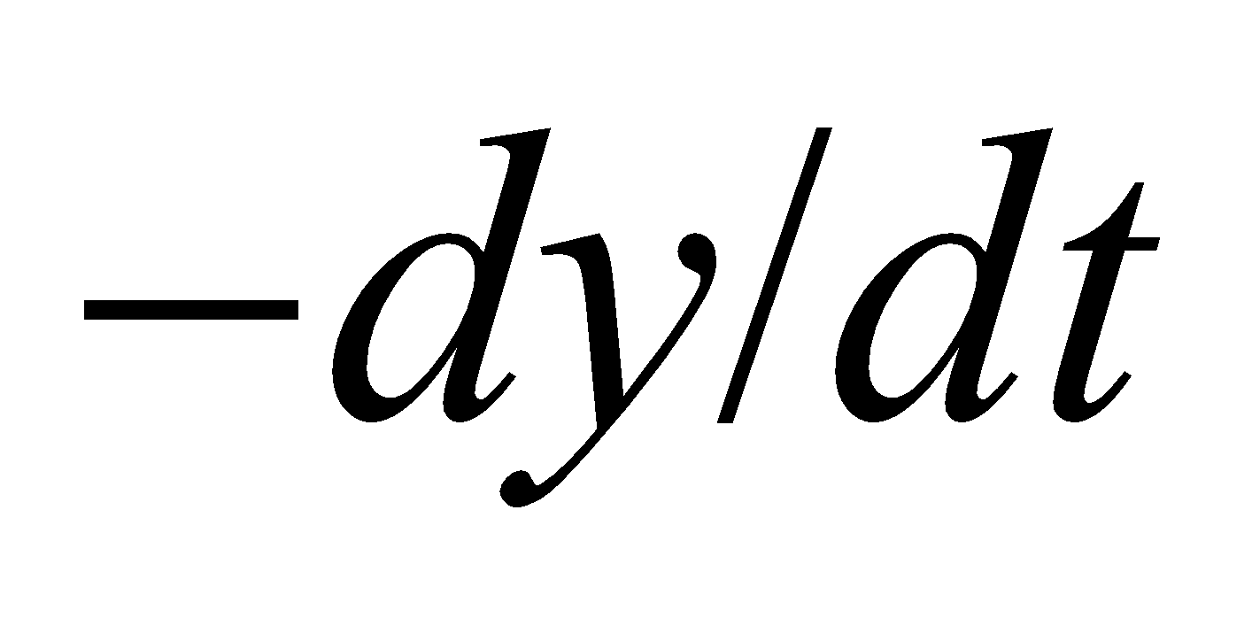is the magnitude of the flow speed of the top surface of the water draining out (*y* decreases as a function of time). The continuity equation gives

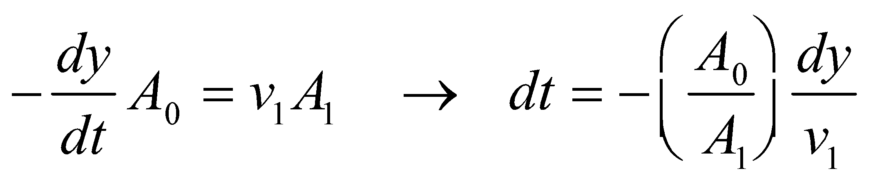

where subscript 1 refers to the small hole in the bottom. For most of the time,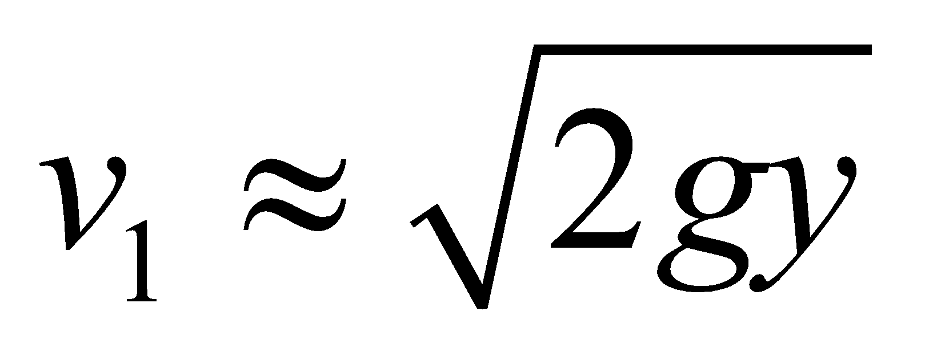(see Example 15.6) and we assume the top of the can is open).

**Evaluate** Carrying out the integration, we find the total time required to be

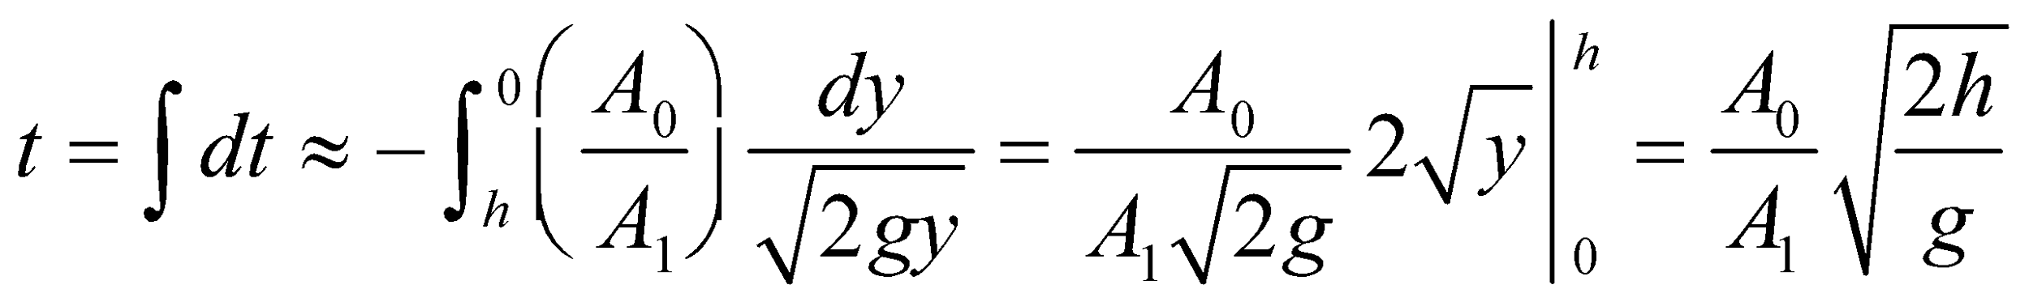

**Assess** This result is approximate since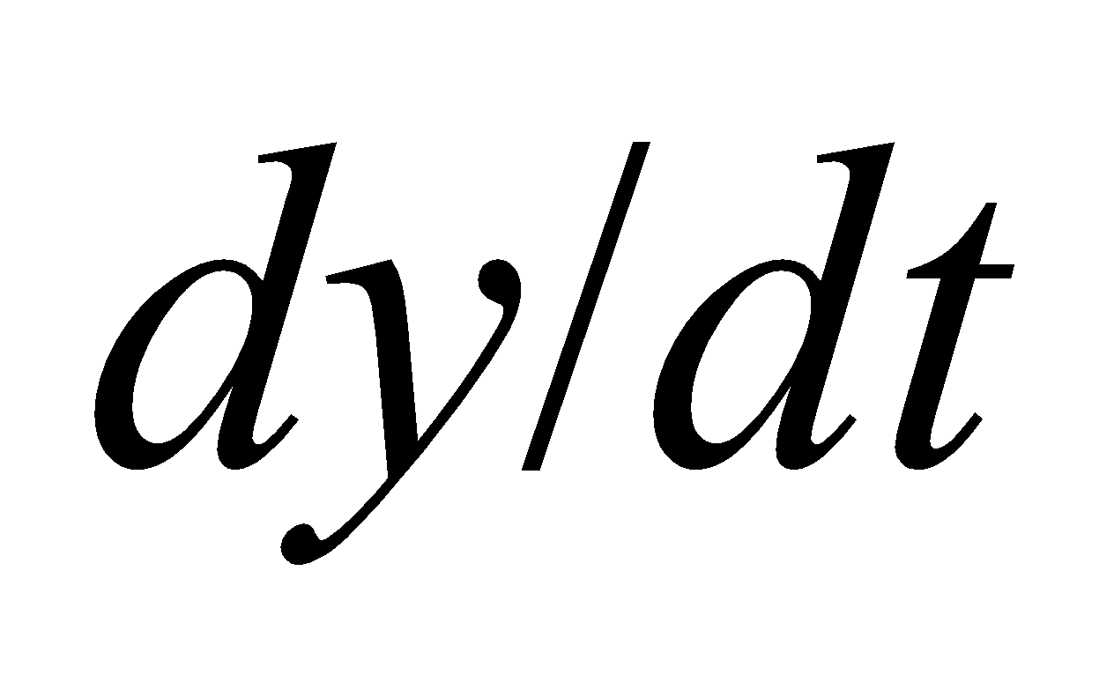cannot be neglected compared to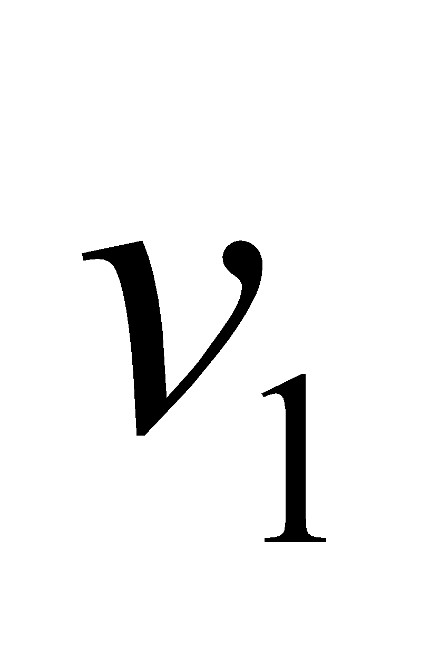when *y* is small. If we use Bernoulli’s equation without this approximation, then

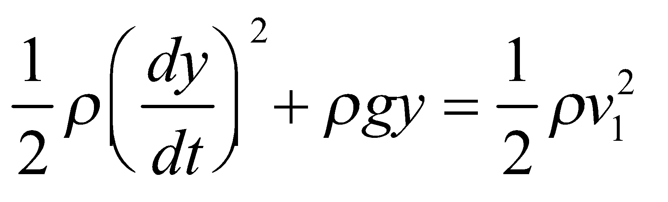

since the pressure is atmospheric pressure at both the top of the can and the hole. Combining with the continuity equation gives

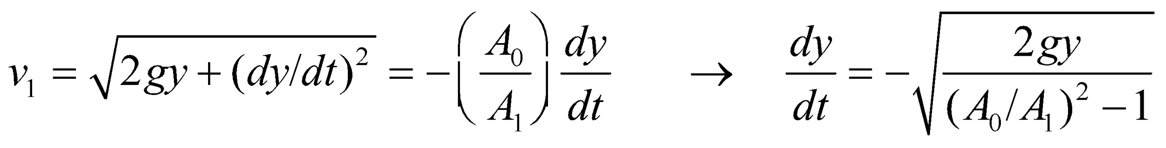

Integration of this yields a more exact outflow time of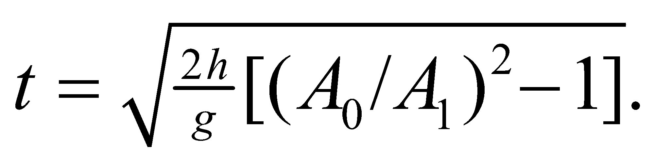

**68. Interpret** Using the fact that the density and pressure in Earth’s atmosphere are proportional: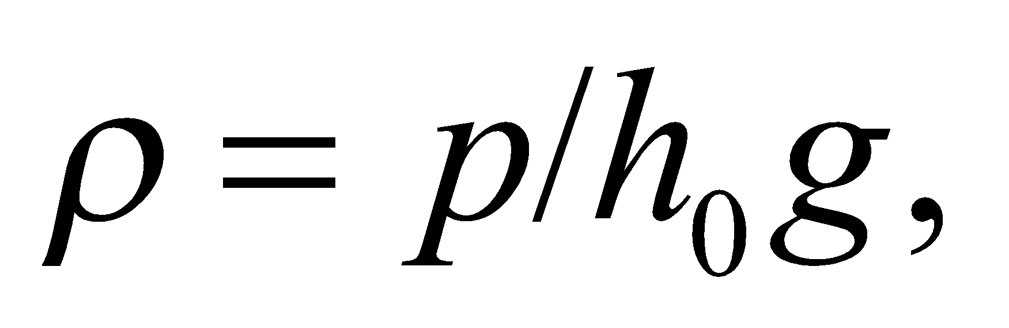where

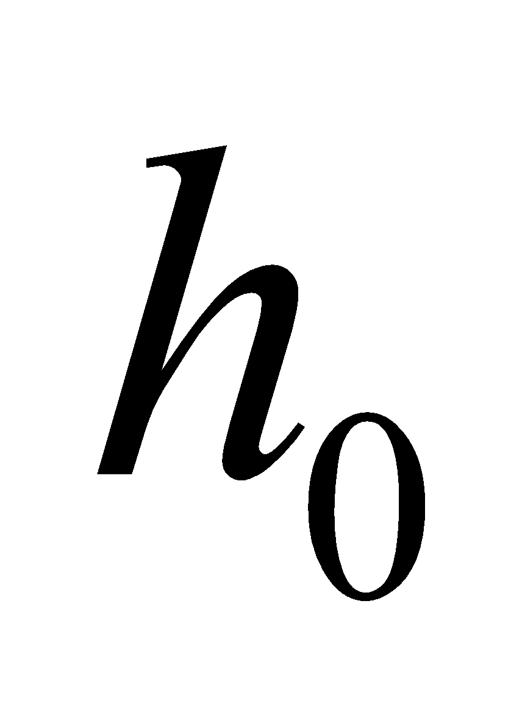is a constant, we want to find the atmospheric density as a function of height.

**Develop** The variation of pressure with height in the Earth’s atmosphere follows from Equation 15.2 (with *h* replaced by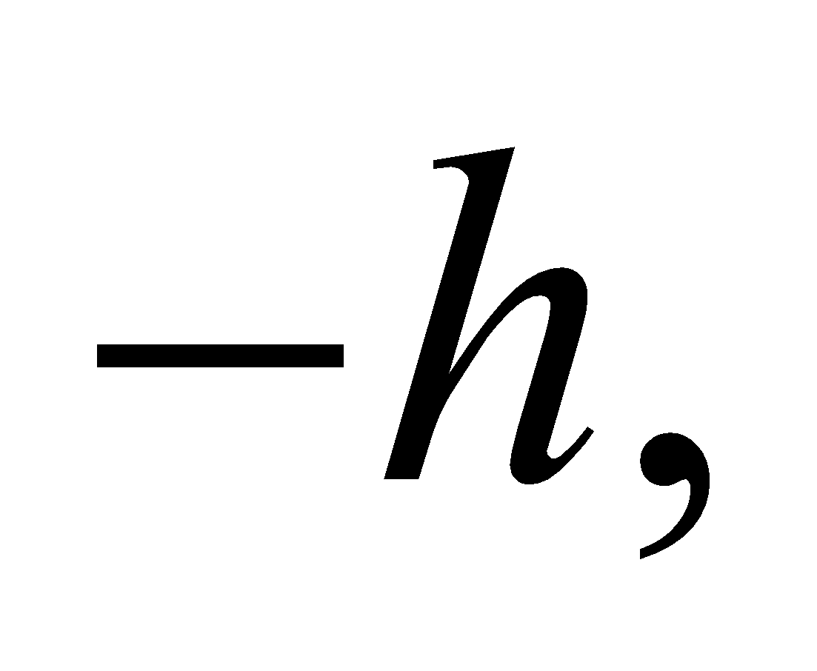since height is positive upward whereas depth is positive downward). Thus, 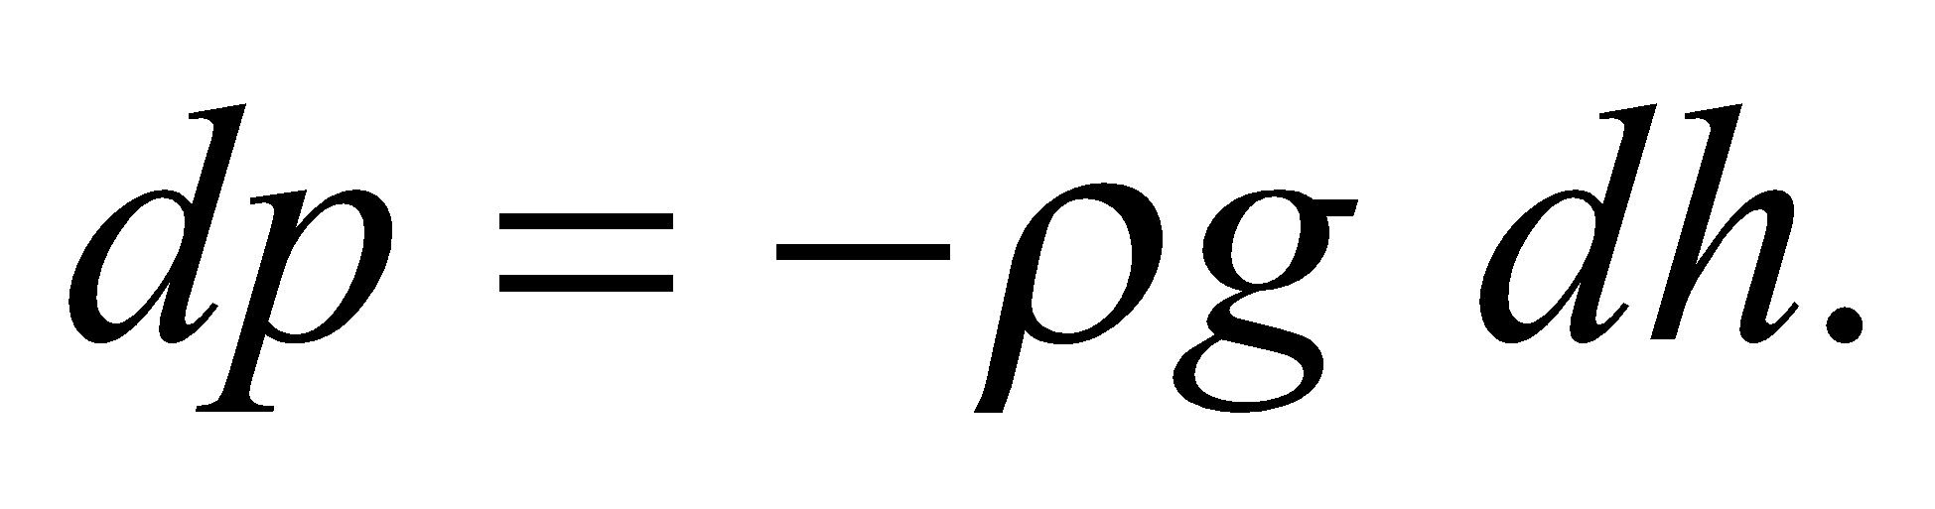 If pressure and density are proportional, then

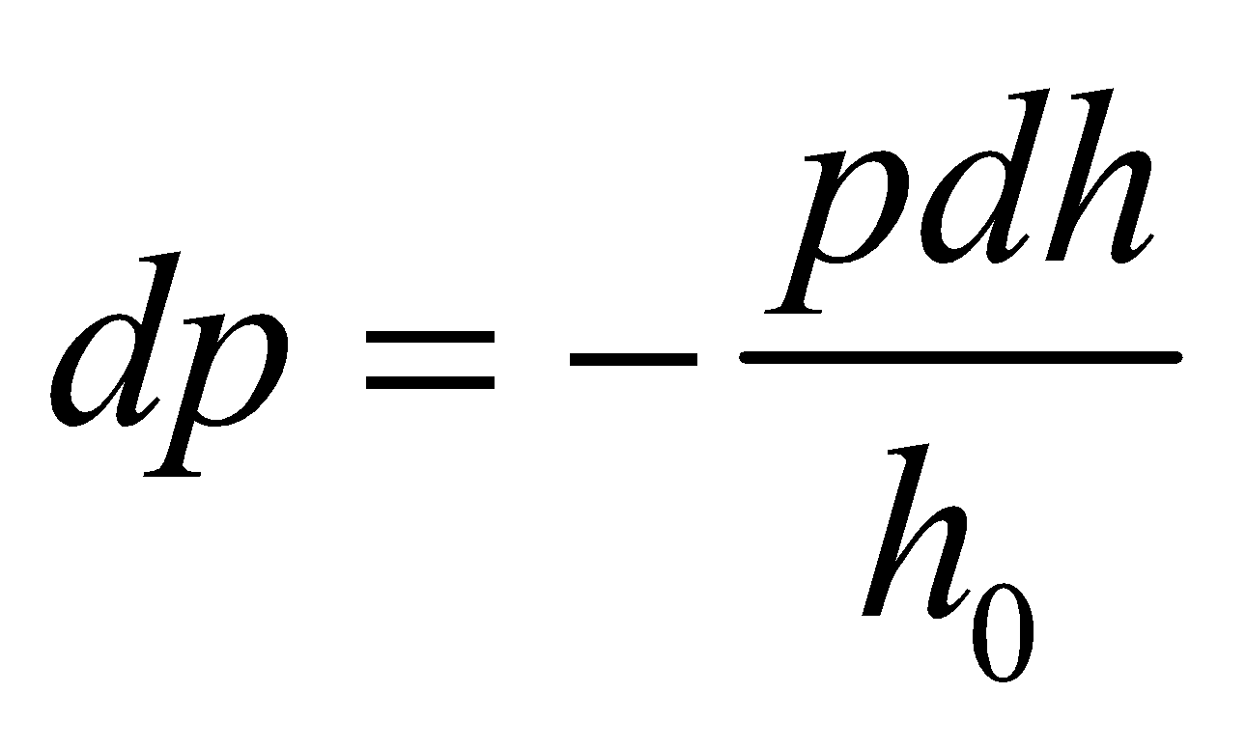

Integrating this expression yields pressure as a function of height *h*.

**Evaluate** **(a)** The above equation can be integrated from the surface values, *h* = 0 and *p* = *p*a (atmospheric pressure) to yield

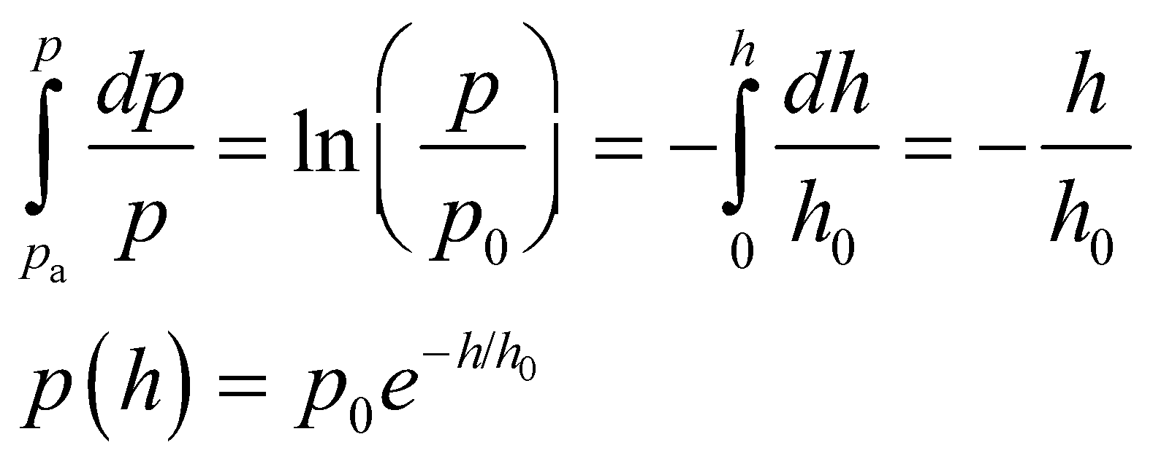

This is called the law of atmospheres; it applies exactly if the temperature is constant.

**(b)** The pressure will drop to half its surface value when *p*(*h*) = *p*0/2, or

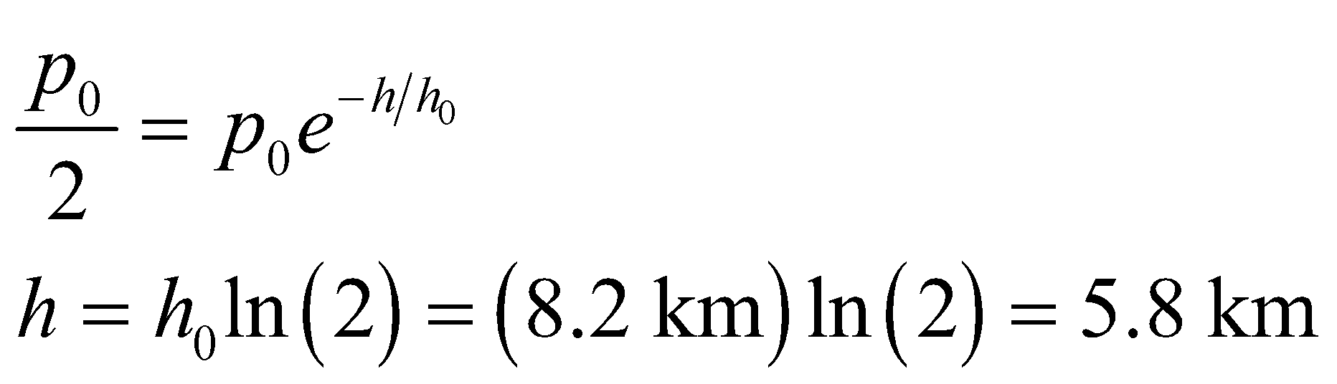

**Assess** Given that three quarters of the Earth’s atmosphere is within 11 km of the surface of the Earth, this result seems reasonable.

**69. Interpret** Using the fact that the density and pressure in Earth’s atmosphere are proportional, we are to use the result of the previous problem to express the atmospheric density as a function of height and to find the height below which half the Earth’s atmospheric mass lies.

**Develop** From Problem 15.68, we have the atmospheric pressure is 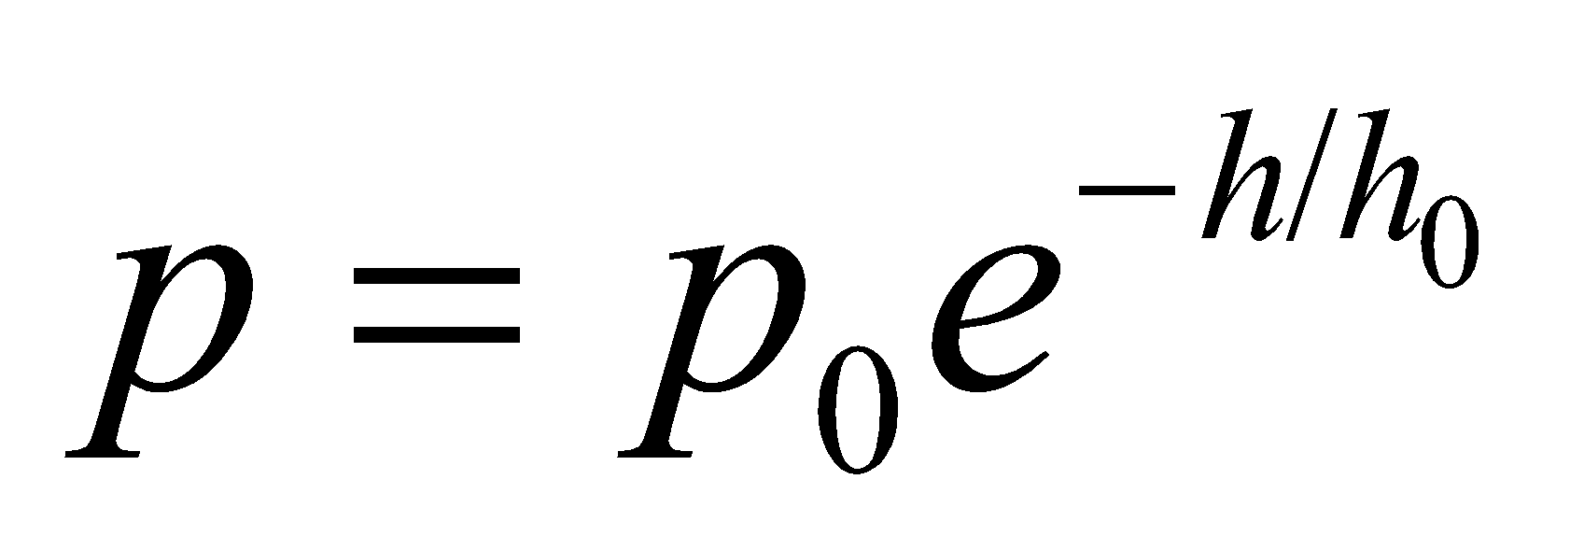. Combining this with the given information that *ρ* = *p*/(*h*0*g*), we can express the density as a function of height *h*.

**Evaluate** **(a)** The atmospheric density as a function of height is

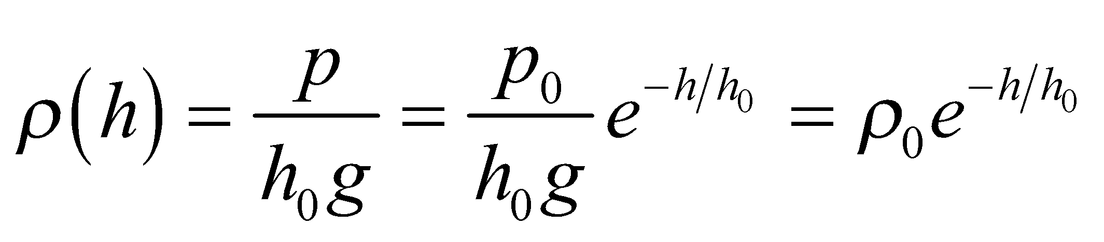

**(b)** The mass of atmosphere contained in a thin spherical shell of thickness *dh*, at height *h*, is



where *R*E is the radius of the Earth and *R*E + *h* is the radius of the shell. The mass of atmosphere below height *h*1 is

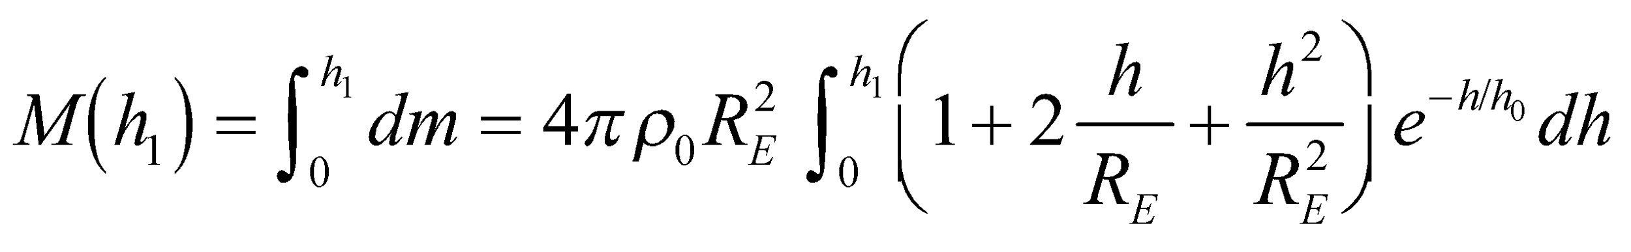

The integrals can be evaluated easily enough with the use of the table of integrals in Appendix B. However, if 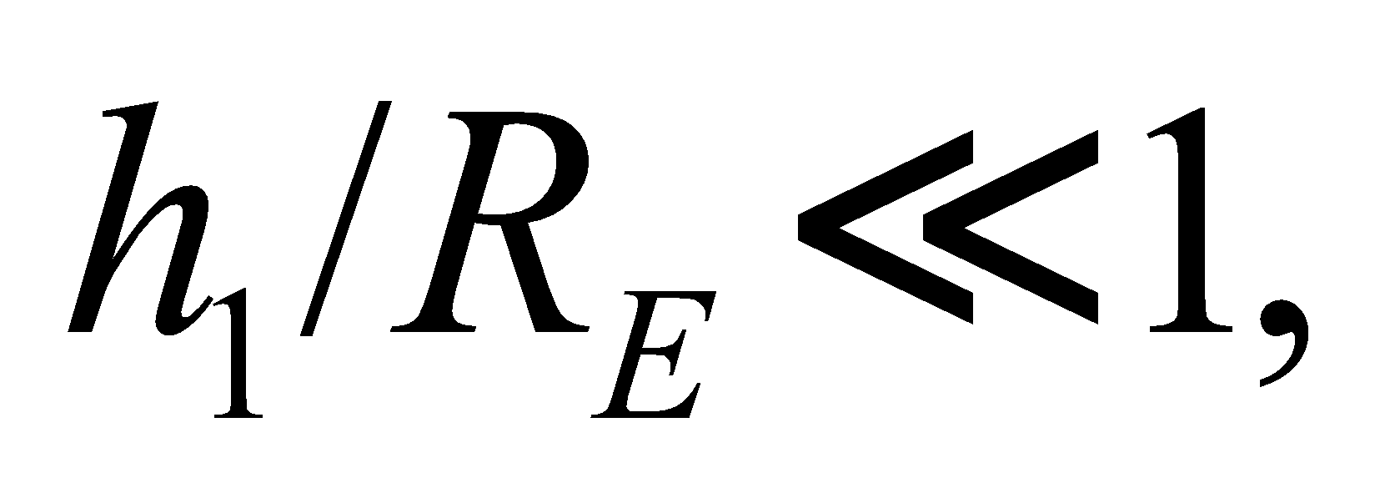 only the first term is important. (Even if *h*1 is large, the exponential term is negligibly small

for 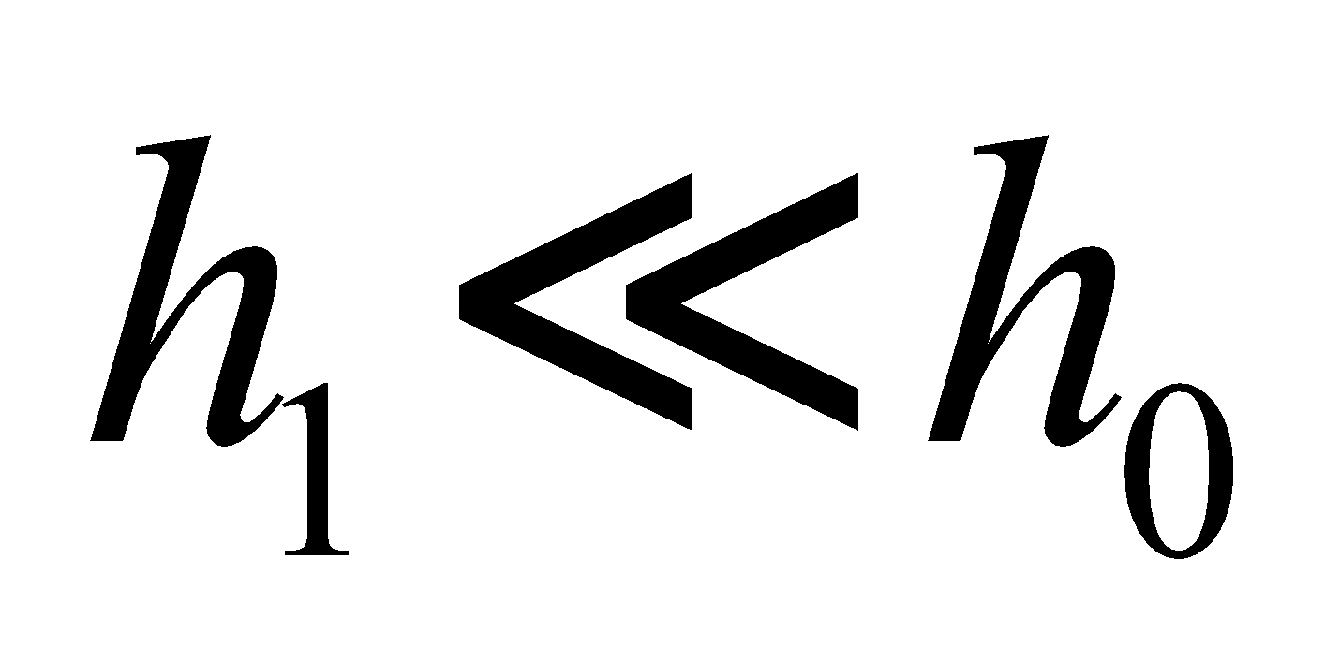 and none of the terms contribute significantly for large *h*.) To a good approximation, therefore

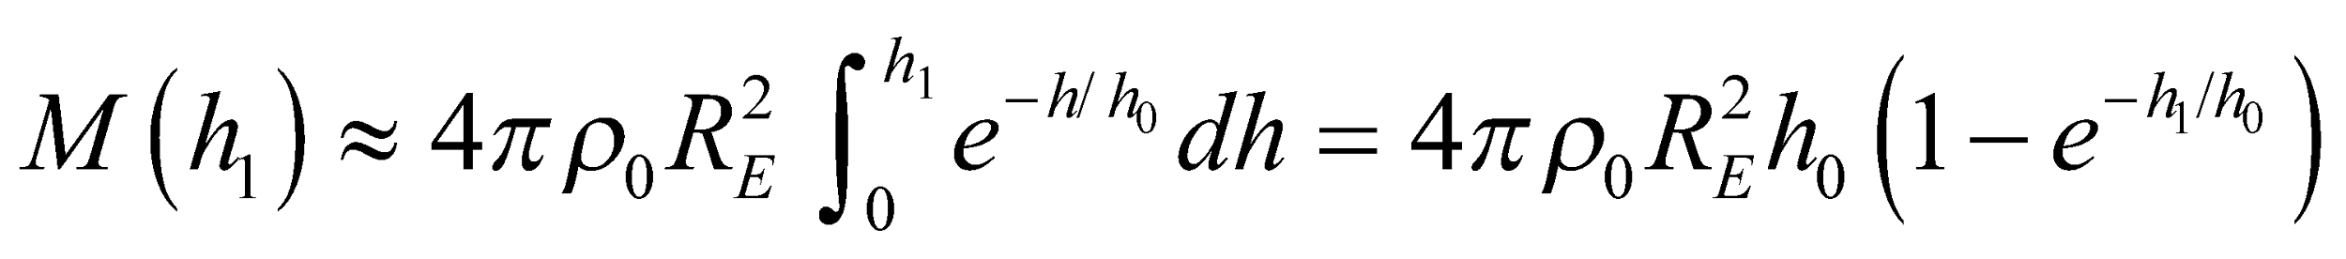

The total mass of the atmosphere is approximately 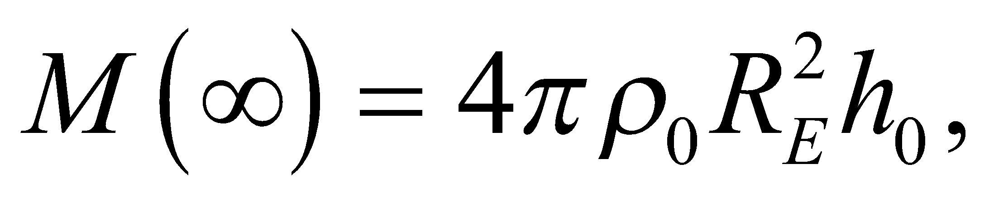 so the height bounding half the total mass is given by the equation 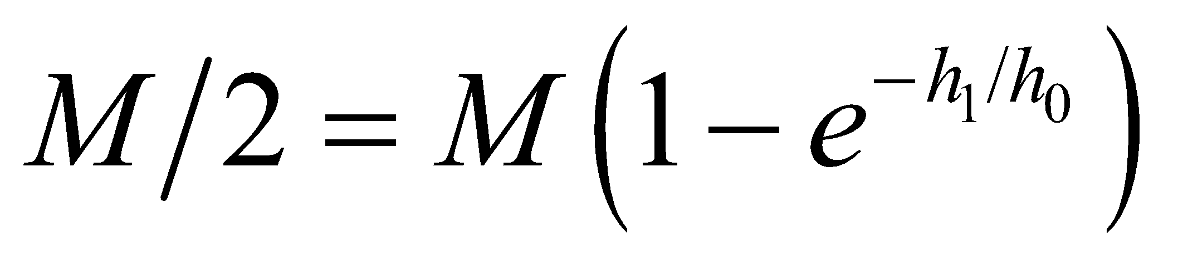 or

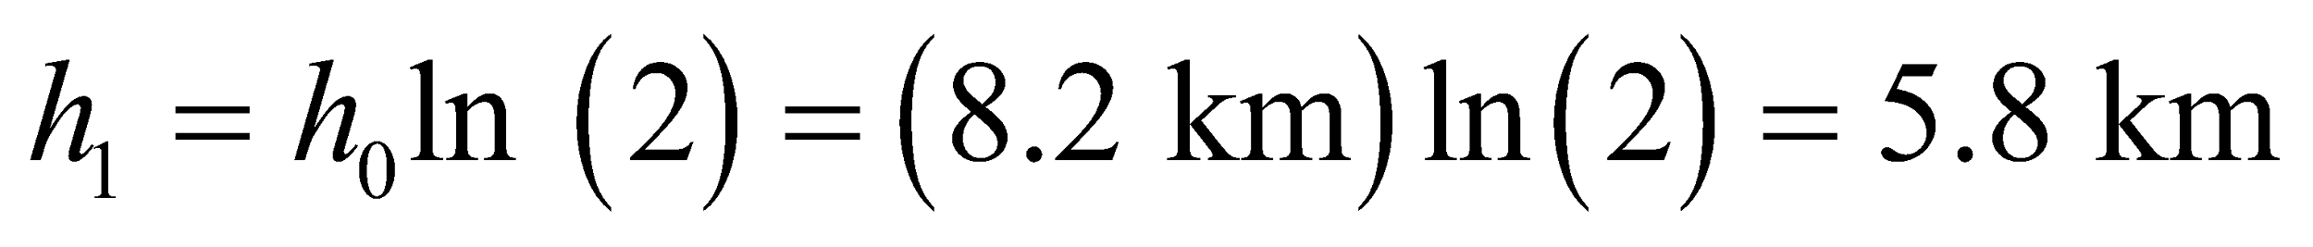

**Assess** This is the same result as we obtained for Problem 15.68.

**70. Interpret** This problem involves a container full of water that is rotating at a given angular speed. We are to find an expression for the pressure on the bottom of the container as a function of the distance from the axis of rotation and an expression for the depth of the water as a function of radial distance. Solving this problem involves Newton’s second law and circular motion.

**Develop** When the water is in equilibrium at constant angular velocity, the vertical change in pressure balances the weight of the water, the radial change in pressure supplies the centripetal acceleration, and there is no change in pressure in the direction tangent to the rotation (i.e., the pressure is constant along a horizontal circle). Introduce vertical, radial, and tangential coordinates, *y*, *r*, and *φ*, respectively, with the origin at the bottom center of the pan and the *y* axis positive upward (these are cylindrical coordinates). Consider a fluid element 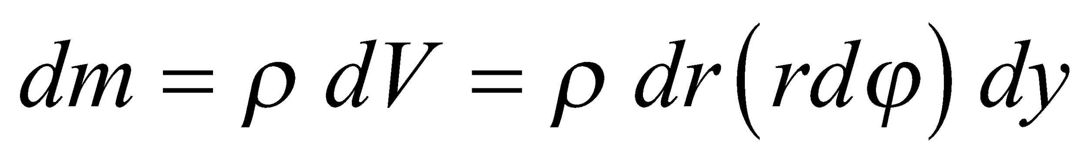 as shown below, where *ρ* is the density and *dV* is the volume element. Applying Newton’s second law (*F* = *ma*) to mass element tells us that the vertical pressure difference must balance the gravitational force, as per Equation 15.2, which gives

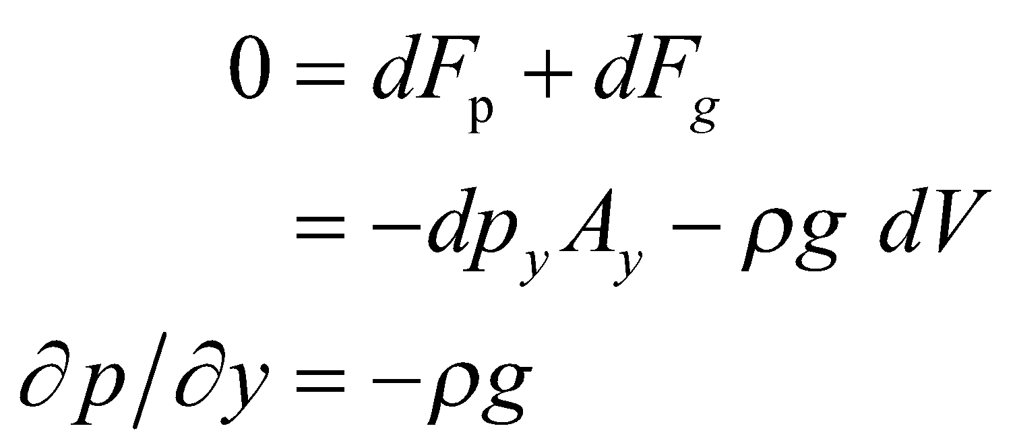

Here, *Ay* = *rdrdφ* is the area of the faces perpendicular to the *y* direction, and we use the partial derivative because the pressure varies with both *y* and *r*. Note that 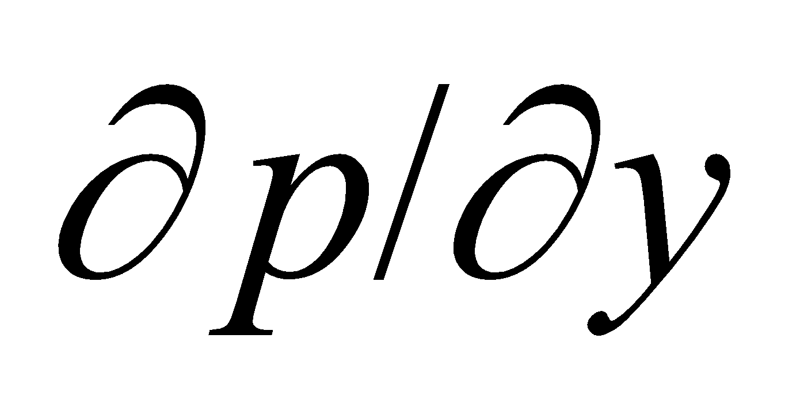 is negative because the pressure increases with depth (decreasing *y*).

Similarly, applying Newton’s second law in the radial direction tells us that the pressure force in the radial direction equals the mass element times the centripetal acceleration, or

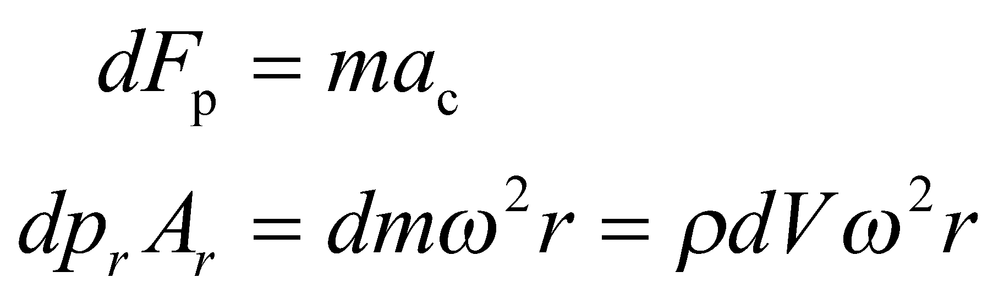

(Recall that 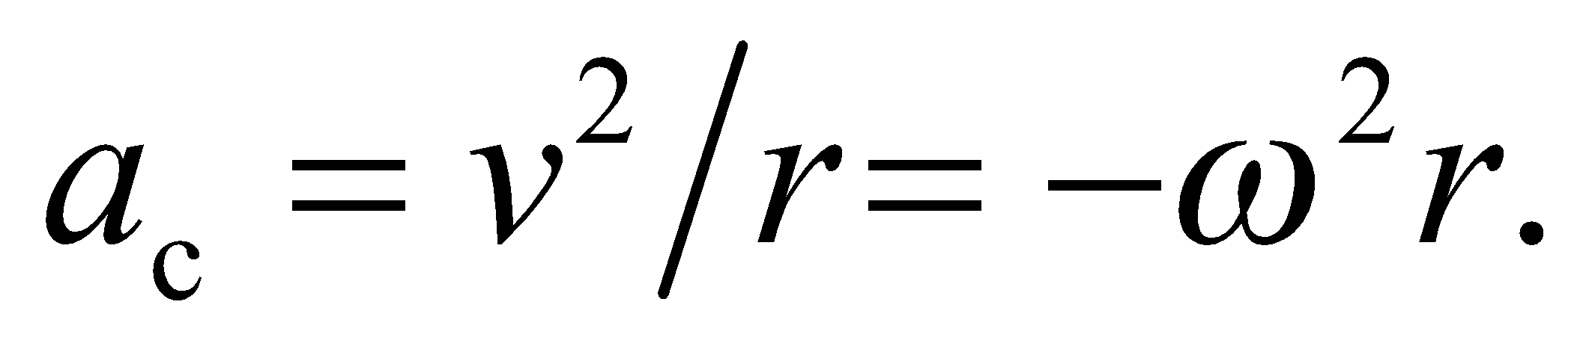) In this equation, *Ar* = *rdφdy* is the area of the faces perpendicular to the radial direction. Since *dV* = *Ardr*, we find

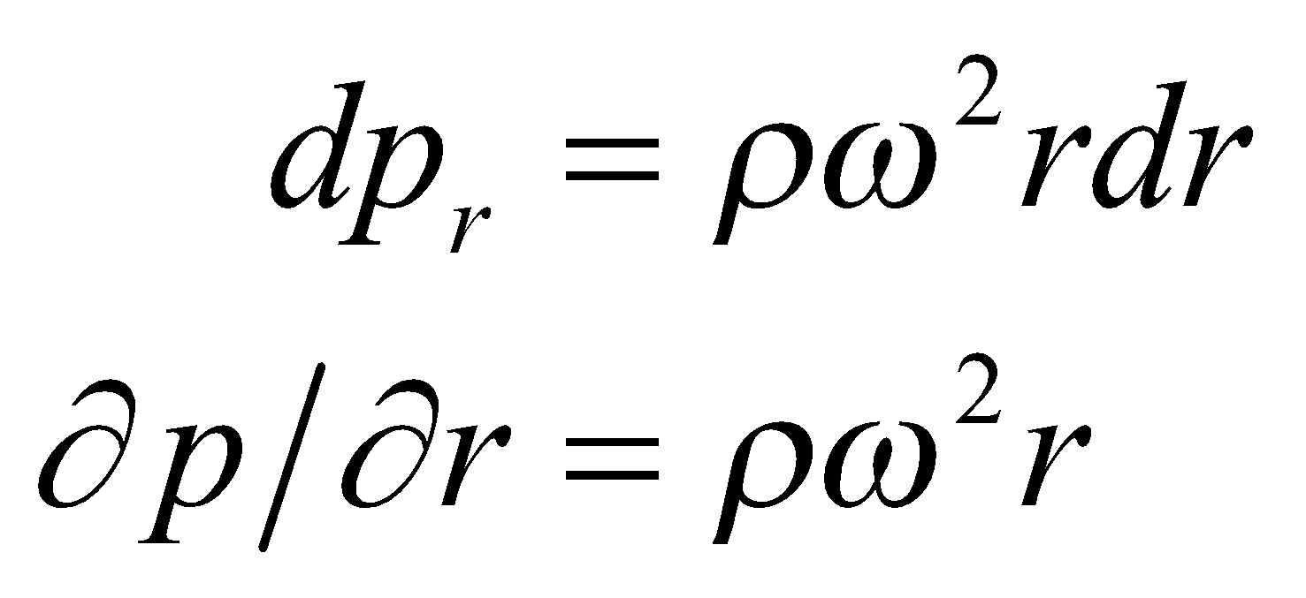

after canceling −*Ay*. Here, 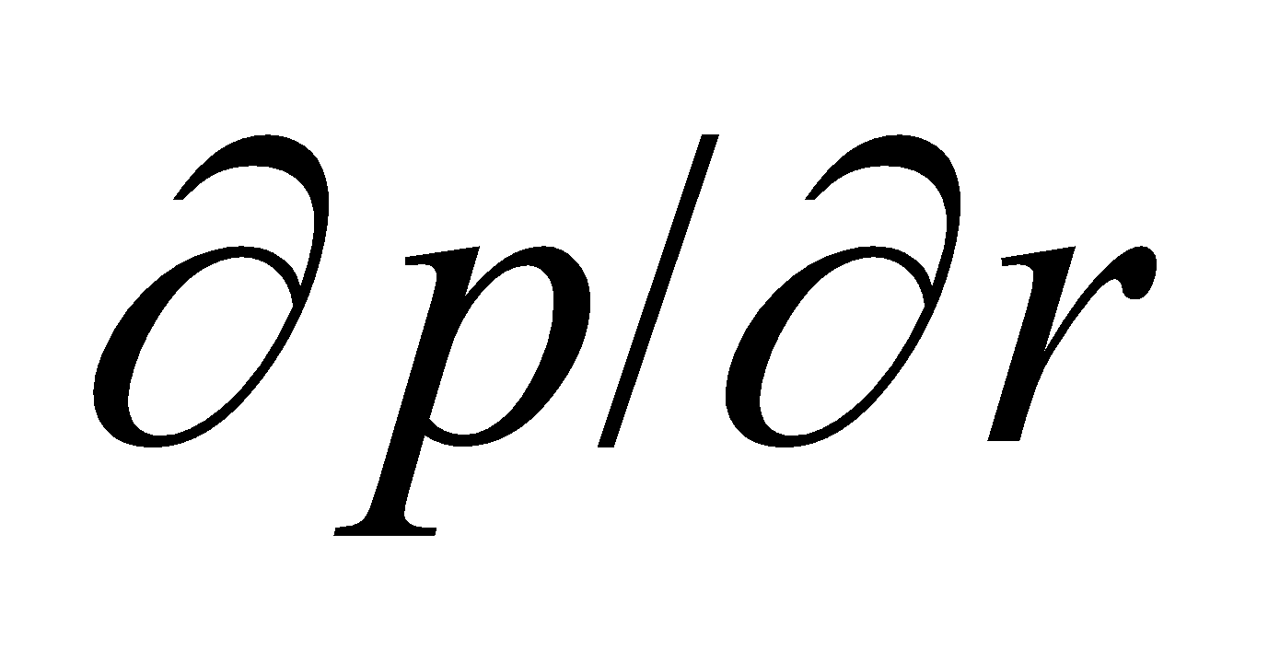 is positive because the pressure increases with *r*. Because the pressure varies with *r* and *y*, we have

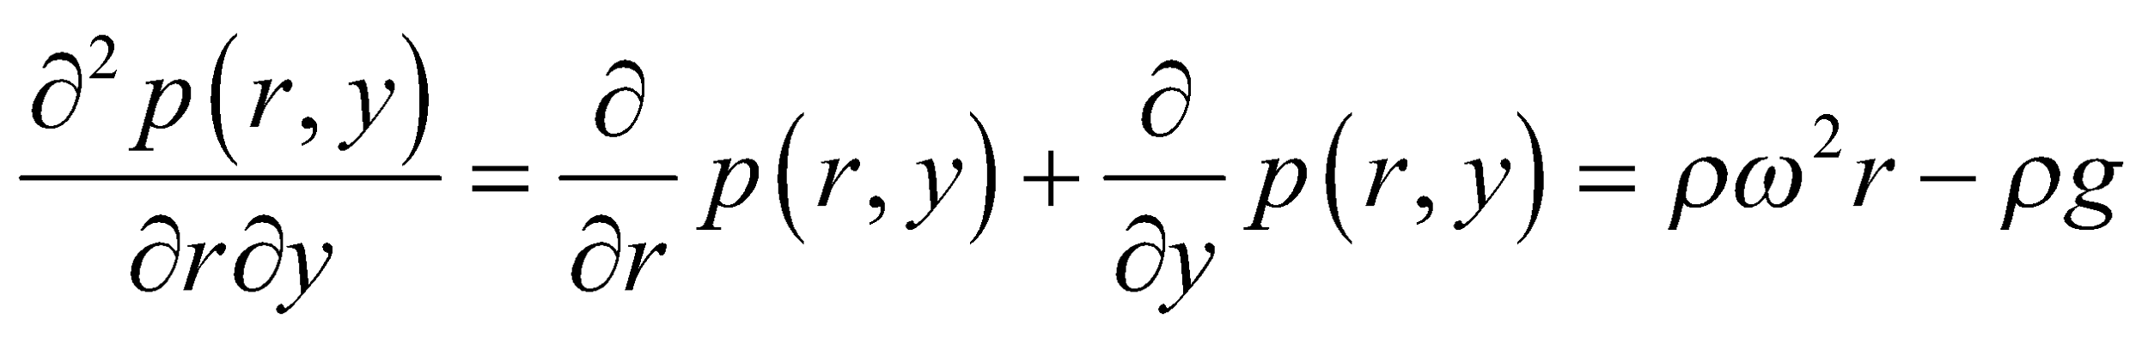

For an incompressible fluid, *ρ* is a constant (not a function of *r* and *y*), so

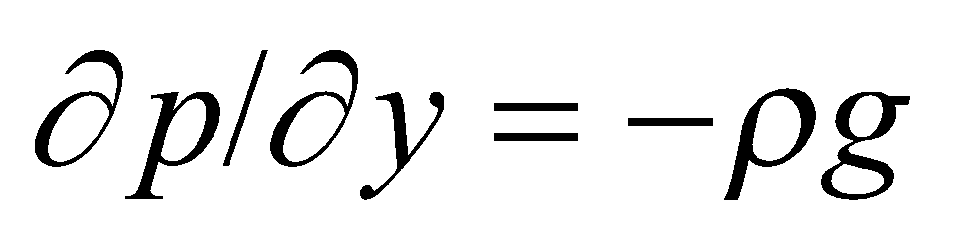 and 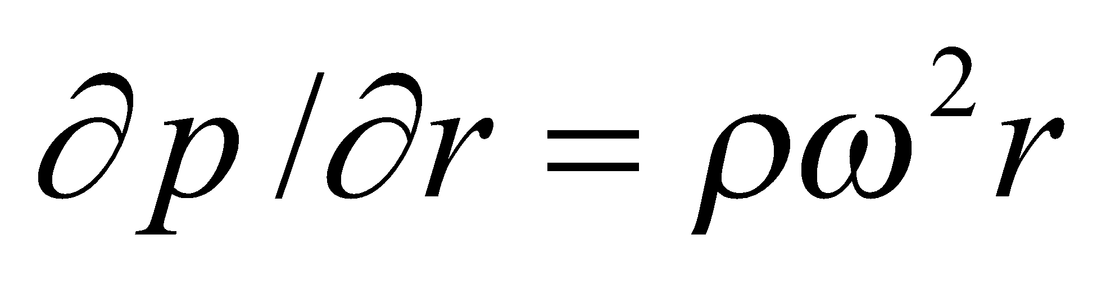

which we can integrate with respect to *r* and *y* to obtain

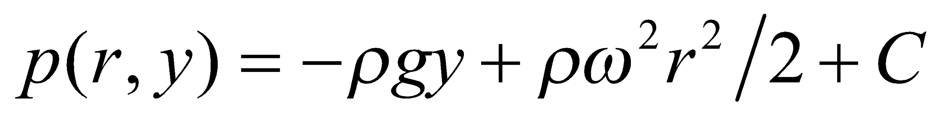

The constant term *C* can be evaluated, since at the surface above the center the pressure is atmospheric pressure, so

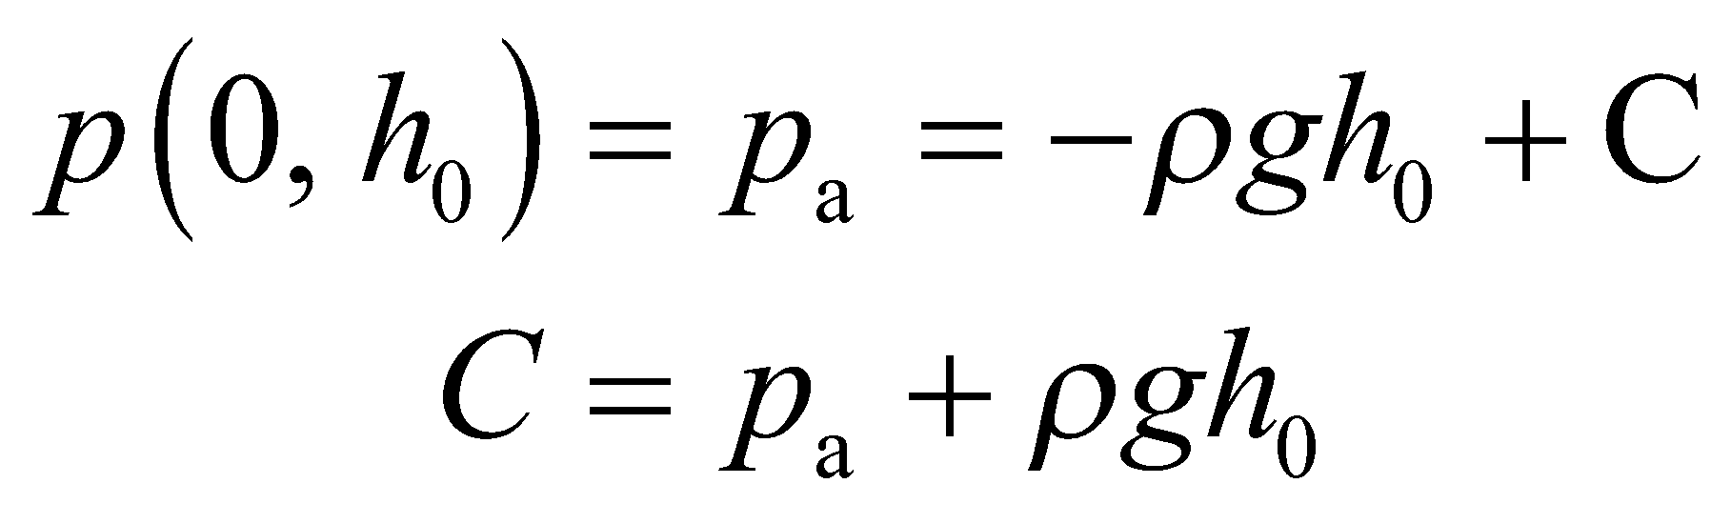

Inserting this constant back into the expression for pressure gives

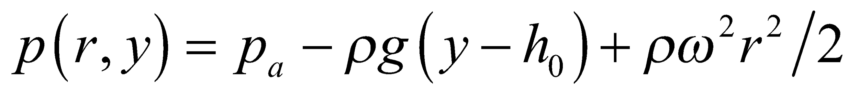

which we can use to express the pressure at the bottom of the container and to find the height of the liquid in the container.



**Evaluate** **(a)** Along the bottom of the pan 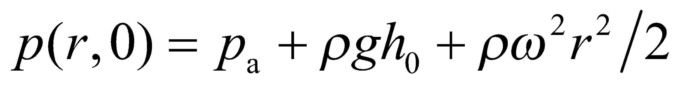.

**(b)** The pressure at the water’s surface is the atmospheric pressure *p*a for all values of *r*, so the height of the surface, *y* =*h*(*r*) is given by the equation 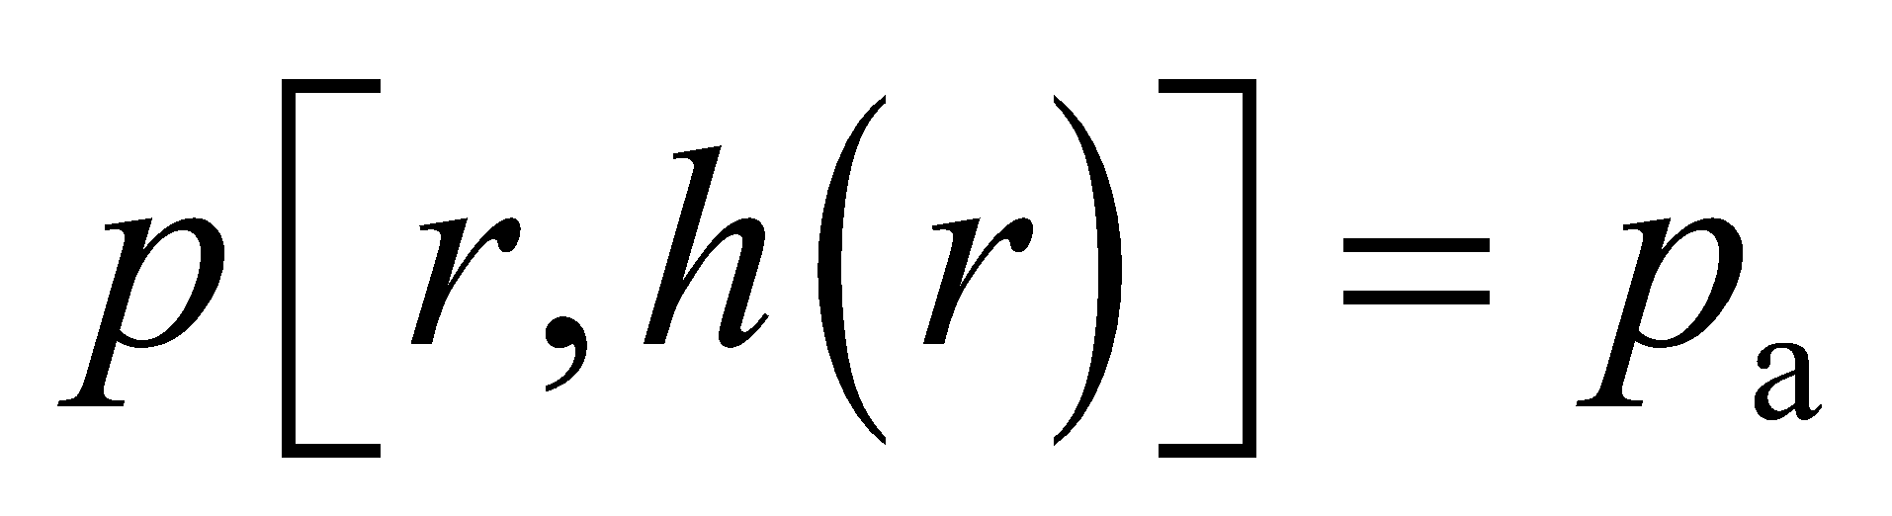, or 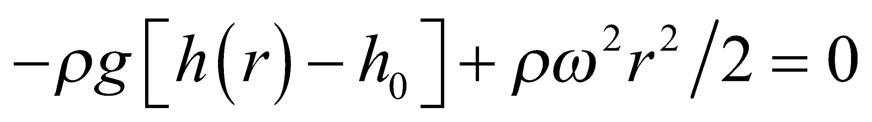. Solving this expression for *h*(*r*) gives

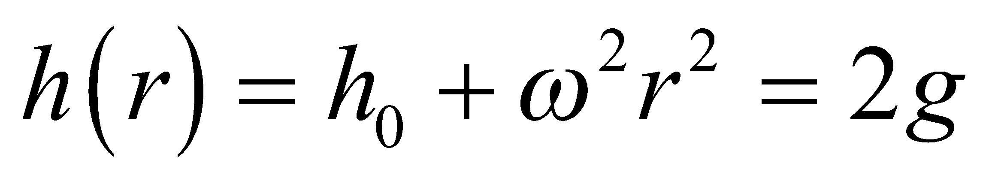

which is a parabola.

**Assess** Such a technique is used to shape large mirrors for astronomical telescopes by a process called spin casting.

**71. Interpret** We're asked to find the density at the center of a non-uniform sphere.

**Develop** We can integrate the formula for the density over the volume and equate it to the total mass of the sphere: 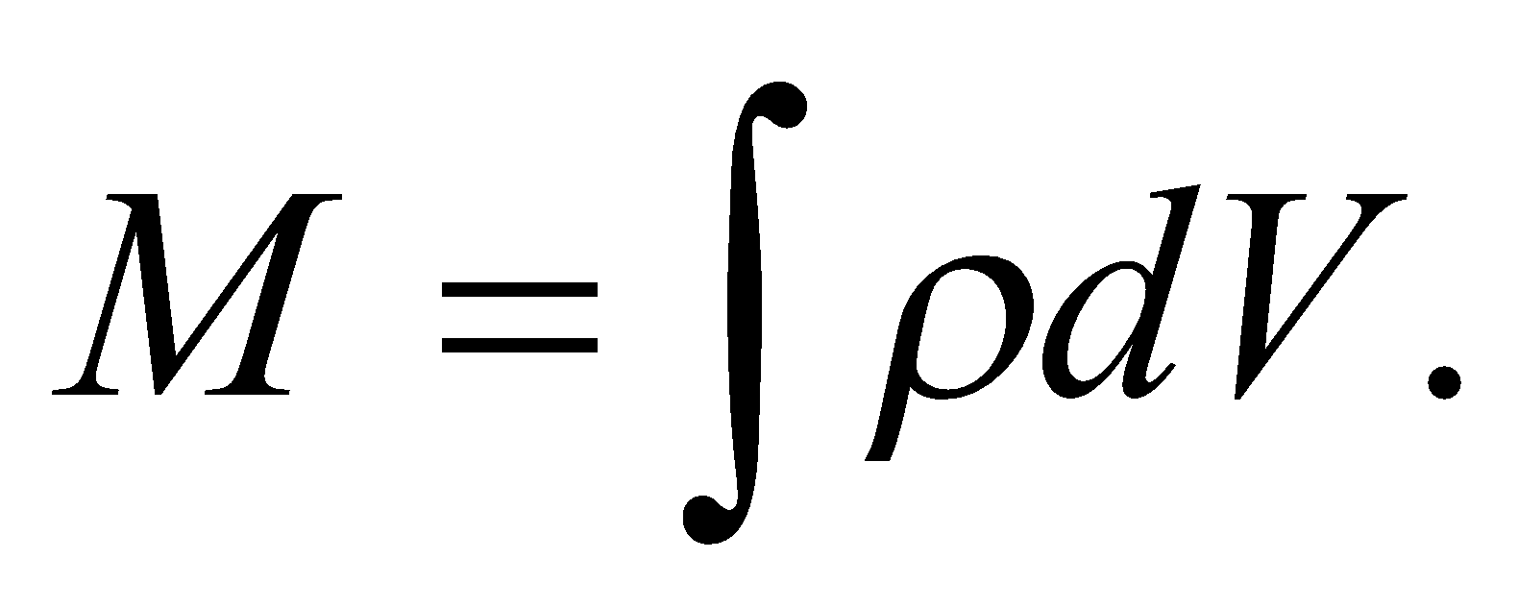 Since the density varies with radius, we can choose to integrate over spherical shells of radius *r* and volume 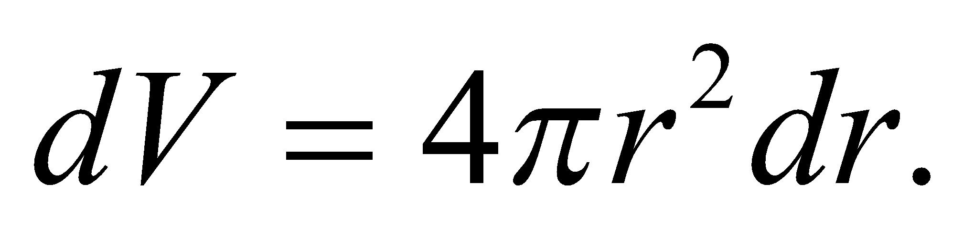

**Evaluate** The integral we have to do has the form:

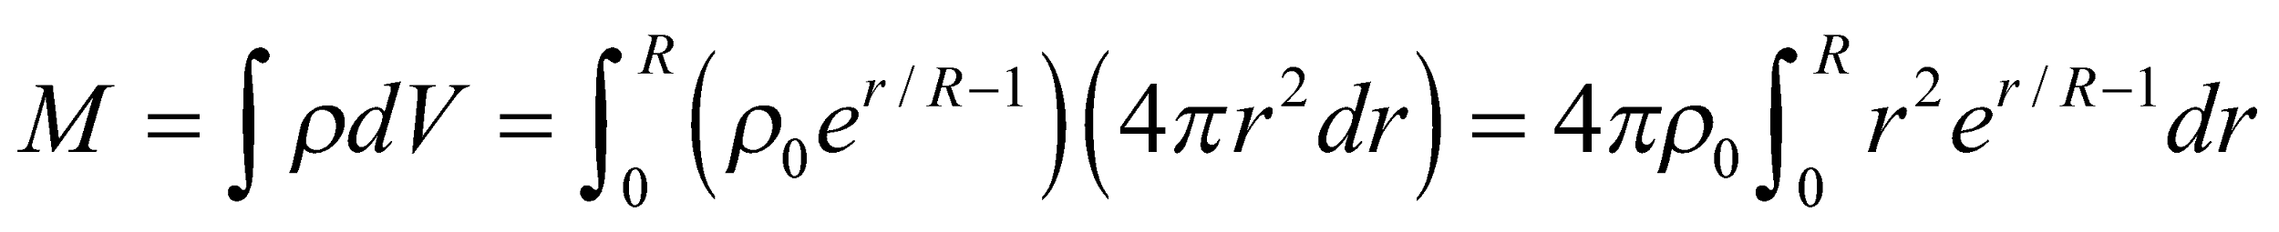

This will require integration by parts, as described in Appendix A.

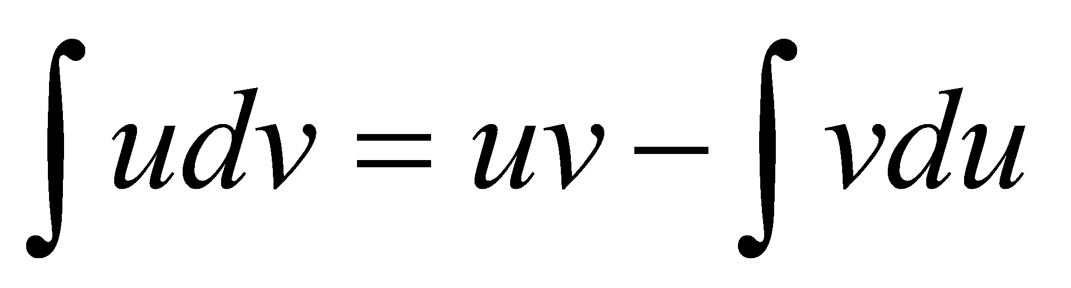

Let 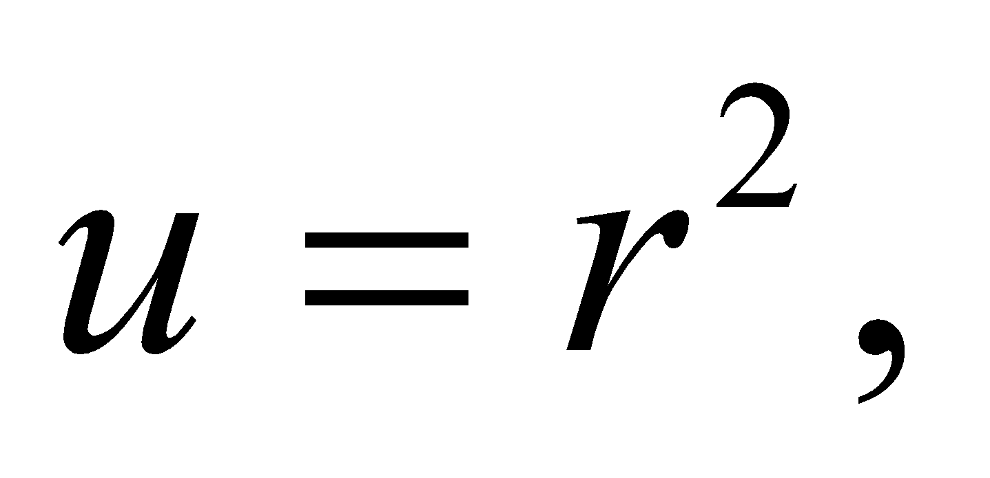 so that 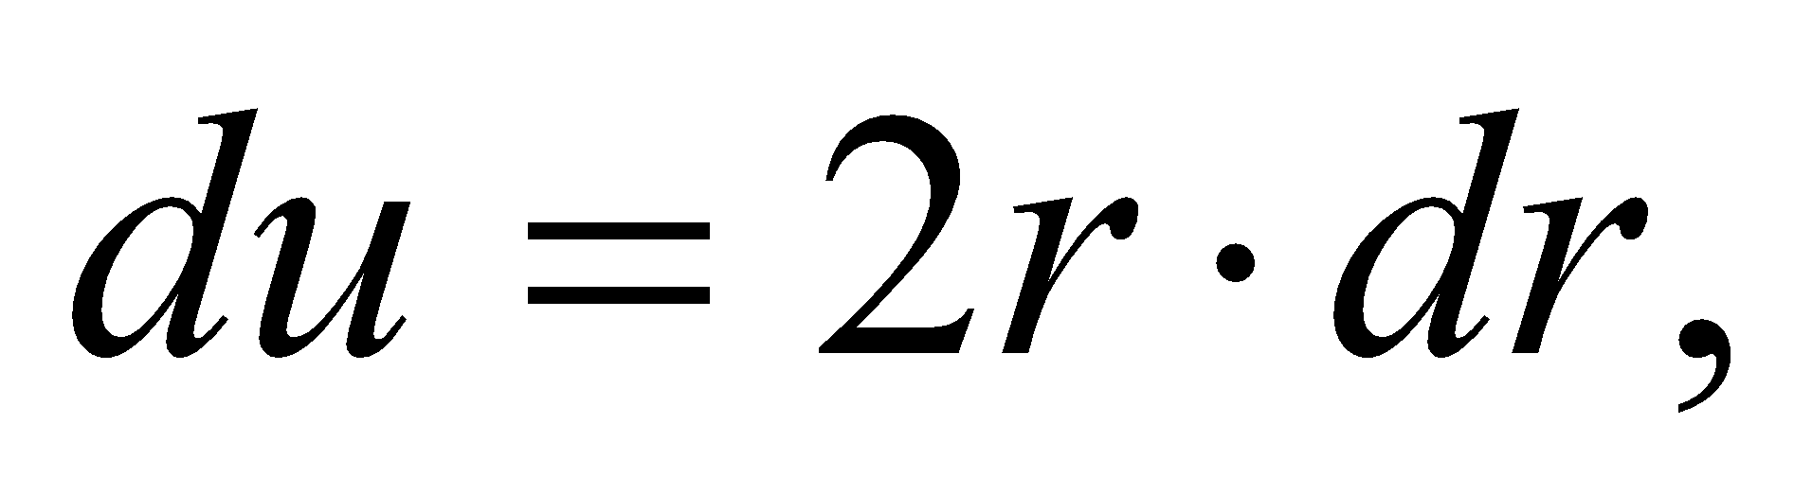and let 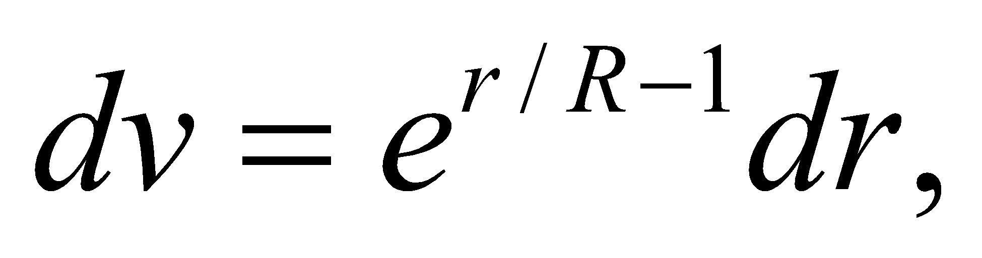so that 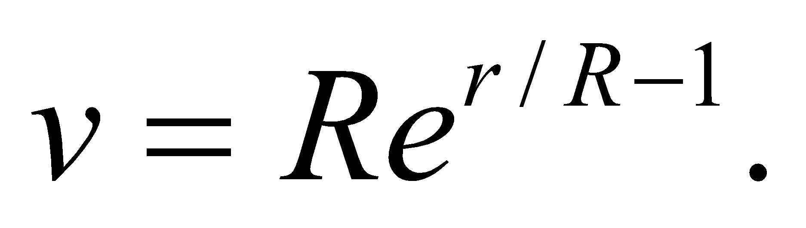Plugging these into the above formula, we get:



To evaluate the remaining integral, we do integration by parts again with 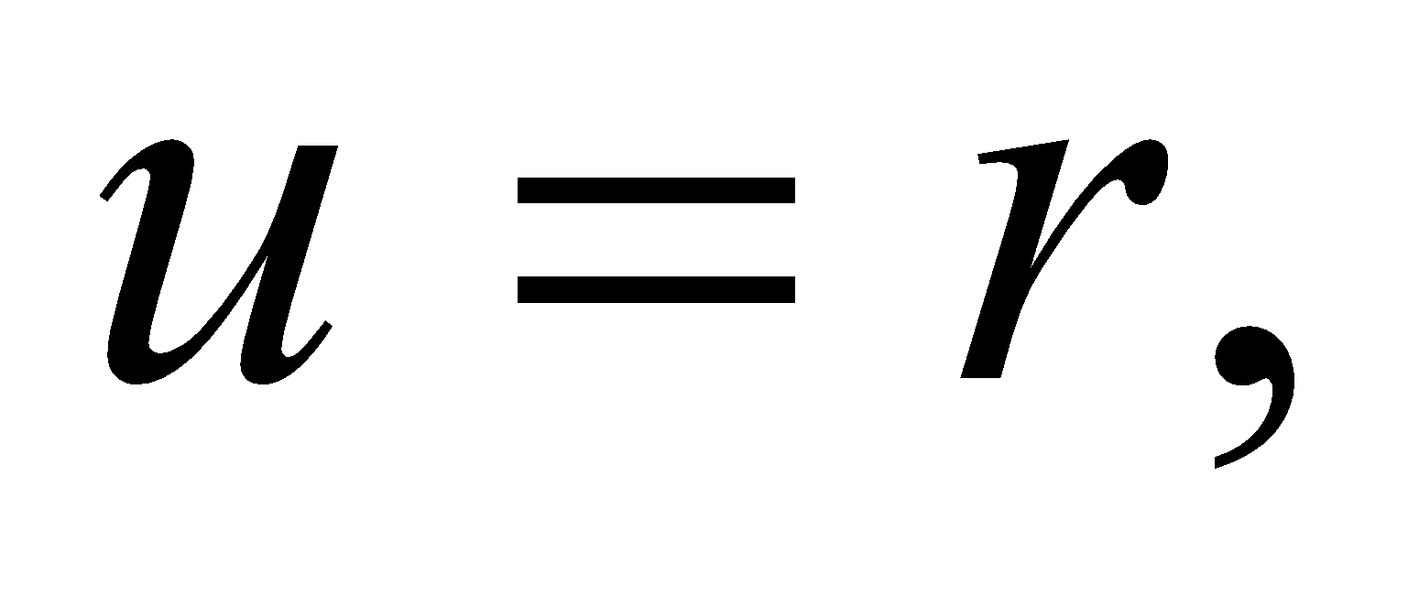and 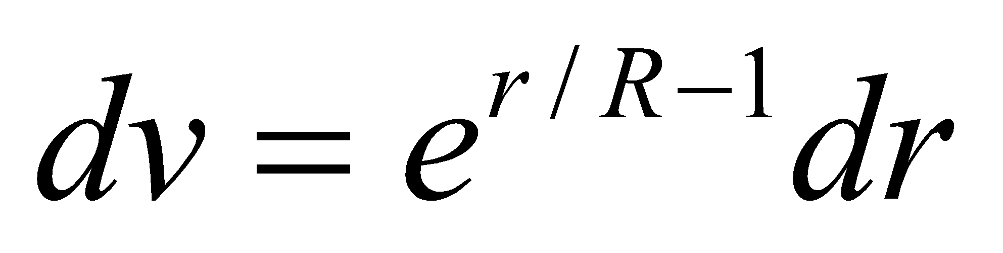:

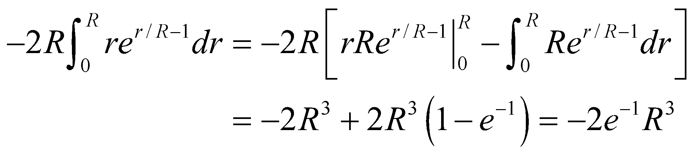

Solving for the central density:

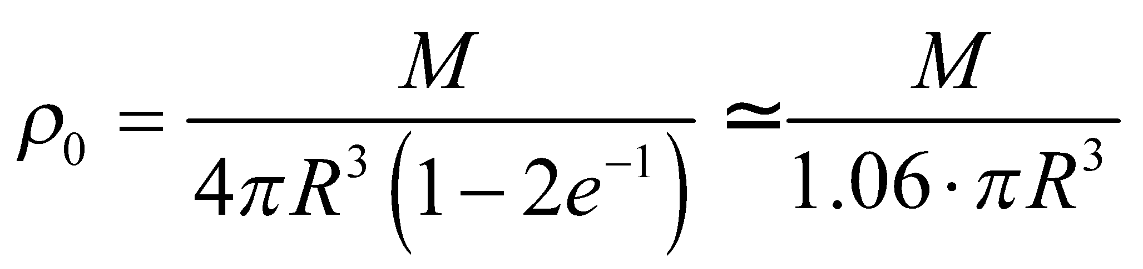

**Assess** The units are correct for a density term.

**72. Interpret** The difference in pressure between the inside and outside of a ball is given as *Δp*. We are asked to integrate this directly to find the pressure force on one hemisphere and show that it is 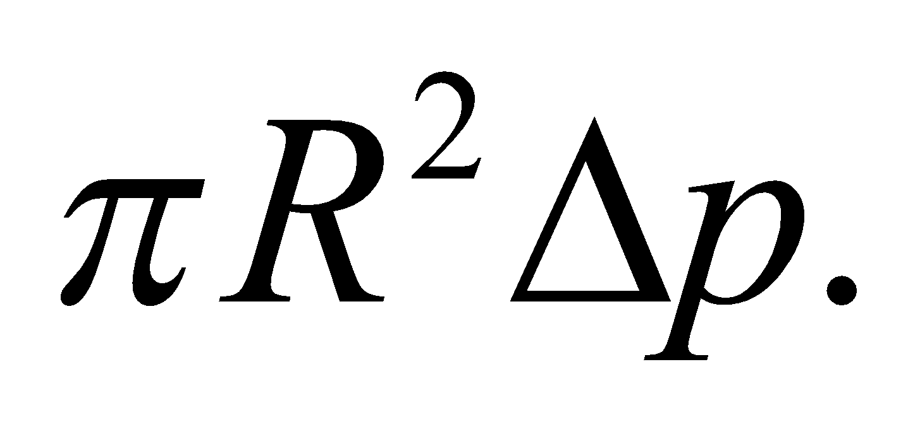

**Develop** We can take any hemisphere we wish, for this problem: so we’ll take the top half of the ball. Using spherical coordinates, the polar coordinate *θ* goes from 0 to *π*/2, and *φ* goes from 0 to2*π*. By symmetry, the components of force in all directions *except* the upward (*z*) direction will cancel, so we can integrate only the *z* component of *F* over this entire hemisphere to obtain the answer. The outwards force is everywhere 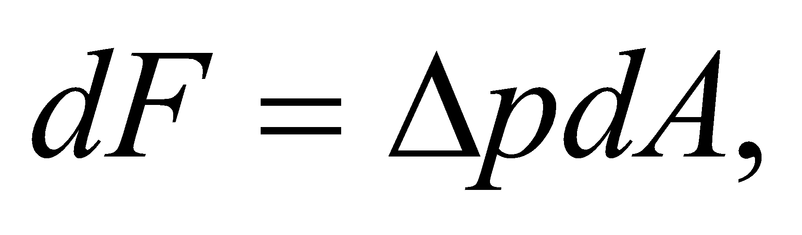 and the *z* component of that force is 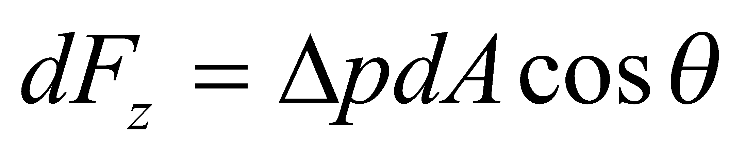.

**Evaluate** 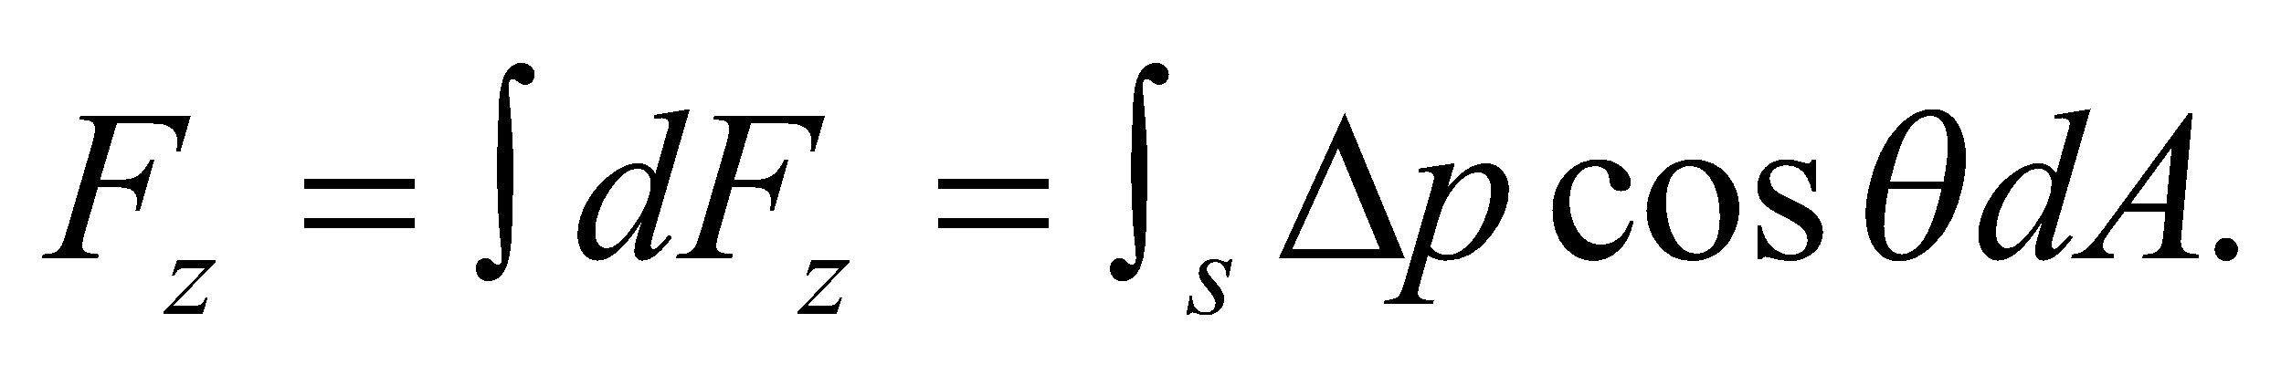 The area element *dA* is 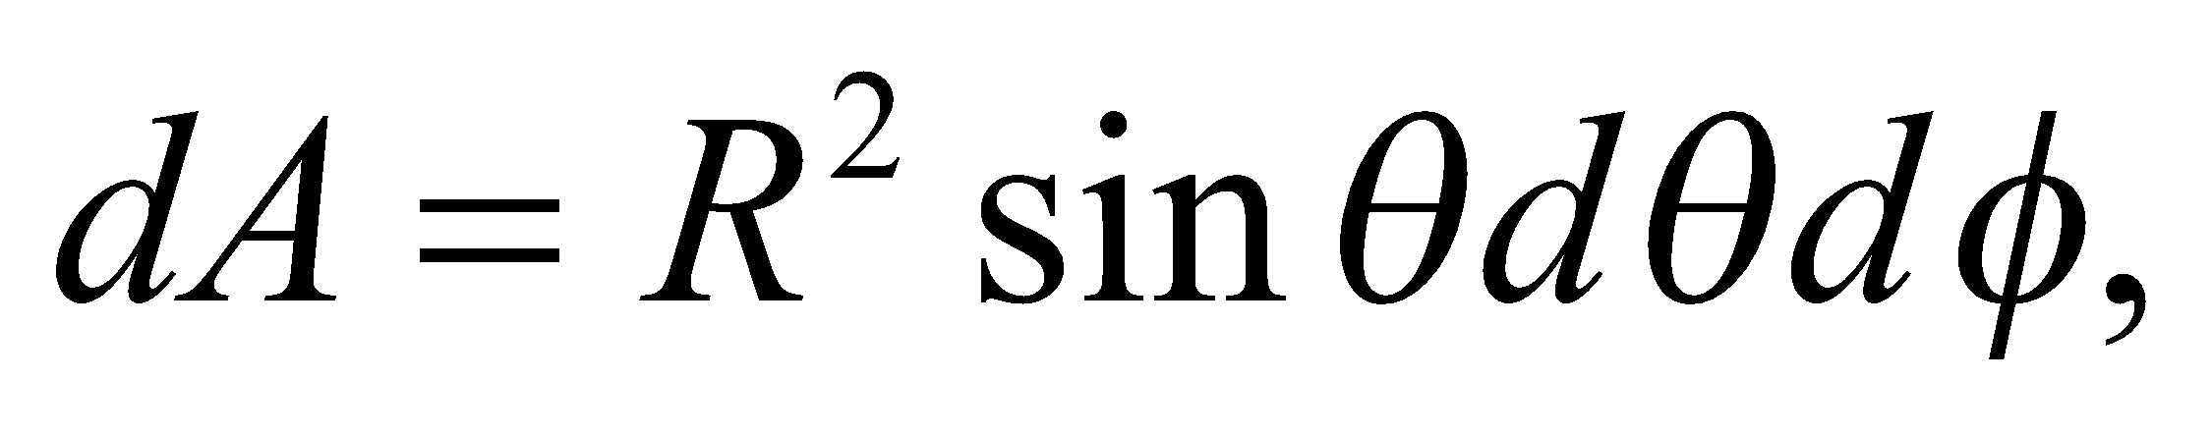 so

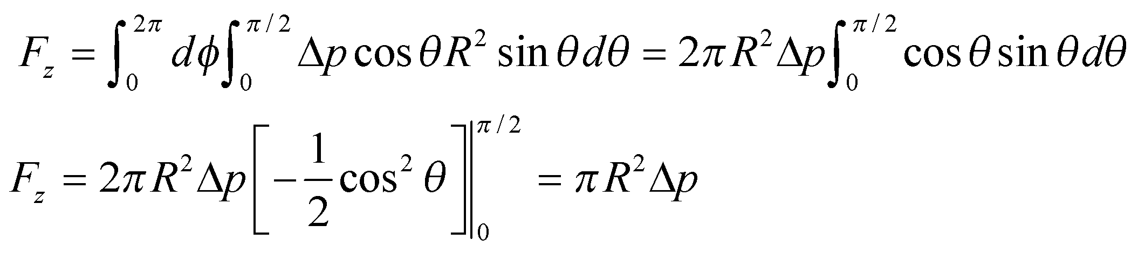

**Assess** We have shown what was required.

**73. Interpret** In Problem 15.42, we determined the force on a dam due to the water behind the dam. In this problem, we find the torque around the bottom edge of the same dam. We will use *F* = *pA* and *τ* = *yF*, as shown in the figure below.

**Develop**The pressure varies with depth, according to 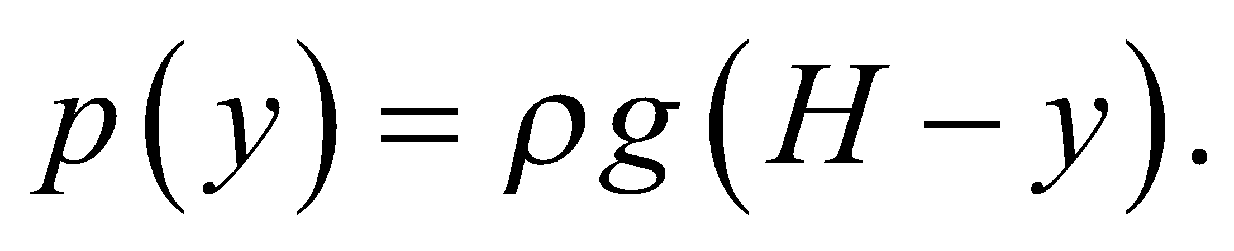 We will find the force 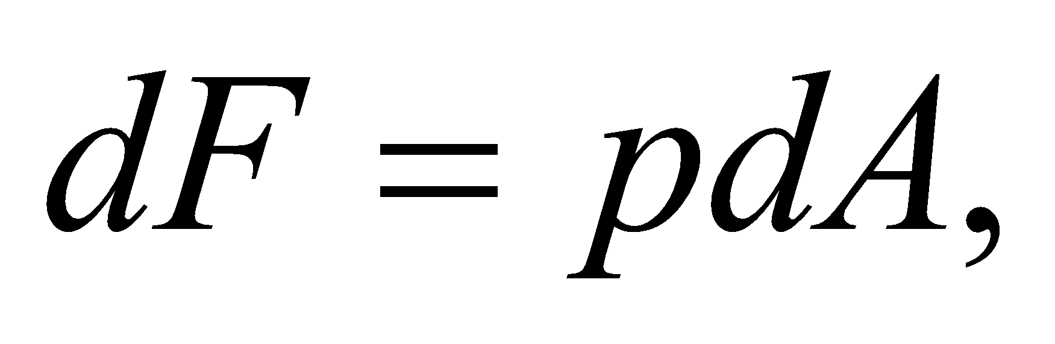 and thus the torque 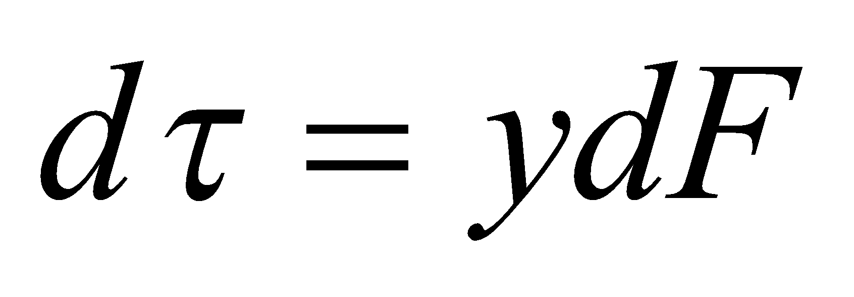 from each horizontal strip across the dam. Integrating *dτ* gives us the total torque. The dam has width *w* = 1500 m and the water is *H* = 95-m deep. The density of water is 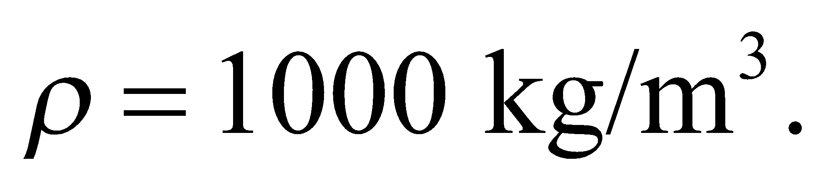



**Evaluate**The pressure  Integrate this from *y* = 0 to *y* = *H*.

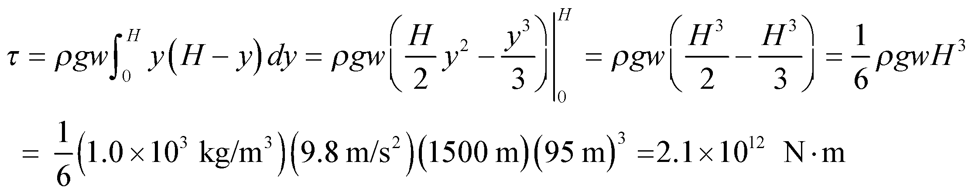

**Assess** The units in our final equation are

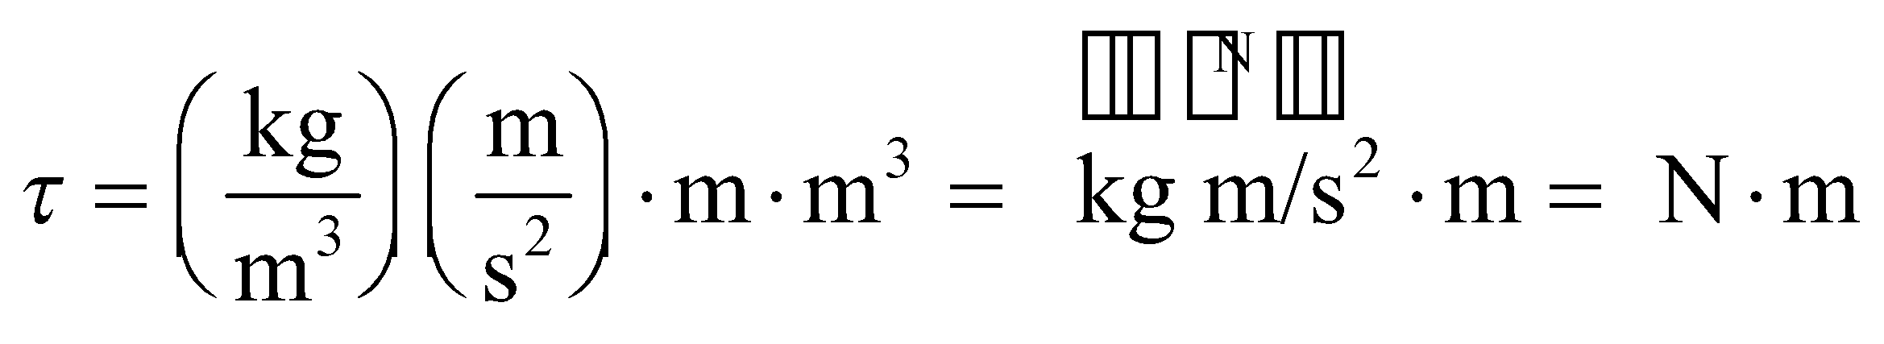

which work out correctly.

**74. Interpret** Find the net force on one vertical wall of a swimming pool. We will integrate the pressure times the area of each horizontal strip of wall, from the top to the bottom of the pool. The pressure varies with depth.

**Develop** First, we draw a picture of the situation, as shown in the figure below. The width varies linearly from 20 m at the top to 10 m at the bottom, so

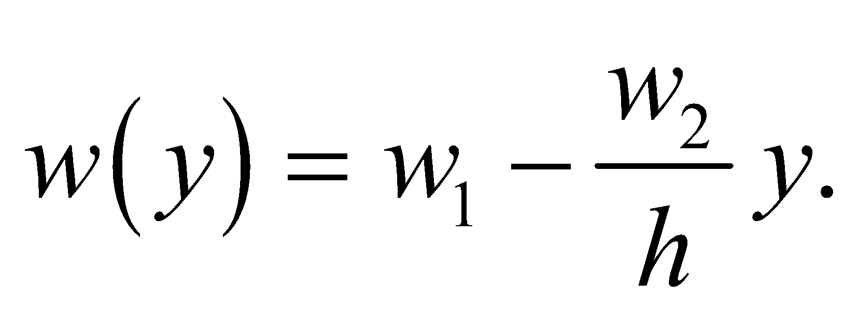

The pressure at depth *y* is 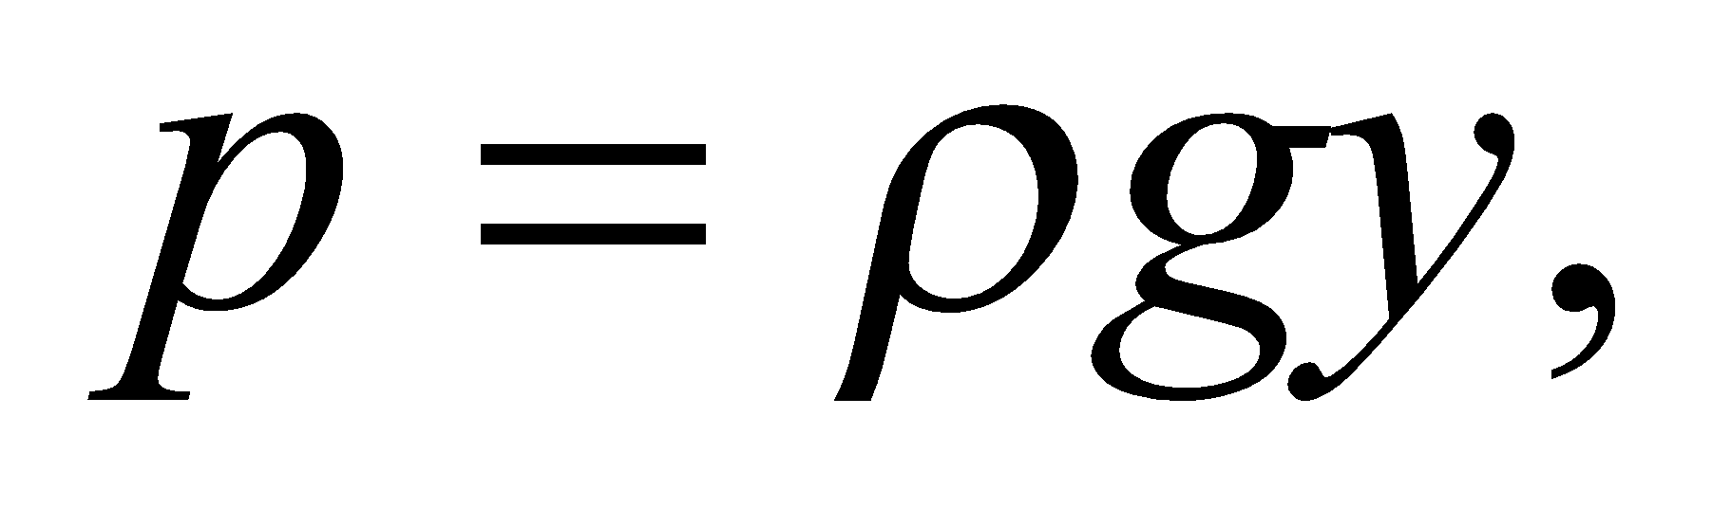 and the force on the strip shown is  where 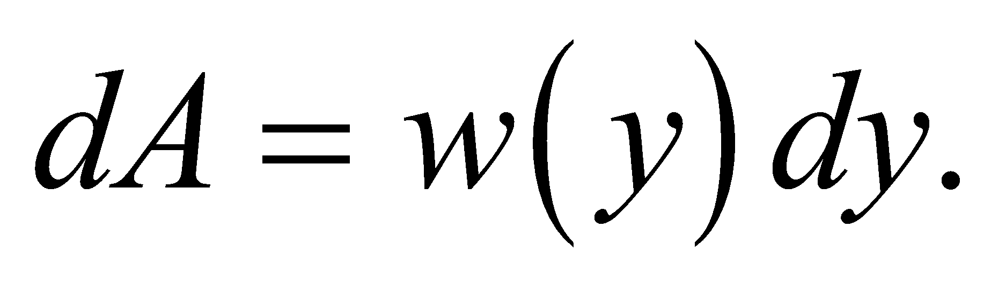 The density of the water is  Integrate *dF* from *y* = 0 to *y* = *h*.



**Evaluate**

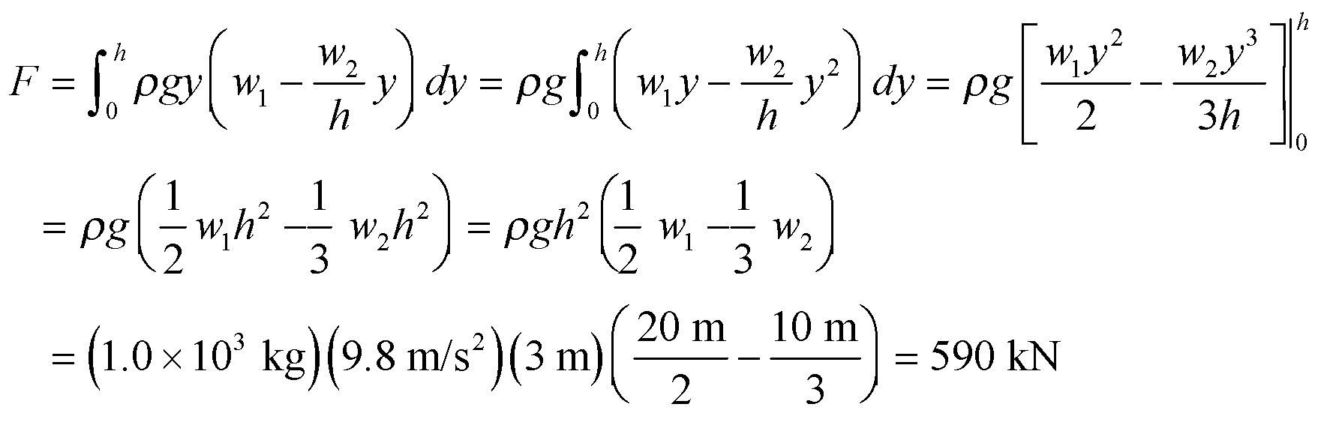

**Assess** Note that this force does not depend on the size of the pool in the other horizontal direction. In other words, if the pool had this cross section and were a centimeter wide, the force on this wall would be the same!

**75. Interpret** We are to find the expected density of a mix of immiscible liquids, and compare it with a measured density to see if the mix is what it should be. The density of a mix of liquids should be the total mass divided by the total volume.

**Develop** The “official” dressing is 1 part vinegar to 3 parts oil, measured by volume. So the dressing should have volume 4*V* and mass 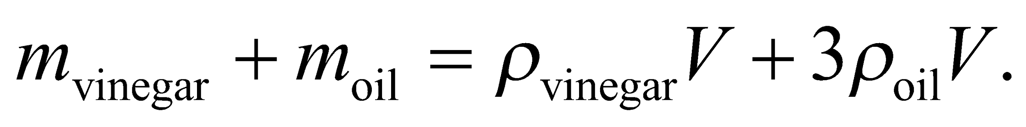 Calculate the density of this mix, and compare it with the measured density 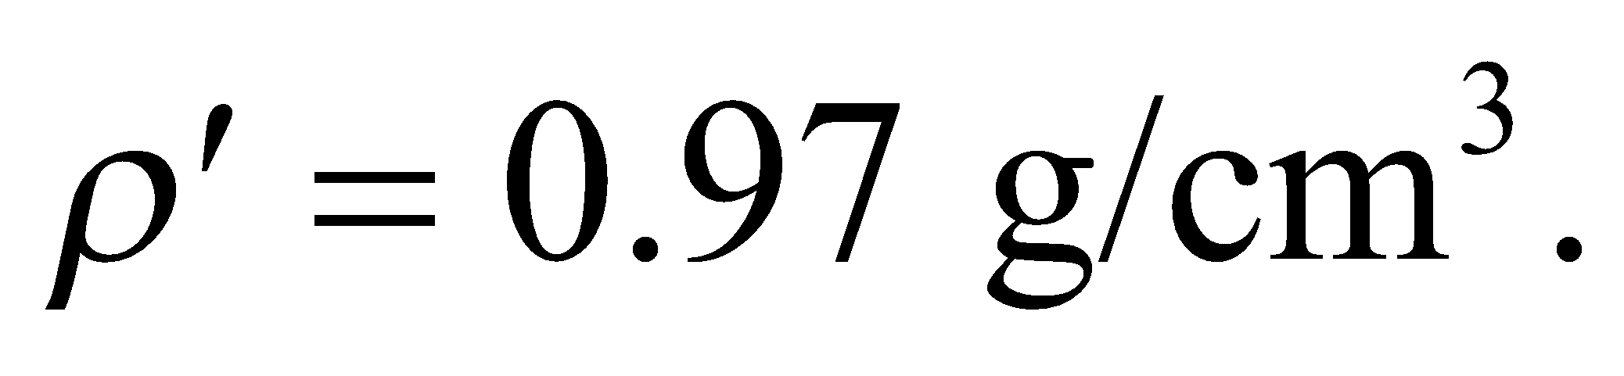 If the density of the sample is higher than it should be, then it has probably been diluted with water. The density of oil is 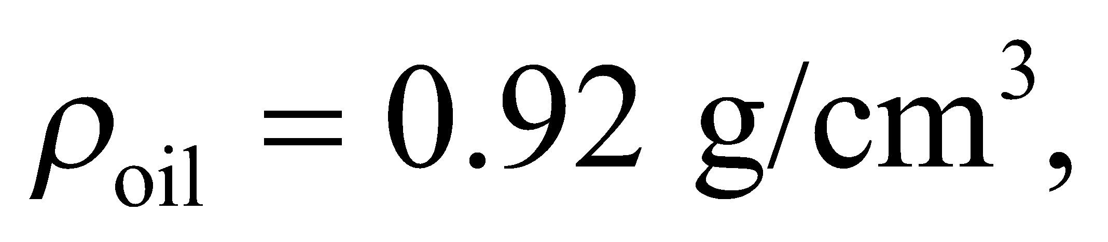 and the density of vinegar is 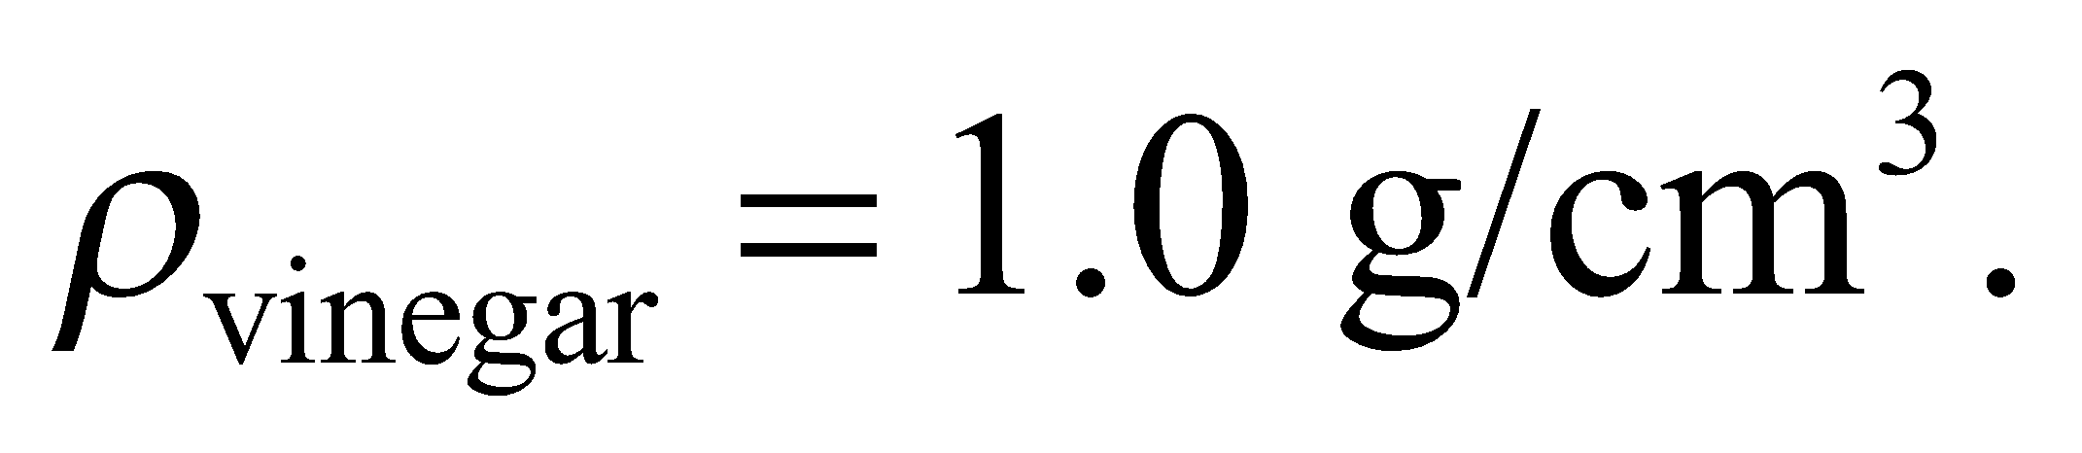

**Evaluate**

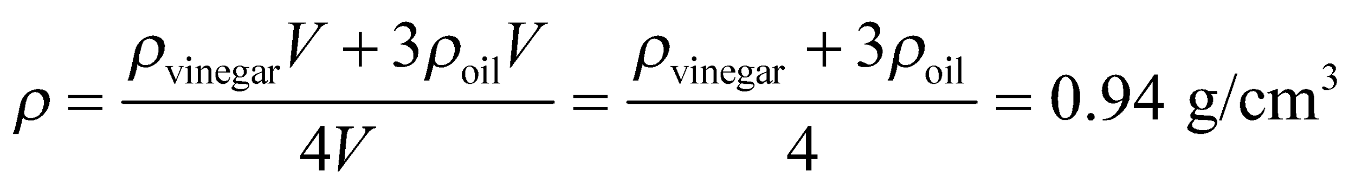

**Assess** The dressing has been altered.

**76. Interpret** The question here is really “Is the water pressure sufficient to get the water to the top floor?” We’ll look at it the other way: if there was a pipe full of water from the top to the bottom of the building, what would be the pressure at the bottom? If the pressure at the bottom of this hypothetical pipe is less than the measured pressure at the water heater, then there is enough pressure at the water heater to get hot water to the top floor.

**Develop** To find the hypothetical pressure in a pipe of height 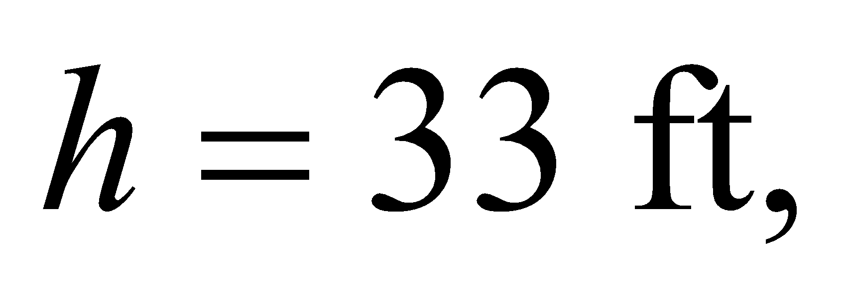we will use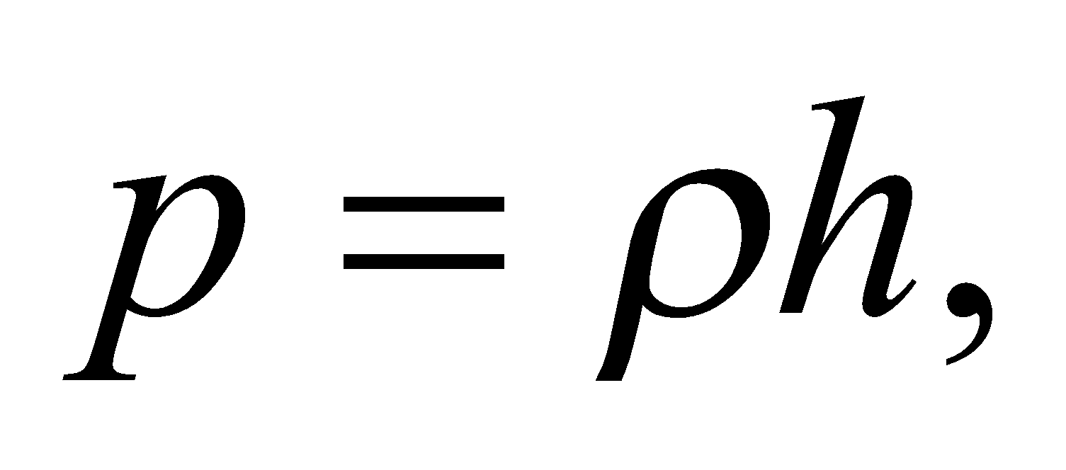where here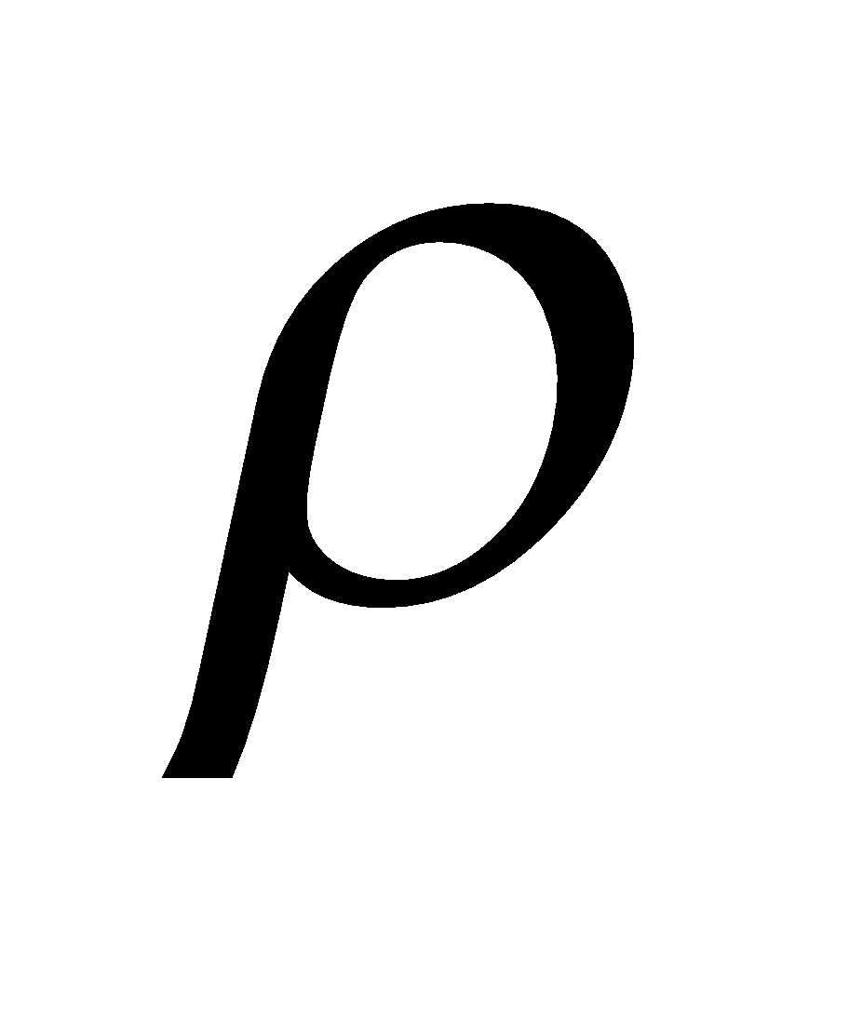is the *weight* density of water in the English system:

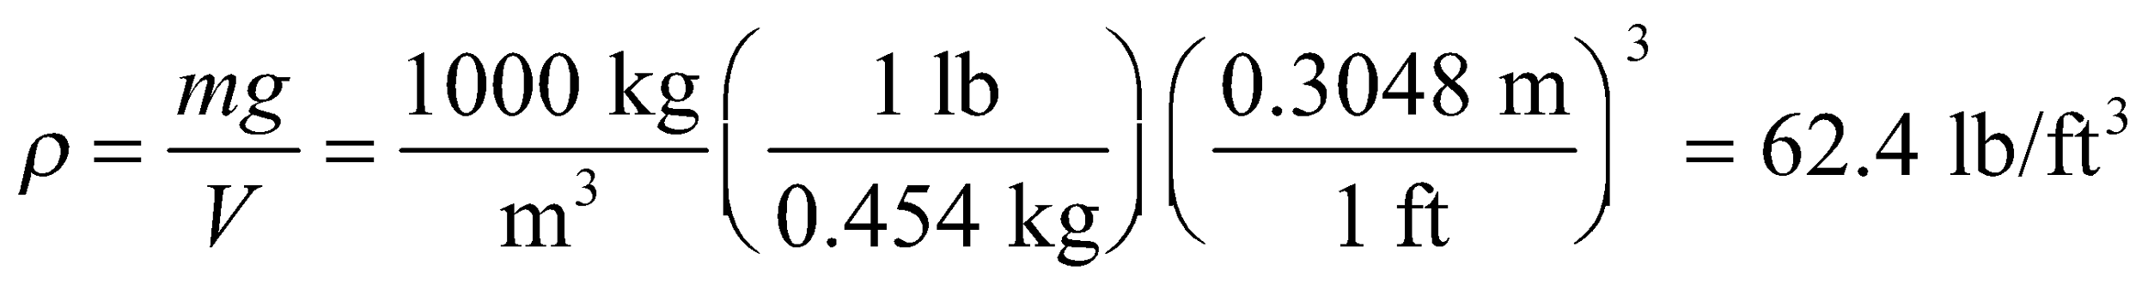

We will compare this hypothetical pressure to the measured pressure:

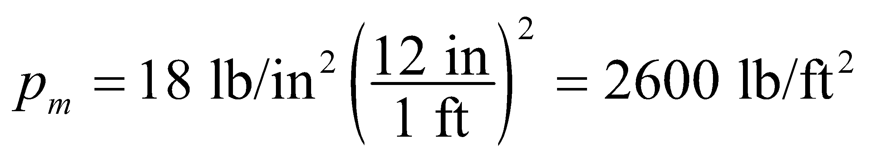

**Evaluate** The hypothetical pressure, or minimum pressure needed to reach the top of the building is:

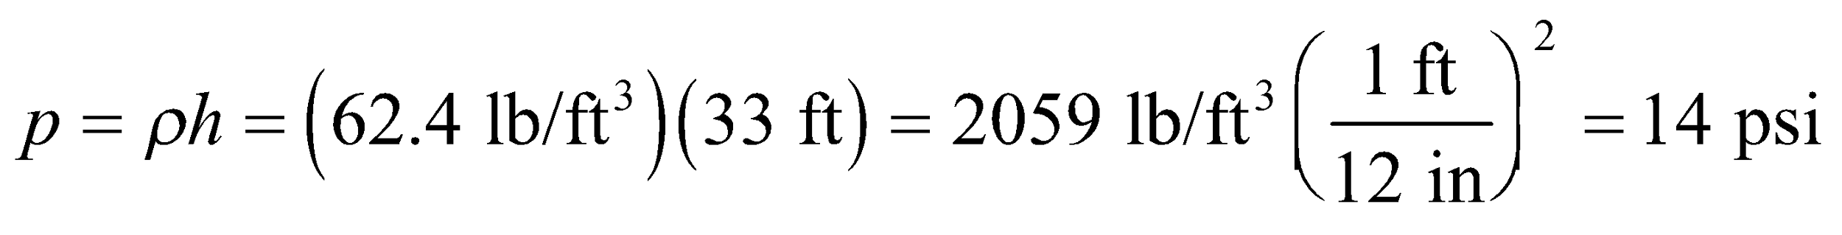

Therefore, the measured pressure is 4 psi more than the minimum pressure needed.

**Assess** A quicker way to solve this is to remember that atmospheric pressure (about 15 psi) can support a column of water about 32 feet high. This pressure (18 psi) is higher, so it can push water even higher.

**77. Interpret** You are asked to find the maximum load that a ship can hold, given the size and shape of the hull, and the initial waterline of the ship.

**Develop** By Archimedes' principle, the buoyant force is equal to the weight of the water displaced by the ship. To find the volume of water displaced, we'll need the formula for the area of an isosceles triangle with apex angle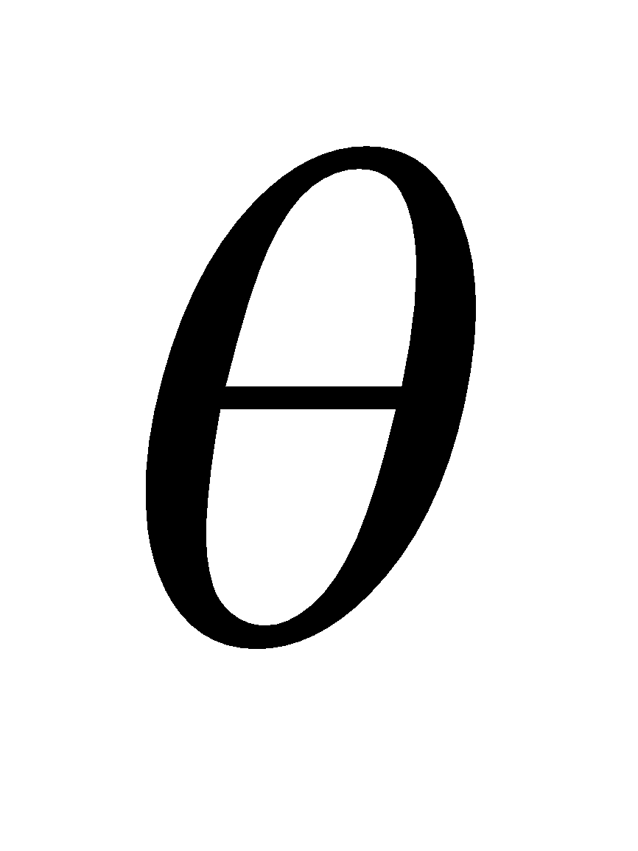and height *h*: 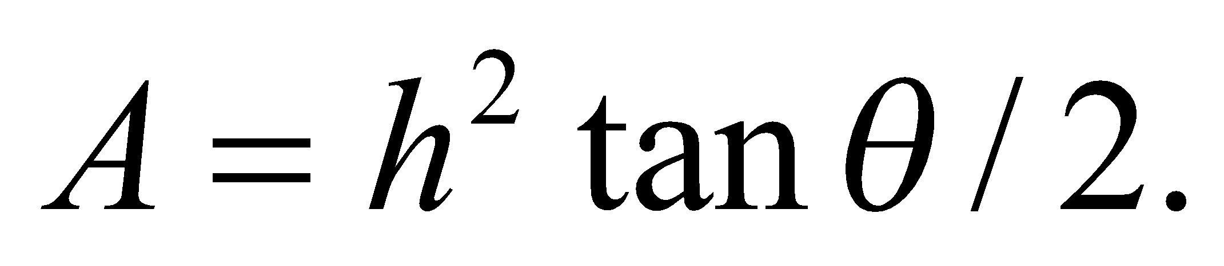

**Evaluate** When the ship is empty, the buoyant force only needs to support the weight of the ship:

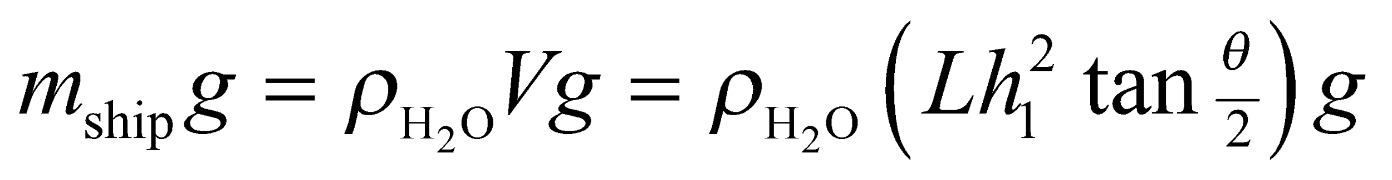

When the maximum cargo load, 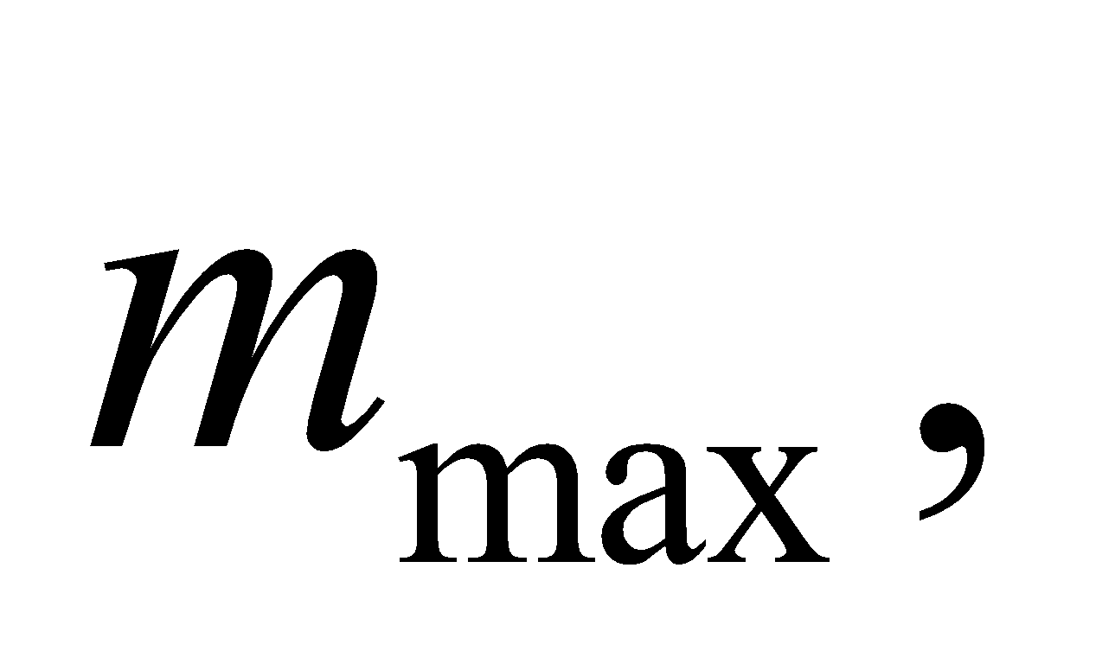is placed on the ship, the entire hull is submerged:

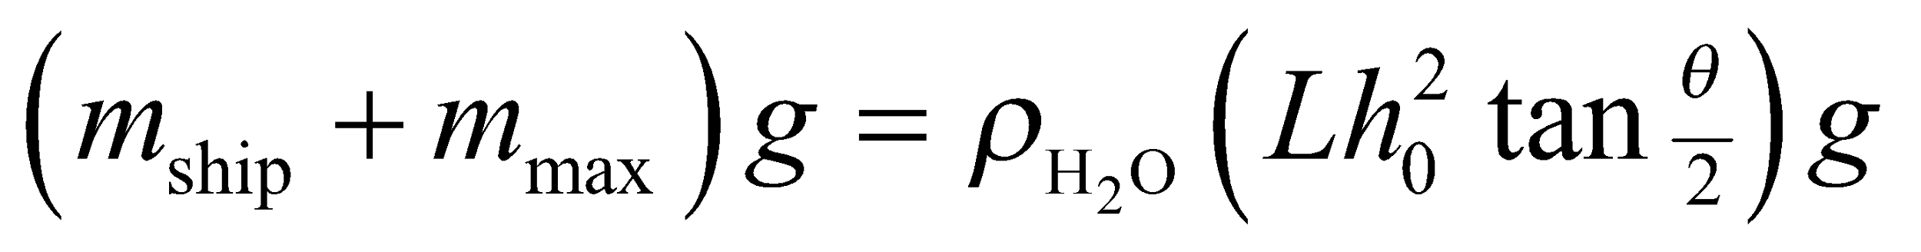

We subtract these two equations to find the maximum load:

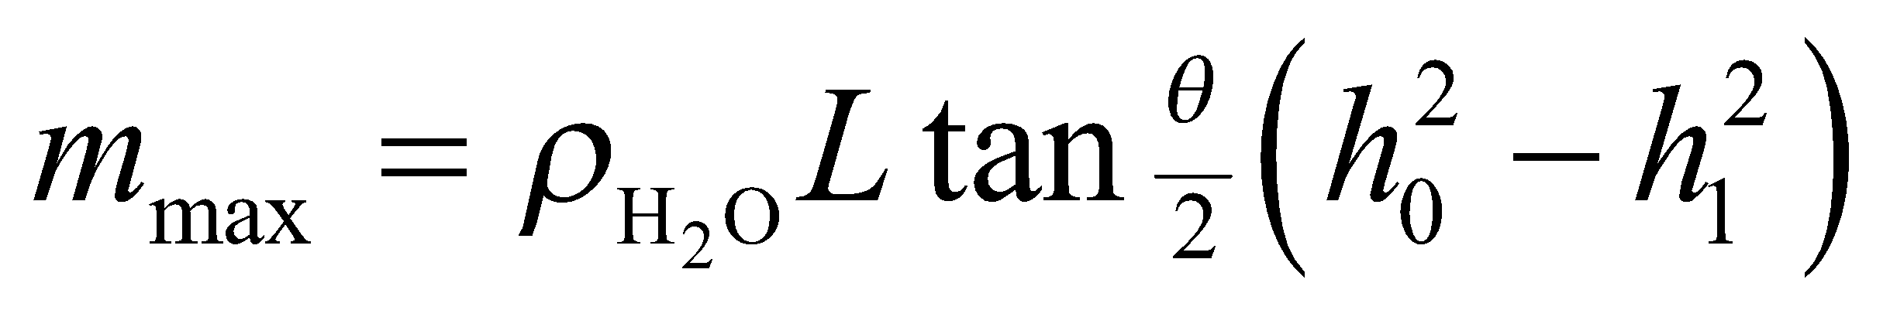

**Assess** A bigger concern for your design might be whether this shape of hull is stable. It is not immediately obvious that the center of gravity is below the center of buoyancy, see Fig. 15.10.

**78. Interpret** We're asked to consider some of the physics of arterial stenosis.

**Develop** The volume flow rate is the cross-sectional area multiplied by the flow speed, 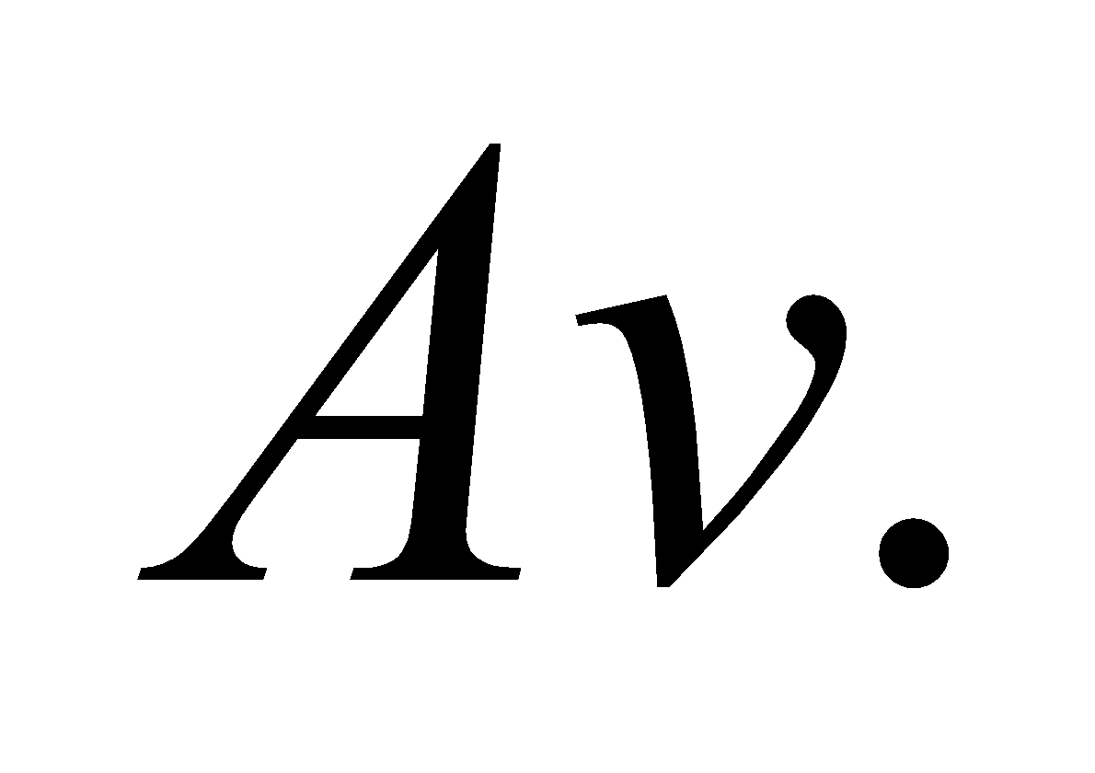

**Evaluate** Like for most fluids, we can assume that blood is incompressible. Therefore, to conserve mass, the volume flow rate must be constant.

The answer is (b).

**Assess** The only time the volume rate is not constant is when the fluid's density changes in response to the change in the cross-sectional area of the flow.

**79. Interpret** We're asked to consider some of the physics of arterial stenosis.

**Develop** The flow speed has to change in order to keep the volume flow rate constant.

**Evaluate** From Equation 15.5: 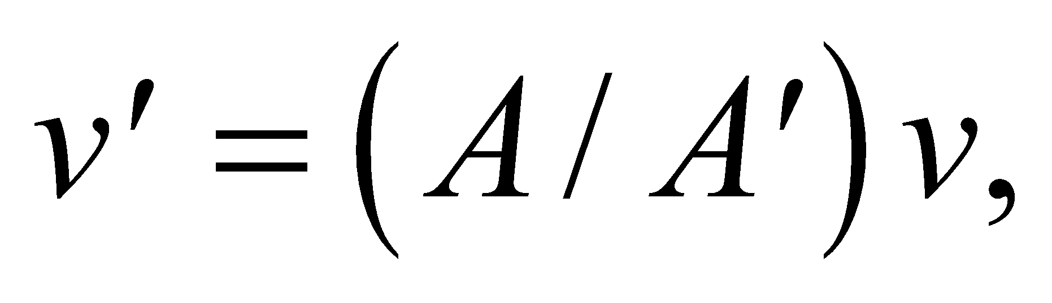 so if the artery wall's thicken and the area decreases: 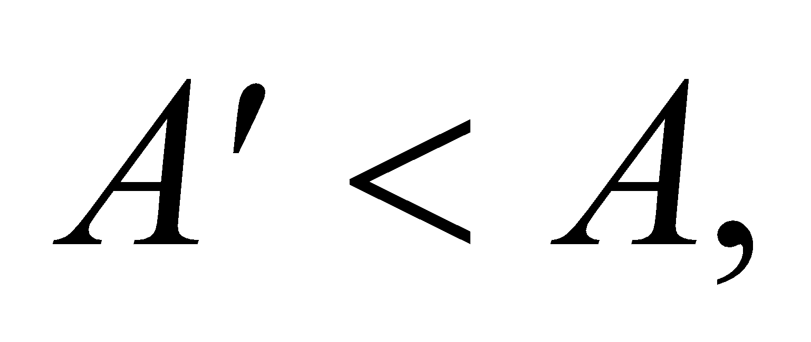then the flow speed must increase: 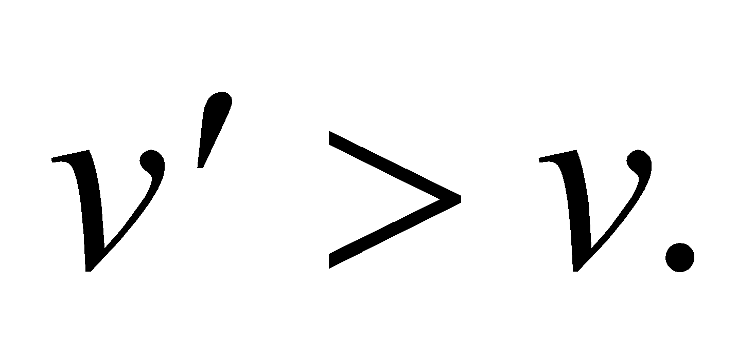

The answer is (c).

**Assess** If the speed didn't increase, the blood would begin piling up in front of the stenosis.

**80. Interpret** We're asked to consider some of the physics of arterial stenosis.

**Develop** We can determine what will happen to the pressure in the artery by using Bernoulli's equation (Equation 15.6). Assuming negligible change in height, the pressure change at the stenosis will be

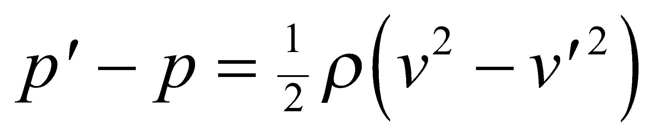

**Evaluate** Since we have already shown in the previous problem that the flow speed increases 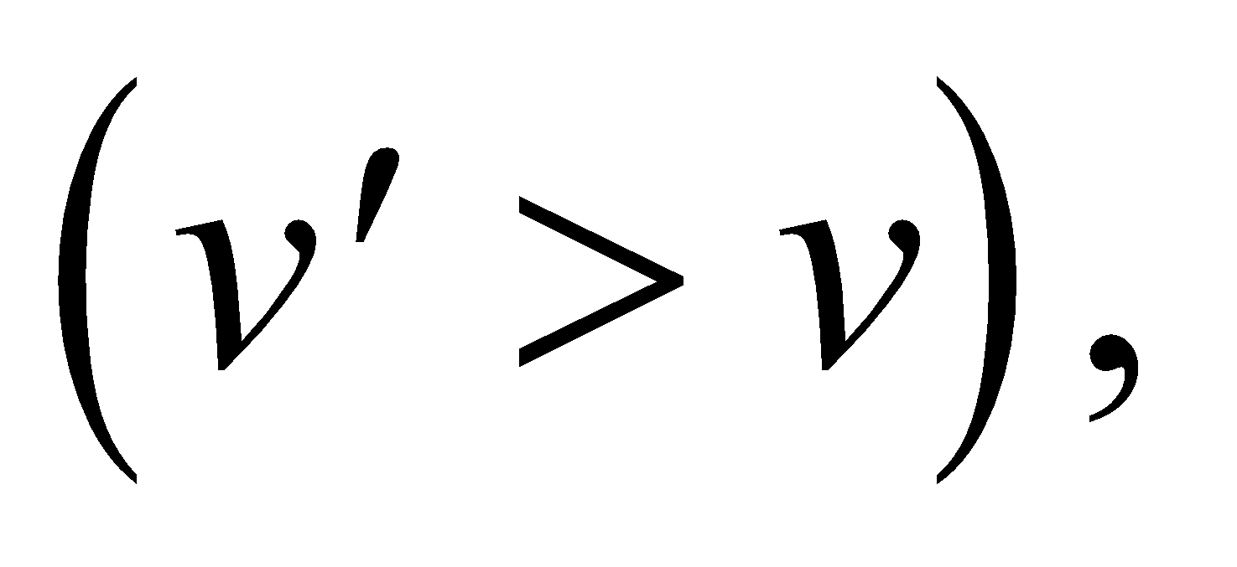the pressure must correspondingly drop.

The answer is (a).

**Assess** This might seem counterintuitive that a constriction in flow might cause the artery to collapse on itself. But when the blood is flowing quickly, the blood molecules take a straighter path through the artery, bumping into the walls less often. This results in less outward pressure on the walls.

**81. Interpret** We're asked to consider some of the physics of arterial stenosis.

**Develop** As pointed out in Problem 15.79, the flow speed in the stenosis is 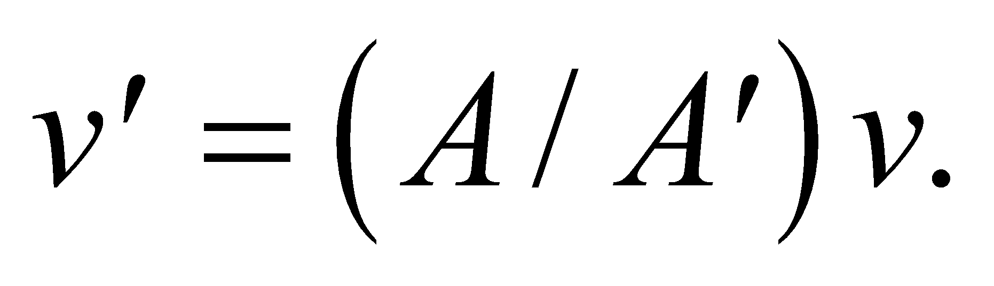 Since the area is related to the diameter by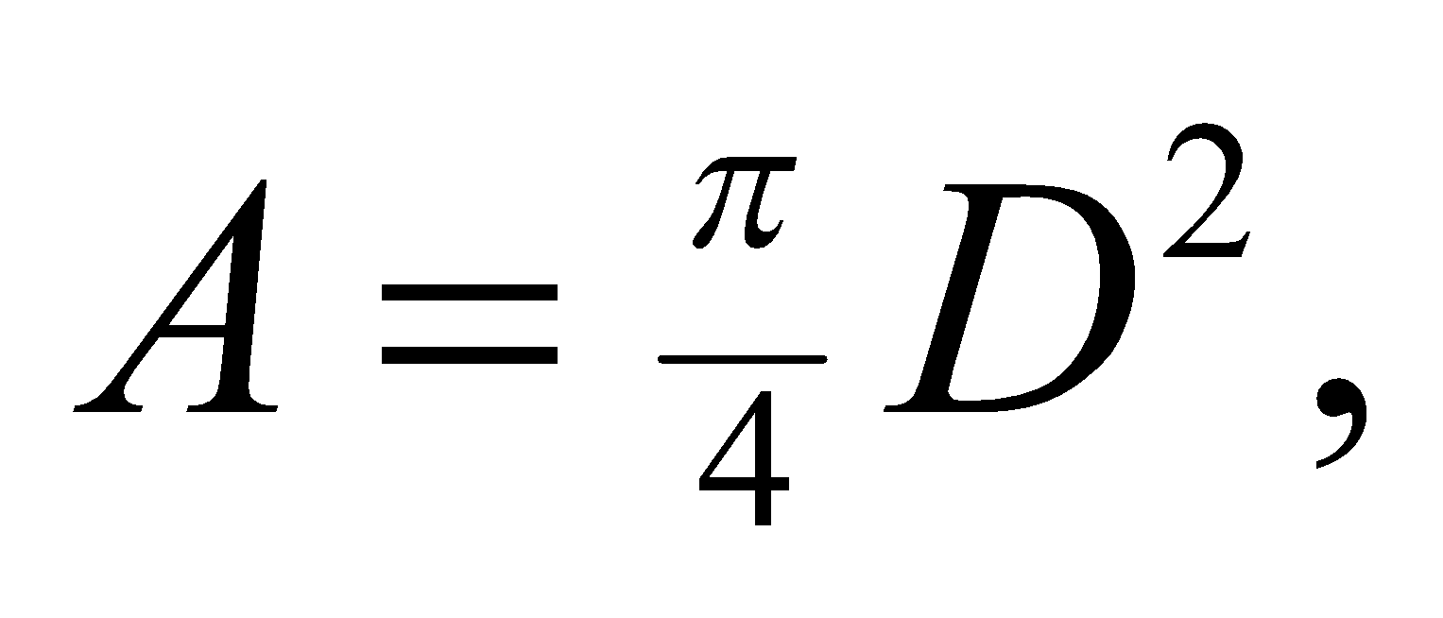the flow speed goes as 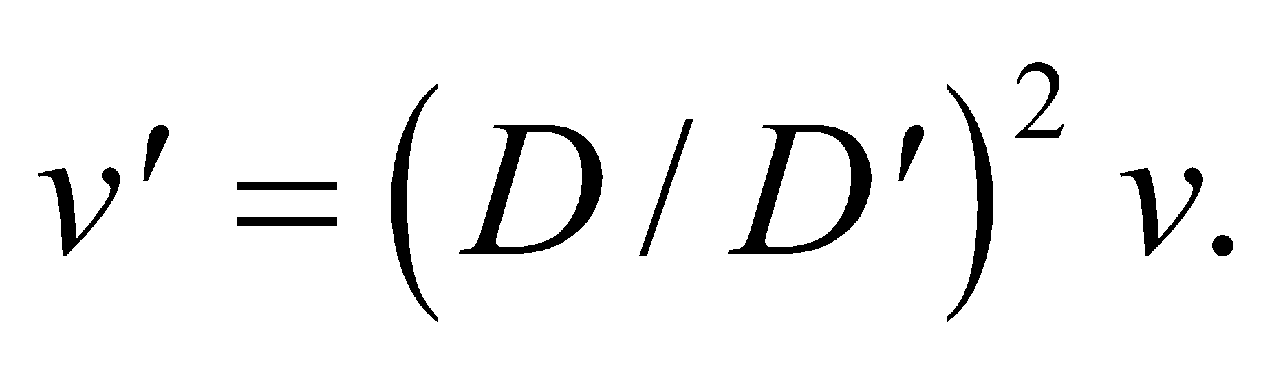

**Evaluate** If the diameter decreases by half, the flow speed increases by a factor of four.

The answer is (e).

**Assess** If we use the values from Problem 15.59: 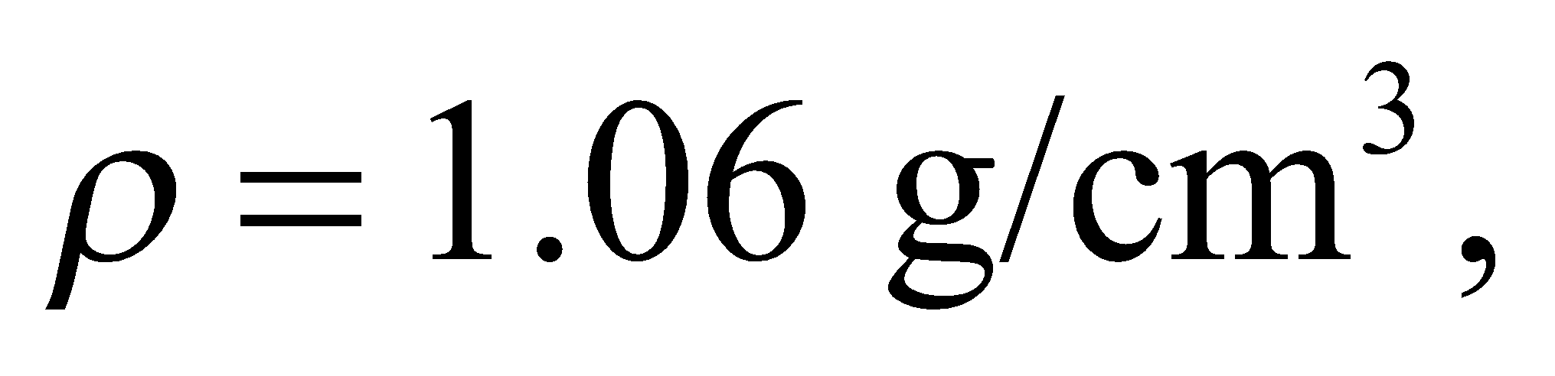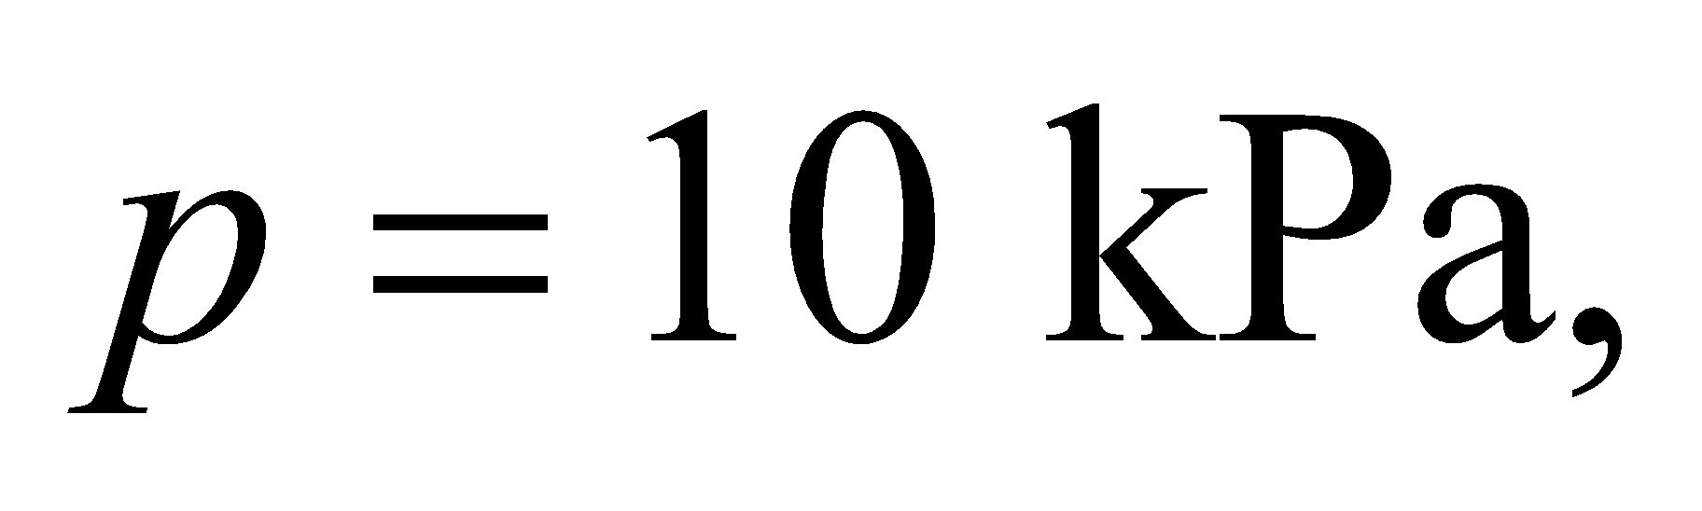and 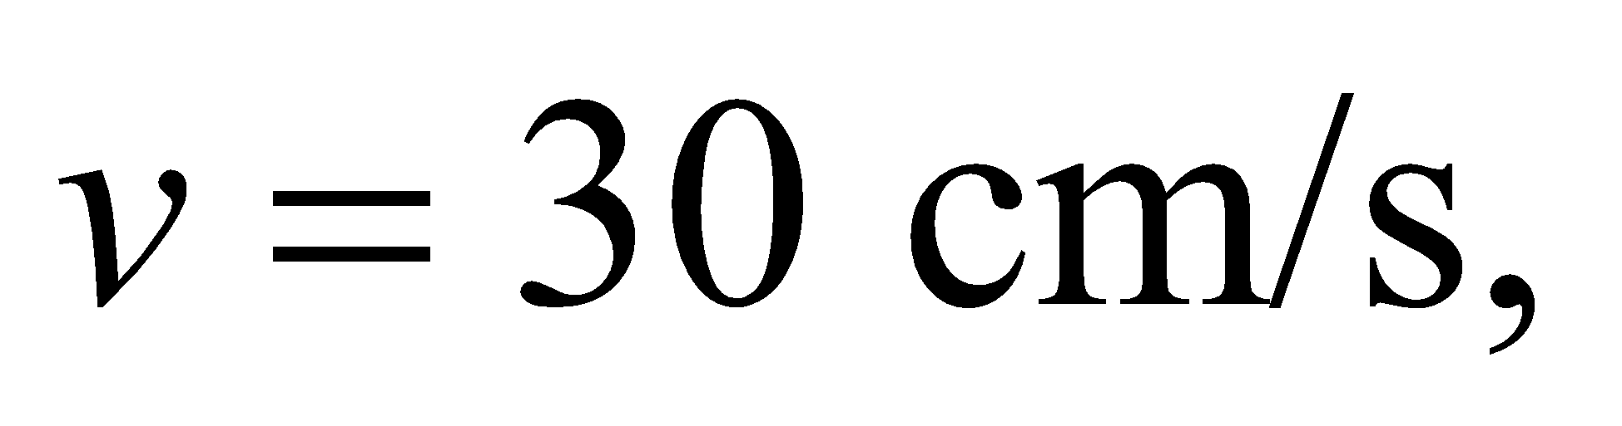then the pressure in the stenosis will drop by 7%.